** **

**ECC 202- Quiz 3**

**Name: MSU #**

Notice: All the calculations need the counting process. It is invalid if there is only one final result.

1. Determine the magnitude of F1 and the distance *y* if *x* = 2.0 m and F2 = 300 N. (5 Points)

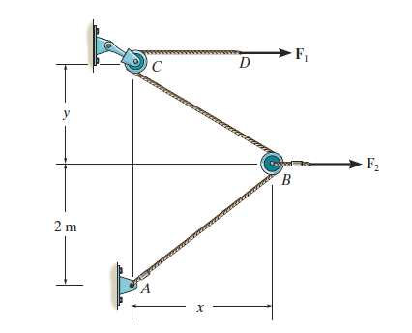

2. Determine the tension in each cord required for equilibrium. The weight of the lamp is 300 N. (5 Points)

