Name ________________________
Section_______________________

AN 102 Lab 2: Genetics and Natural Selection
50 Points

**Read carefully to ensure you answer ALL questions!

DNA
- Where is DNA found in the cell? (1 pt)

- What is the shape of the DNA molecule called? (1 pt)

- The following is a sequence of 12 bases on one strand of DNA. What would the sequence of bases on the complementary strand of DNA be? (1 pt)
A C C A G T T G C A A G
__ __ __ __ __ __ __ __ __ __ __ __

- Here is a different sequences of bases on a strand of DNA:
CTC GTA ACC AGT ATA CCA GAA GCA GGA CCA

  - What is the chain of amino acids that the above DNA strand codes for? Use Figure 1 on the last page of the lab to answer this question. (hint: think of what the corresponding mRNA strand would be) (2pts)
  - What is the name and function of the protein that is made by this chain of amino acids? Refer to Table 1 of the Appendix to answer this question. (2pts)
__________________ – _____________________________________________
(Protein Name) (Protein Function)
Karyotype
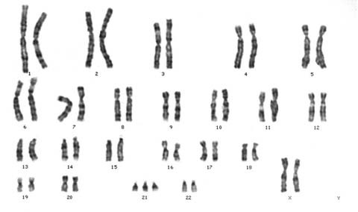
Use the karyotype shown here to answer the following questions:
- Is this individual male or female? (1 pt) ____________________________________
- How do you know? ______________________________________________________
- Are there any variants in this karyotype from a typical human genome? (1 pt)
________________________________________________________________________
- What is the phenotype associated with the karyotype variant you’ve identified? (1 pt)
________________________________________________________________________
- What is the typical number of chromosomes found in a human cell? (1 pt) __________
Of these, how many are autosomes? (1 pt) ___________
How many of these are usually sex chromosomes? (1 pt) ____________
How many autosomes does the above karyotype have? (1 pt) _____________
- Does the number of chromosomes that a species has in its karyotype indicate how “advanced” the species is? (1pt) _____________________________________________
________________________________________________________________________

Mendelian Genetics
- Having dimpled cheeks is a Mendelian trait, in which having dimples is dominant (D), and not having dimples at all is recessive (d). What are the possible genotypes of an individual who has dimples? (1 pt)

- What is the phenotype for the genotype Dd? (1pt)

- Having freckles is a Mendelian trait in which having freckles (F) is dominant to not having freckles (f). Construct two (2) possible Punnett Squares showing the offspring of a mother with freckles and a father without freckles. (6 pts)

- Assuming the above conditions for freckles, what is the probability of a mother without freckles and a father with freckles having a child with freckles? (1 pt)

Given the same parents, what are the chances of a child without freckles? (1 pt)

Sneezing for Mendel
Autosomal Dominant Compelling Helioopthalmic Outburst (ACHOO) Syndrome is an interesting phenotype in which individuals, when suddenly exposed to intense sunlight, uncontrollably sneeze (also called photic sneezing). Typically, it’s a bit more mild than a full dramatic sneeze, expressed as a prickling sensation in the nose. ACHOO Syndrome is autosomal dominant (A), while not having photic sneezing is recessive (a). Step outside at midday on a sunny day this week, and completely cover your face from the sun (e.g., with a sweater or shirt). After a full minute or two of darkness, suddenly take off your face covering to look to the sun.

- Did you feel a prickle in your nose (or sneeze)? (1 pt) ____________________________
- Based on your response, what is or what could be your genotype for this trait? Remember that, with simple Mendelian inheritance, one of the phenotypes has two potential genotypes (1 pt) __________________________________________________
- We are, as yet, unsure of the genetic basis of ACHOO Syndrome, and think it may have something to do with over-excitation of the visual cortex. What, if any adaptive scenario could be involved with this? (1 pt)

Pedigree Exercises
- In the figure below, you are shown a pedigree in which squares are males, circles are females, and darkly colored shapes indicate an individual affected by a Mendelian disease. You can also see the parental genotypes in the first generation. Please fill in the genotypes of the successive generations. (6 pts)
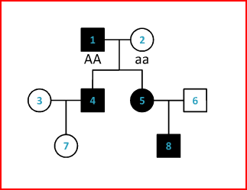

Build a Beast!
We have talked about different patterns of inheritance. Some are simple Mendelian dominant or recessive traits. Some are more complex, such as incomplete dominant or codominant traits. In this activity you will investigate how a combination of these genes work together to create an organism – in this case, a beastly monster.
Part 1 Procedure: Note the dominance relationship between the traits coded for each allele at each trait locus. Based on the alleles and their relationships to each other, determine the phenotype resulting from the genotype given at each trait locus for our female beast. (6pts)

Table 1. Genotypes and Phenotypes for Female Beast
Trait | Allele 1 | Allele 2 | Genotype | Phenotype
Eye Color (Incomplete) | Red (R) | White (R’) | RR’
Skin Color (Codominant) | Green (G) | Blue (B) | BG
Tail Color (Mendelian) | Purple (P) | Orange (p) | Pp
Presence of a Tail (Mendelian) | Have tail (T) | No tail (t) | Tt
Feet (Incomplete) | Four toes (F) | Two toes (F’) | F’F’

Part 2 Procedure:
The female beast (you created in Table 1) mates with a male beast (see Table 2 below) and the female is pregnant. They would like to predict what their brood of babies will look like. To start, however, they’ll need to know the male’s genotypes. Complete the missing genetic information in the table for the male. (5pts)

Table 2. Genotypes and Phenotypes for Male Beast
Trait | Genotype | Phenotype
Eye Color (incomplete) |  | White
Skin Color (codominant) |  | Green
Tail Color (Mendelian) | Pp
Presence of a Tail (Mendelian) |  | No tail
Feet (incomplete) | FF’

- Create Punnett squares in the area provided below to predict what traits would result from a cross between the two monsters for each trait. Using your Punnet squares, answer the following questions (4pts):
  - Eye color – What percent of offspring will have red eyes? ___________________
  - Skin color – What percent of offspring will have entirely green skin? __________
  - Tail – What percent of offspring will have a tail? __________________________
  - Feet – What percent of offspring will have three (3) toes? ___________________

Appendix
Figure 1. For Question 2a of DNA section of lab
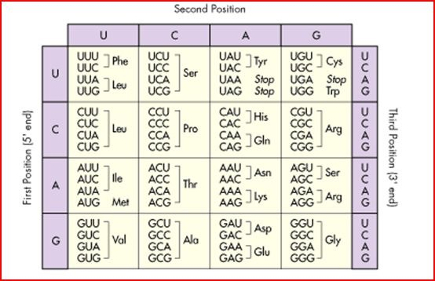

Table 1. For Question 2b of DNA section of lab
Protein Name | # of amino acids making up the protein | Function
Thyrotropin Releasing Hormone | 242 | Causes the pituitary gland to release thyrotropin
Gonadotropin-Releasing hormone | 10 | Promotes the release of LH and FSH from the pituitary gland
Vasopresssin | 9 | Causes reabsorption of water by the kidney
Substance P | 11 | Causes the contraction of smooth muscle in the digestive tract
Corticotropin | 39 | Causes release of steroid hormones from the adrenal glands

