**Activity 1**

**Question 1: When you look at the letter “e” under the microscope, is the letter oriented in the same direction as when you look at the slide? If it is oriented differently, why do you think that might be the case (see the optics diagram in the pre-lab to help you out)**

**Question 2: How is what you see now different from what you saw under the 4X objective? Explain what that difference is?**

**Question 3: How is this view different from what you saw at 10X? Write a short statement that describes what is happening in what you see as you change from the 10X to 40X objectives.**

Question 4: When you move the stage from left to right, which direction does the image of the letter “e” move? Why do you suspect this is the case?

Colored Threads Slide:

Question 5: Do all of the strands on the slide appear to be completely in focus at the same time at this magnification?

**Question 6: Why do the strands appear to be in focus at some magnifications and not others? (Hint: are the threads really flat, or is there depth to them?)**

## **Activity 2**

Question 7: In the space below, give a general description of the look of the epithelial cells. In the pictures below, label any structures can you see (nucleus, cytoplasm, cell membrane). Estimate the size of these cells using the procedure you learned in the pre-lab.

### Epithelial Cells

**40X Objective**

**Total Magnification: ____**

**Estimated Size: _______**

### Epithelial Cells

**10X Objective**

**Total Magnification: ____**

**Estimated Size: ________**

Question 8: In the space below, give a general description of the cells in the tip of the Elodea leaf. In the pictures of the cells below, label any structures can you see (cell wall, cell membrane, cytoplasm, chloroplasts, nucleus, vacuole).

### Elodea

**40X Objective**

**Total Magnification:_____**

**Estimated Size: _____**

### Elodea

**10X Objective**

**Total Magnification: ____**

**Estimated Size: _____**

## **Activity 3**

### Paramecium

**Objective Used:__40X___**

**Total Magnification:_____**

**Estimated Size: _____**

### Euglena

**Objective Used: _40X_**

**Total Magnification:_____**

**Estimated Size: _____**

**Activity 4**

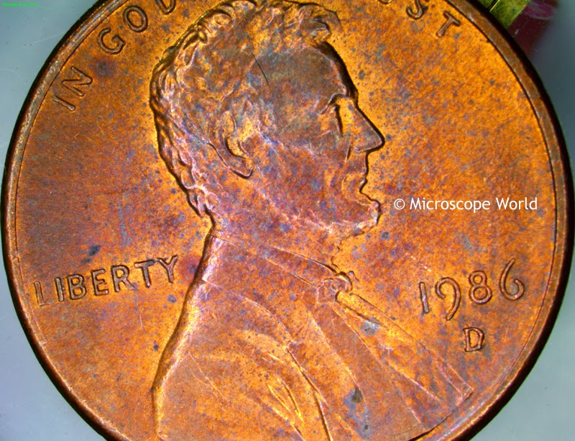

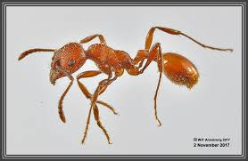

### Specimen:____ANT_____

**Objective Used: _10X__**

**Total Magnification: ____**

**Estimated Size: _____**

### Specimen: penny

**Objective Used: 4X**

**Total Magnification: ____**

**Estimated Size: ______**