Create a Javascript calculator that also has plotting capability. First start by writing the Javascript code/function that can solve the Standard Deviation equation:

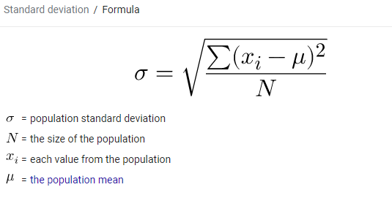

Your equation may have one dependent variable (y) and an independent variable (x) that has a range of values.  If the equation has other variables, then the use must be able to enter values for them (please put in a set of seed values in the text box).

Once the code is working, you will then then to us the calculator for plotting. Please note – the equation should plot the dependent variable on the Y axis, the dependent variable on the X axis. Please use Highcharts or D3.js  for the plotting. See <http://www.highcharts.com/> for reference or <https://d3js.org/>.