**Instructions:** Complete the Photosynthesis Virtual Lab using the website listed below:

Photosynthesis Lab Website: <http://www.glencoe.com/sites/common_assets/science/virtual_labs/LS12/LS12.html>

Please note that this virtual lab should take you about 3 hours to complete.

* **Answer the questions and type in all your answers using this bold blue font. Do not change the font size.**
* **This font makes it easier for me to see and grade your answers. I will not grade answers that are not clearly printed in this color!**
* Check that your answers, graph, and data table are all neat and easy to read. Make your report look professional!
* Save the file on your computer and submit a copy of the file in Word format.

# **Part 1: Introduction**

1. Visit the Photosynthesis Lab website listed above.
2. Review the Purpose, Objectives, and Procedure listed on the left side of the virtual lab space.
3. Select the “Video” button in the lower left side of the virtual lab space to watch an animation about photosynthesis.

Answer the following questions:

1. What is overall research question for this experiment?
2. List the two objectives for this virtual lab.

# **Part 2: Effect of Various Colors of Light on Plant Growth**

1. Write a hypothesis about which color of light will cause the GREATEST amount of plant growth for spinach, lettuce, and radish plants. You may write your hypothesis in the form of a prediction using the “If – then” format.
2. Write a hypothesis about which color of light will cause the LEAST amount of plant growth for spinach, lettuce, and radish plants. You may write your hypothesis in the form of a prediction using the “If – then” format.
3. Next, follow the “Procedure” steps provided to collect data to complete the following table:

Note: To calculate the average, you should measure the heights of the three plants, add these three heights together, then divide by 3. For example, if the three plants measured 24 cm, 35 cm, and 20 cm, respectively, then the average would be (24 + 35 + 20) / 3 = 26.3 cm

|  |  |  |  |
| --- | --- | --- | --- |
|  | Average Height (cm) | | |
| Light Color | Spinach | Radish | Lettuce |
| Red |  |  |  |
| Violet |  |  |  |
| Blue |  |  |  |
| Green |  |  |  |
| Orange |  |  |  |

1. Identify the independent variable in this experiment.
2. Identify the dependent variable in this experiment.
3. Generate a line graph with X axis and Y axis based on the data in the table.
   1. Remember that the independent variable is located on the X axis (horizontal axis) and the dependent variable is located on the Y axis (vertical axis).
   2. Use the Graph Checklist document provided in Moodle to make sure you have the necessary components of an X-Y line graph.
   3. You may use Excel (or other graphing software) to create your graph, then copy/paste your final graph here.
   4. Crop the image to get rid of unneeded parts.
   5. Size the image to fit neatly in the space of your page.

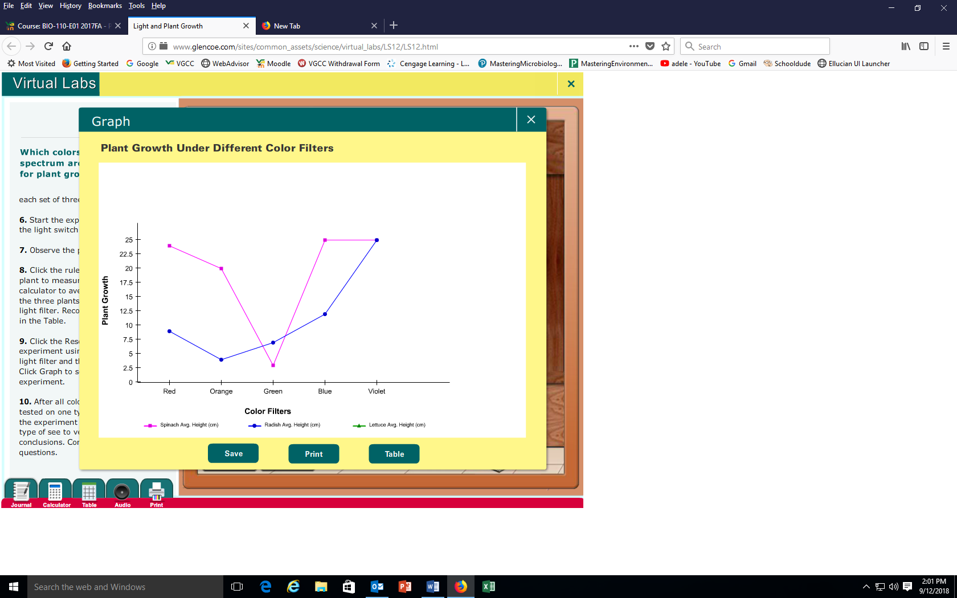Example of what a graph may look like (note: there should be three lines in your graph):

1. Based on the data collected in the table and the graph, is your hypothesis about which color of light will cause the GREATEST amount of plant growth fully supported, partially supported, or rejected? Explain your answer.
2. Based on the data collected in the table and the graph, is your hypothesis about which color of light will cause the LEAST amount of plant growth fully supported, partially supported, or rejected? Explain your answer.