# Assignment 6: Reflection on structural engineering

Copy paste the following questions and type your brief answers underneath them. As always, submit the work at the beginning of the class.

1. What was most interesting to you from the structural engineering presentation? What was confusing to you in the presentation?
2. Use what you learned from the presentation, the web, and engineer friends/relatives to come up with five examples of what a structural engineer may analyze or design? Do any of these appeal to you?
3. Visit this website. Reflect on what you learned. <http://www.ncsea.com/>
4. Visit this website. Reflect on what you learned. <https://www.istructe.org/>
5. Familiarize yourself with SeaOO by visiting these sites and reflect on what you learned: <https://seaoo.org/about.php> and <https://www.linkedin.com/in/ut-seaoo/> If you are interested in the UT-SEAOO chapter, contact them ASAP.
6. Rank your current interest in structural engineering with 1 being least interested and 5 being most interested. Explain your reasoning.
7. Here are companies (see next page) that recently hired our students for civil/environmental engineering jobs. You had already filled this table out for environmental and geotechnical engineering. Copy paste the info from your earlier table and add on to the table below the new info on structural engineering.

|  |  |  |  |  |  |  |  |  |
| --- | --- | --- | --- | --- | --- | --- | --- | --- |
| **Company** | **Web Address** | **Environmental engineering?** | **What type of environmental work?** | **Geotechnical engineering?** | **What type of geotechnical work?** | **Structural engineering?** | **What type of structural work?** | **Does this company currently interest you?** |
| American Bridge | <https://www.americanbridge.net/> |  |  |  |  |  |  |  |
| Arcadis | <https://www.arcadis.com/> |  |  |  |  |  |  |  |
| Applied Environmental Solutions | <https://www.appliedenv.com/> |  |  |  |  |  |  |  |
| Army Corp of Engineers | <https://www.usace.army.mil/> |  |  |  |  |  |  |  |
| Baker Concrete Construction | <https://bakerconcrete.com/> |  |  |  |  |  |  |  |
| Beaver Excavating | <https://www.beaverexcavating.com/> |  |  |  |  |  |  |  |
| Danis | <https://www.danis.com/> |  |  |  |  |  |  |  |
| Douglas Company | <https://www.douglascompany.com/> |  |  |  |  |  |  |  |
| EPA – Environmental Protection Agency | <https://www.epa.gov/> |  |  |  |  |  |  |  |
| Jones and Henry Engineers | <https://jheng.com/> |  |  |  |  |  |  |  |
| Hull and Associates | https://hullinc.com/ |  |  |  |  |  |  |  |
| Kokosing | <https://www.kokosing.biz/> |  |  |  |  |  |  |  |
| Kiewit | <https://kiewitcareers.kiewit.com/> |  |  |  |  |  |  |  |
| Langan | <https://www.langan.com/> |  |  |  |  |  |  |  |
| Lathrop Turner | <http://www.turnerconstruction.com/> |  |  |  |  |  |  |  |
| Marathon Petroleum | <https://www.marathonpetroleum.com/> |  |  |  |  |  |  |  |
| Mannik and Smith | <https://manniksmithgroup.com/> |  |  |  |  |  |  |  |
| Matrix Technologies | <https://matrixti.com/> |  |  |  |  |  |  |  |
| Messer Construction | <https://www.messer.com/> |  |  |  |  |  |  |  |
| ODOT – Ohio Department of Transportation | <https://www.transportation.ohio.gov/> |  |  |  |  |  |  |  |
| Powers Engineers | <https://www.powereng.com/> |  |  |  |  |  |  |  |
| Rudolph Libbe | <https://rlgbuilds.com/> |  |  |  |  |  |  |  |
| SME | <https://www.sme-usa.com/> |  |  |  |  |  |  |  |
| Tetra Tech | <https://www.tetratech.com/> |  |  |  |  |  |  |  |
| Tyme Engineering | <https://tymeengineering.com/> |  |  |  |  |  |  |  |

1. Pressure = Force / Area

Ex: If we have a point load of F = 300N, and Area = 30m2

Then P = F/A = 300/30 = 10 N/m2

**Question:** For F = 250N , and Area = 50m2 , Calculate the pressure in this area.

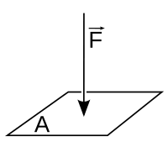

1. For a simple supported beam, with a load M in the middle, the vertical reaction forces on both supports would be equal to M/2.

Ex: For the given beam below, for M = 200 kips, both vertical reactions in the support would be equal to Ay = By = 100 kips.

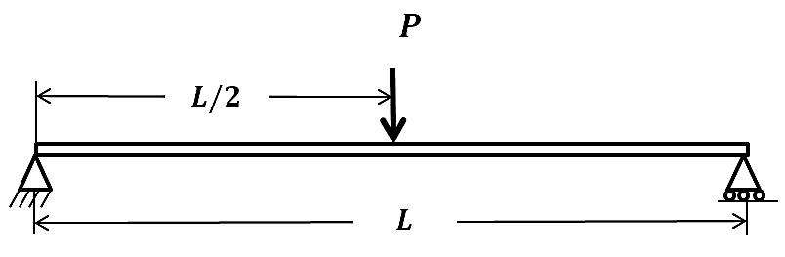**Question:** If we have a load M = 500 kips, calculate the vertical reactions on both supports knowing that the load M is in the middle as shown in the picture below. Express your answer in both kips and kN. 1kip = 4.45kN=1000lbf

**A**

**B**

**M**