Algebra with Trig and Stats Name: _______________________

Module 1 Assessment Review Date: __________

**For questions 1-4 use the following:**

**Josh finds an old tank and decides to fill it with reptiles from a local pet store for $60. He needs to spend $40 per month on food and supplies to feed the reptiles**

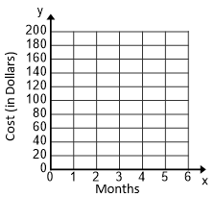1. Write a function, *R(m),* to represent the cost to buy the reptiles and purchase food and supplies in terms of the number of months *(m)* that Jalen owns the reptiles.

2. Graph the function *R(m).*

3. Find the Domain and Range of the function, *R(m),* in the context of this situation*.*

4. Suppose Josh keeps the reptiles for 18 months. Find the total amount of money will he have spent. Show the mathematics used to calculate your answer.

**For Questions 5-8 use the following:**

**Tyrique is saving money in a savings account to buy a motorcycle for $495. He adds the same amount of money to his account every time he shovels snow in the winter. The function, *f(x)* = 30*x* + 75, models the amount of money he will save after shoveling *x* driveways.**

6. How much money does Tyrique put into his account every time he shovels a driveway?

5. How much money does Tyrique start with in his savings account?

8. Tyrique ends up shoveling 34 driveways during the winter. Find the total amount of money that he earned. Show all of your work.

7. How many driveways will Tyrique need to shovel to have a total of $495 in his savings account? Justify your reasoning.

**For questions 9 – 14 use the following:**

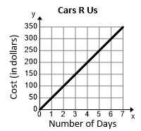**Jada is planning to rent a van for her vacation to Virginia Beach. The daily costs for two rental car agencies are shown below. Robbie’s Car Rental**

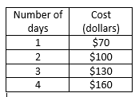

9. Write a function, *R(d),* to represent the cost for Jada to rent a van from “Robbie’s Rentals.”

10. What is the rate of change, in cost per day, at “Robbies’s Rentals?”

11. Write a function, *C(d),* to represent the cost for Jada to rent a van from “Car’s R Us.”

12. What is the rate of change, in cost per day, at “Car’s R Us?”

13. Find the number of days, *d*, when *R(d) = C(d).* What is the cost at each Rental company for this number of days? Show all of the steps used to calculate your answer.

14. Suppose Jada wants to rent a van from one of the companies above for all 4 days of her vacation. Which rental car agency should she choose? Justify your reasoning.

**For Questions 15 – 18 use the following:**

**Ruth goes to a carnival with her little brother and she has $96 to spend on adult and children rides. Adult rides cost $8.00 each and children rides cost $4.00 each. Ruth decides that she only has time for 18 rides total.**

15. Write an inequality to represent the different combinations of adult rides, *x*, and children rides, *y*, she can purchase while remaining within her 18 ride limit.

16. Write an inequality to represent the different combinations of adult rides, *x*, and children rides, *y*, she can purchase while remaining within her $56 limit.

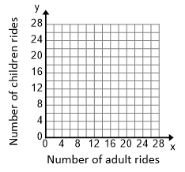

17. Graph the 2 inequalities on the *xy* coordinate grid. Label each inequality.

18. Ruth decides she wants to ride 6 adult rides. How many children rides can she purchase for her little brother? Justify your answer.