**Question 1**

Crystals are made when a substance has atoms or molecules that form in a very organized, repeating, what number dimensional pattern?

Group of answer choices



1



3





2

**Question 2**

Is boiling water a physical or chemical change?

Group of answer choices



physical



change

**Question 3**

Select the pure substances in this lab. (Read through the procedure.)

***Select all that apply, even if you did not use it in your crystal snowflake.***

Group of answer choices



salt



sugar



borax



snowflake



water

**Question 4**

Select the pure substances and mixtures in this lab. (Read through the procedure.)

***Select all that apply, even if you did not use it in your crystal snowflake.***

Group of answer choices



sugar



borax



salt



water



snowflake

**Question 5**

How many liquid ounces are in a single pint?

 Record your answers to the correct number of significant figures.



**Question 6**

How many gallons is 1 pint?

 Record your answers to the correct number of significant figures.



**Question 7**

How many milliliters are in 1 pint?

Record your answers to the correct number of significant figures.



**Question 8**

Select the **original** postulates of Dalton’s atomic theory ***(select all that apply)***

Group of answer choices



Compounds are formed when the atoms of different elements combine with each other in fixed, non-whole-number ratios



Compounds are formed by a combination of two or more different kinds of atoms.



All matter is made up of atoms, which are tiny, divisible particles



All atoms of a given element are identical in mass and properties.



Compounds are formed when the atoms of different elements combine with each other in fixed, whole-number ratios



All atoms of a given element are identical in number of protons and properties.



All matter is made up of atoms, which are tiny, indivisible particles



Atoms can be combined, separated, or rearranged via chemical reactions

**Question 9**

**Pre-Lab**

Regarding the beverage lemonade, what is the solute and the solvent for this solution?

solvent =              ["", ""]           

solute =              ["", ""]           

**Question 10**

**Pre-Lab**

Google search how to make "Sweet tea"

Why is solution considered to be supersaturated?

Group of answer choices



Sugar can dissolve in water



You have to heat the solution



This beverage is caffeinated



You have to mix sugar with water

**Question 11**

**Pre-Lab**

Please match the appropriate definition with the term on the left.

Group of answer choices

supersaturated



saturated



unsaturated



**Question 12**

**Pre-Lab**

Regarding solubility of solids in liquid, please check all the apply that will increase the solubility of a solid in liquids.

Group of answer choices



agitation (stirring)



removal of heat



addition of heat



decrease surface area



increase surface area

**Question 13**

**Pre-Lab**

Watch the video and answer the questions below:

<https://www.youtube.com/watch?v=d7Qge1QbcaE&feature=youtu.be>

1. What was the solute and solvent in the video?              ["", "", ""]           
2. After first adding the solute, what did the narrator do?              ["", "", ""]           
3. What type of solution is the first solution?              ["", "", ""]           
4. After she adds more sugar, she notices that after stirring, some sugar remains at the bottom of the glass. What type of solution is this?              ["", "", ""]           
5. After heating the solution, she notices that the excess sugar that wasn't dissolved earlier, is dissolved even after it cools. What type of solution is this?              ["", "", ""]           

**Question 14**

**Pre-Lab**

Each solid will have a maximum amount of solid that can be dissolved per given temperature. This can be found on a solubility curve.

A **solubility curve** is a data based graph comparing the amount of solute that will dissolve in a given amount of solvent at various temperatures. The most typical **solubility curves** are graphed based solid and gaseous solutes dissolved in 100 grams of water.

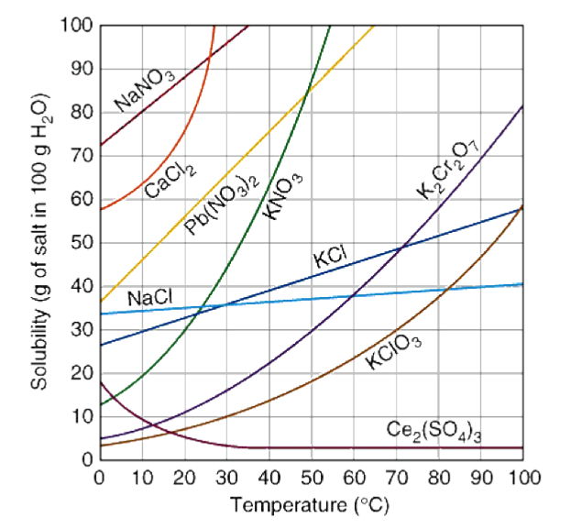

To read these graphs, each line represents the maximum amount (in grams) of that compound per a certain amount of water (100g) at a given temperature. For example, look at **green line**, which represents the compound KNO3.

Looking at the temperature value of **20oC**, the maximum amount of KNO3 that can be dissolved in 100g of water is **30g of KNO3. That means that a solution that has 30g KNO3 in 100g of water is saturated.**Therefore, for **20oC**, any amount under 30g would be unsaturated and any amount over 30g would be **supersaturated**.

Using this, determine if the following solutions are unsaturated (below the line), saturated (on the line), supersaturated (above the line) for a given temperature.

1. A solution of **30g NaCl** per 100g of water at**20oC**              ["", "", ""]           
2. A solution of **40g NaCl** per 100g of water at**90oC**              ["", "", ""]           
3. A solution of **30g KCl** per 100g of water at**50oC**              ["", "", ""]           
4. A solution of **50g KCl** per 100g of water at**50oC**              ["", "", ""]           
5. A solution of **10g KClO3** per 100g of water at**30oC**              ["", "", ""]           

**Question 15**

**Data**

Regardless if your snowflake formed or not, why would the solute (borax, sugar, salt) form around pipe-cleaners the day after?

***(select all or any that apply)***

Group of answer choices



The solution warmed up overnight



The solution became saturated overnight



The solution stayed supersaturated overnight



The solution cooled down overnight



The solution became unsaturated overnight

**Question 16**

**Data**

What solute did you use to make your snowflake?

Write one of the following: borax, sugar, salt



**Question 17**

**Data**

Regarding your snowflake, what is the solute and the solvent for your solution?

solvent = 

solute = 

**Question 18**

**Data**

Did your snowflake appear after overnight?

(write yes or no)

**Question 19**

**Post-Lab**

Which postulate of Dalton’s atomic theory is studied in this lab?

(select all that apply)

Group of answer choices



Compounds are produced through different whole-number combinations of atoms.



All atoms of an element are identical.



A chemical reaction results in the rearrangement of atoms in the reactant and product compounds.



Everything is composed of atoms, which are the indivisible building blocks of matter and cannot be destroyed.



The atoms of different elements vary in size and mass.

**Question 20**

**Data**

Explain why your snowflake did appeared OR if your snowflake did not appear.

**Question 21**

**Data**

Take a picture of your glass containing your snowflake (if nothing happened take a picture of the container regardless).

***(Add it as a picture)***

**Question 22**

**Data**

Upload your data pages.

Upload

Choose a File