GEO3020 – Fall 2020

Internal Order in Crystalline Solids: Translation Symmetry and Lattices

Material: As for PS1, you can either choose to print the PS2-2020.doc document, write/draw your answers manually and then upload the scan of your document (one single PDF format preferred), or you can use the PS2.ppt file and enter your answers directly by typing/drawing them in powerpoint.

I. Background
a. Symmetry of a Crystal.
The purpose of this exercise is to demonstrate the relationship between the symmetry of a lattice and the symmetry of a crystal.

b. Space Lattice Types. There are four basic types of space lattice whose unit cells have an unspecified geometrical shape except for the number and locations of lattice points. These are:

(1) Primitive (P): The lattice points are at the corners of the unit cell. There is a total of one lattice point per unit cell because each corner point is shared by 8 unit cells (1/8 x 8 = 1).

(2) Side-centered (B or C): The lattice points are at the corners of the unit cell and centered in pairs of opposite faces of the unit cell. There is a total of two lattice points per unit cell. Each corner point is shared by 8 unit cells (1/8 x 8 = 1). Each side-centered point is shared by two unit cells (1/2 x 2 = 1).

(3) Body centered (I): The lattice points are at the corners of the unit cell and centered in the body of the unit cell. There is a total of two lattice points per unit cell. Each corner point is shared by 8 unit cells (1 lattice point), but the point located in the center of the unit cell is unshared (1 lattice point).

(4) Face centered (F): The lattice points are at the corners of the unit cell and centered in each face of the unit cell. There is a total of four lattice points per unit cell. Each corner point is shared by 8 unit cells (1/8 x 8 = 1). Each face centered point is shared by two unit cells (1/2 x 6 = 3).

[Note that a fifth type of unit cell exists: The rhombohedral unit cell that can be chosen in one of two ways. Either a primitive unit cell with one lattice point per unit cell may be used or a multiple unit cell with three lattice points per unit cell may be used. We did not discuss this type in class]

c. Bravais Lattices. The 14 permissible combinations of space lattice type and crystal systems are known as Bravais lattices. The restrictions imposed by point group symmetry of a pattern on the dimensions of the Bravais lattices are summarized below.

Isometric P, I, F a1 = a2 = a3 α = β = γ = 90°

Tetragonal P, I a1 = a2 ≠ c α = β = γ = 90°

Hexagonal P, R a1 = a2 = a3 ≠ c α = β = 90°, γ = 120°

Orthorhombic P, C, F, I a ≠ b ≠ c α = β = γ = 90°

Monoclinic P, C a ≠ b ≠ c α= γ = 90°, β ≠ 90°

Triclinic P a ≠ b ≠ c α ≠ β ≠ γ

II. Guidance
For the exercise, consider only mirror planes or rotation axes that are perpendicular to the plane of the page (or your screen). Show mirror planes as a line, labeled m. Rotation axes can be shown perpendicular to the page with the following symbols:
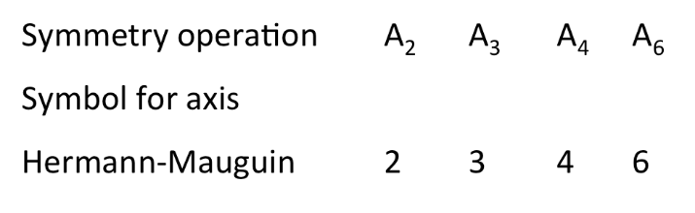

If I ask: draw a simple motif, using a combination of 3, that has a symmetry 3. I’m expecting, for instance:
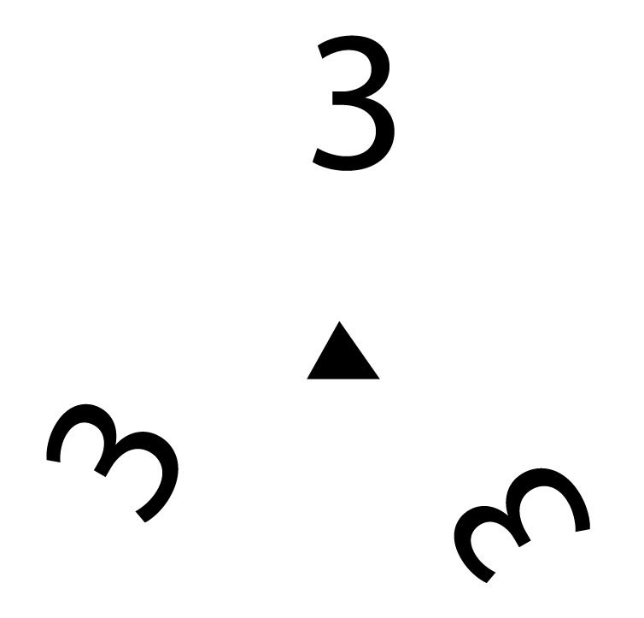

If I ask: Using the motif you have just drawn, draw a 2-dimensional pattern on the lattice below , I’m expecting:

• • • • •

• • • • •

• • • • •

• • • • •

