Name:
Lab Work Week 6
First let’s review Chapter 5 and 6:
- Probability values range from ____ to ____.
- In a space bar there were 14 storm troopers, 3 Wookies, 9 humans, and 2 musicians. An android enters, fires a shot, and hits someone in the cheek. What is the probability that a musician was hit?
- The next question uses the picture below:
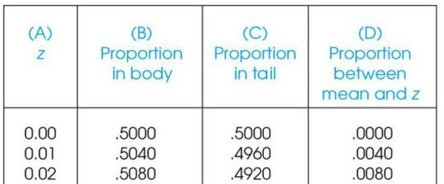

- What does column a refer to?
- What does column b refer to? Please describe and draw.
- What does column c refer to? Please describe and draw.

- Let’s remember that the average IQ score for the population is 100 with a standard deviation of 15. What is the standardized score for someone:
- Who has an IQ of 93? Please show your work, draw your distribution, and place the z-score for this IQ score on the distribution. Is this a typical or unusual score?
- Who has an IQ of 135? Please show your work, draw your distribution, and place the z-score for this IQ score on the distribution. Is this a typical or unusual score?

- When the original Star Wars movie came out (1977), there was much excitement about the movie. Let’s look at some problems based on the characters and film.
On average it takes Han Solo 45 seconds to check the coordinates and jump into hyperspace. The standard deviation of this important task is 5 seconds. When Han and Chewbacca and their passengers are leaving Alderaan, they make the jump in 33 seconds. What is the probability of such a jump? Please show your work, draw your distribution, and place the z-score for this jump on the distribution.

Now let’s make sure we understand Chapter 7:
- All the possible random samples (n = 10) are taken from a population with µ = 100 and ơ = 15. What is the mean of the distribution of sample means µ_{m}?

- All the possible random samples (n = 10) are taken from a population, means are calculated, and a distribution of sample means is created. Next, all the possible random samples (n = 100) are taken from the same population, means are calculated, and a distribution of sample means is created. How will the distribution of sample means for n = 10 compare with the distribution of sample means for n = 100?

- You are interested in the degree to which UNCW students enjoy the new Disney Star Wars movies. Possible answers range from 0 (do not enjoy them at all) to 10 (enjoy them immensely).
- If all possible random samples of UNCW students, each with n = 4 scores are selected from the population of UNCW with a µ = 7 and ơ = 2, how much distance is expected on average between the sample means and the population mean? Please show your work.
- Next, if all possible random samples of UNCW students, each with n = 25 scores are selected from the population of UNCW with a µ = 7 and ơ = 2, how much distance is expected on average between the sample means and the population mean? Please show your work.
- Last, if all possible random samples of UNCW students, each with n = 100 scores are selected from the population of UNCW with a µ = 7 and ơ = 2, how much distance is expected on average between the sample means and the population mean?

- A normal population has a µ = 100 and ơ = 8. A random sample of n = 16 scores from this population has a mean of M = 104.
- What is the z-score for this sample mean?
- Please show your work, draw your distribution, and place the z-score for this mean on the distribution.
- What percentage of sample means would be expected to be greater than this sample mean?
- What percentage of sample means would be expected to be less than this sample mean?

- A random sample of n = 25 is selected from a normally distributed population with µ = 600 and ơ = 100. What is the probability that the sample mean will be less than 590?
- What is the z-score for this sample mean?
- Please show your work, draw your distribution, and place the z-score for this mean on the distribution.
- What proportion of sample means would be expected to be less than this sample mean?
- What proportion of sample means would be expected to be greater than this sample mean?

