**Student’s name: ____________________ Grade: _______**

**CAPACITOR LAB**

Objective: To study capacitor, capacitance, capacitors in series and parallel, calculating capacitance and energy stored in charging capacitor.

Theory: Refer to chapter 25 of Resnik and Halliday (Fundamentals of Physics, 10th edition) or chapter 26 of Randall Knight (Physics for Scientists & Engineers, 4th edition)

Introduction:

*Capacitor is one extremely common device used by engineers. It is a device in which electrical energy can be stored.*

Beside the most common use for capacitors is energy storage, additional uses include power conditioning, signal coupling or decoupling, electronic noise filtering, and remote sensing. Because of its varied applications, capacitors are used in a wide range of industries and have become a vital part of everday life.

Capacitance: This is “how much” charge can be stored in the capacitor.

Parallel-plate capacitor:

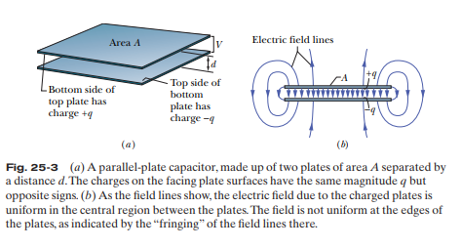

When a capacitor is charged, its plates have charges of equal magnitudes but opposite signs +q and –q. However, we refer to the charge of a capacitor as being q, the absolute value of these charges on the plates.

Because the plates are conductors, they are equipotential surfaces – all points on a plate are at the same electric potential. The electric potential difference between the two plates is ΔV or V (for historical reason). The charge q and the potential difference V are proportional to each other:

q = CV

where C is a constant named the ***capacitance*** of the capacitor. Value of C depends only on the geometry of the plates, not on q or V. Unit of C is [**F**] (Farad).

$C=\frac{ε_{o}A}{d}$ (figure 25-3)

The permittivity constant $ε_{o}$ = 8.85x10-12 C2/N.m2

Cylindrical capacitor:

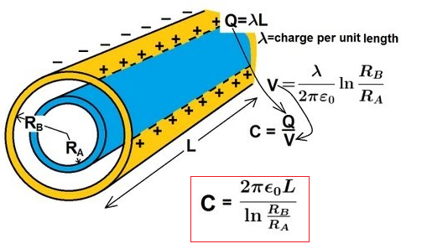

Spherical capacitor:

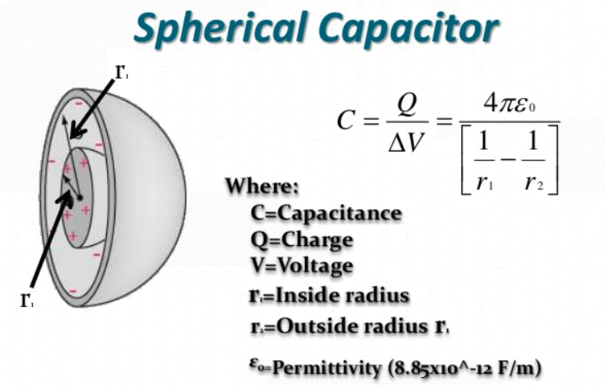

Capacitors in series and parallel:

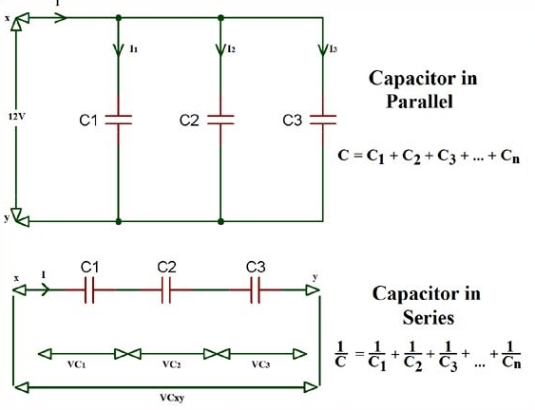

Energy stored in capacitor:

$U=\frac{q^{2}}{2C}=\frac{1}{2}CV^{2}$ (Potential energy)

**ANSWER THE FOLLOWING QUESTIONS**

1. Play with this simulation <https://www.new3jcn.com/Phyc240/capacitor.html>

How the capacitance changes if you change distance between two parallel plates? How the capacitance changes, if you change the areas of the plates? Explain? (2 pts)

1. What is the capacitance of a parallel-plate capacitor of plate area A = 115 cm2 and plate separation is d = 1.24 cm? (2 pts)
2. A cylindrical capacitor having a length of 8 cm is made of two concentric rings with an inner radius as 3 cm and outer radius as 6 cm. Find the capacitance of the capacitor? (2 pts)
3. A spherical capacitor is made of two concentric spheres with an inner radius as 3 cm and outer radius as 5 cm. Find the capacitance of the capacitor? (2 pts)
4. Given C1 = 8 µF, C2 = 6 µF, and C3 = 8 µF connected to a 12 V battery. When switch S is closed so as to connect uncharged capacitor C4 = 6 µF. How much charge passes through point P from the battery and how much charge shows up on capacitor 4? (2 pts)

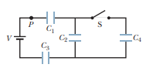

1. Four capacitors C1 = 10 µF and C2 = C3 = C4 =20 µF. The charge on capacitor one is 30 µC.

What is the magnitude of the potential difference VA – VB? (2 pts)

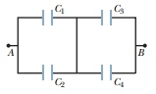

1. Three capacitors C1 = 1 µF, C2 = 2 µF, C3 = 4 µF are in series. They are parallel with other group C4 = 1 µF, C5 = 3 µF, C6 = 5 µF in series (See the circuit on the left of the simulation in question 8 ). Find the equivalent capacitance? Compute total energy stored in 6 capacitors, in case of V = 9 V? (2 pts)
2. Using this simulation: <https://www.new3jcn.com/Phyc240/capacitor_deltastar.html>

to verify your answer in question 7 (the equivalent capacitance). What is percent error? Insert your screenshot here. (1 pt)

1. Compute the equivalent capacitance of the network on the right side of the above simulation (show your works). Compare your answer with the answer from the simulation. What is percent error? Insert your screenshot here. (5 pts)