CE 210 Introductory Computer Aided Design and Drafting for Civil Engineers
Assignment #2

1. To print out a drawing, we will usually set up the layout in the paper space in order to print the drawing properly. Based on the learning from the class and your exercise experience, please answer what the primary steps needed for setting up a new layout for plotting are? Include your explanation of why it is needed for each step in your answer. (15%)

2. A floor plan (40'×30') is sketched in full scale in the Model Space. In the layout, this floor plan is prepared for plotting, with the measurement zoomed to be 8'' × 6'', to fit the Letter Size paper.

- Suppose the scale in the plot dialog box is 1 to 1 (i.e., 1 inch = 1 unit). What is the scale for the printout of this drawing? (3%)

- Suppose that the scale in the plot dialog box still is 1 to 1. The viewport scale in the layout is changed to 3/4'' = 3'. Then, what is the measurement of one unit in the layout for plotting? (3%)

3. Answer the following short questions. (16%)

- From which direction as default does AutoCAD start measuring angles?

- What is the length of the line connecting two absolute coordinate points, (1, 4) to (4, 4)?

- What is the length of the line from an absolute point, (1, 4), to the point, @4<5?

- Explain three basic methods to select objects.

- In the MOVE command, what is the option, “displacement,” for the first point and second point?

- When you use some of the commands to modify existing objects, the commands ask to specify a base point. What is the role of the base point in these commands?

Submission Guideline
Download this MS-Word file to answer the questions and save your answer pages as a PDF to upload at the eCampus.
4. Construct the following drawing, using draw and modification commands.
- Shape (15%)

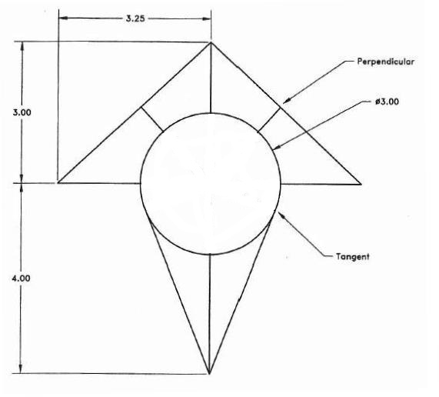

Drawing Suggestions
- Open AutoCAD, start a new drawing using the template “set-inch.dwt”.
- No need to dimesion the drawing. The dimensions are for your reference.
- All dimensions in the drawing are in inches.

Submission Guideline
- The border and title must be set to deliver the printout. Use the “Border & Title A-5.dwg” to prepare for the border & title of your drawing.
- In the border & title, set your drawing name: Shape, drawing scale: 1:1, the date is the date you draft the drawing, and the number is 001.
- Save file as “CE210-HW#2.1-YourName.dwg”, e.g., CE210-HW#2.1-JohnMiller.dwg.
- Upload two files (e.g., PDF and DWG) to Assignment-2 at the eCampus.

- Site Layout (48%)

Boundary Dimensions

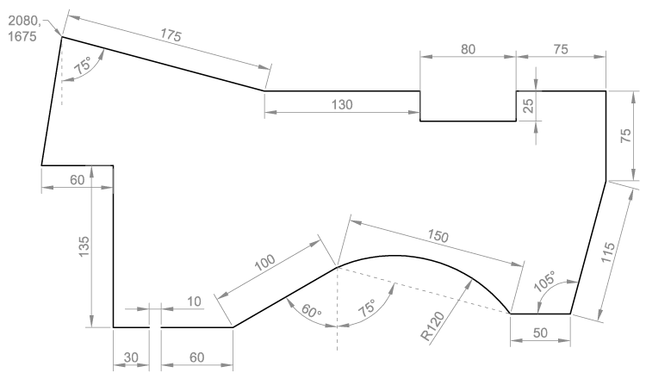

Building Dimensions

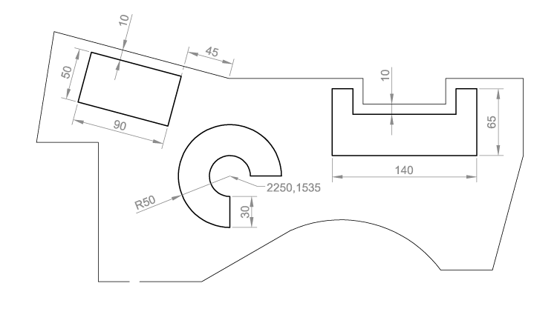
Drawing Suggestions
- The illustration above shows the boundary of a development site with three office buildings, an access road, some trees and a lake. See the next two pages for dimensions. All linear dimensions are in METERS.
- Use the dimensions and coordinates to accurately draw the site boundary, building footprints and other features
- You do not need to show the dimensions. They are for information only.
- You do not need to place colors and hatches. You will learn it in your future study.
- When you have the site layout in a model space completed, set up a layout with a letter paper size and the plot scale at 1 unit = 2,000 mm.

Submission Guideline
- Use the “Border & Title A-5.dwg” to prepare for the border & title of your drawing.
- In the border & title, set your drawing name: Site Layout, scale: 1:2,000, the date is the date you draft the drawing, and the number is 001.
- Save file as “CE210-HW#2.2-YourName.dwg”, e.g., CE210-HW#2.2-JohnMiller.dwg.
- Upload two files (e.g., PDF and DWG) to Assignment-2 at the eCampus.

