To do items:

1. Identify decision variables

* 1 month investment (6% yield) = Y1
* 3 month investment (8% yield) = Y2
* 7 month investment (12% yield) = Y3

1. Identify objective statement

* Maximize Investment opportunities while paying bills on time
* Maximize Z = .06Y1 + .08Y2 + .12Y3

1. Identify constraints

* S = Monthly salary: $29,400 / 12 months = $2,450
* B = Starting Budget = $3,800
* January = X1 = B + S - 2,750
* February = X2 = X1 + S - 2860
* March = X3  = X2 + S - 2335
* April = X4 = X3 + S - 2,120
* May = X5 = X4 + S - 1205
* June = X6 = X5 + S - 1600
* July = X7 = X6 + S - 3050
* August = X8 = X7 + S - 2300
* September = X9 = X8 + S - 1975
* October = X10 = X9 + S -1670
* November = X11 = X10 + S - 2710
* December = X12 = X11 + S - 2980

1. Develop model for Susan (using her $3,800 of savings)
2. Develop model for Susan if she only uses a portion of her $3,800 towards her budget and what is the optimal amount to invest versus how much she should use for the budget

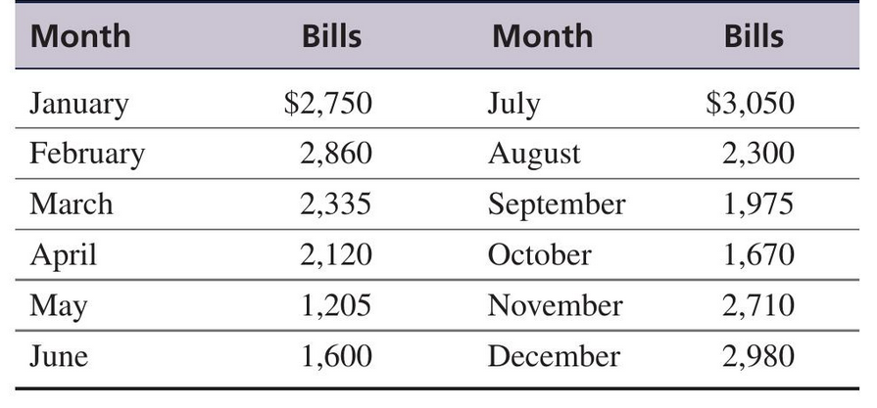

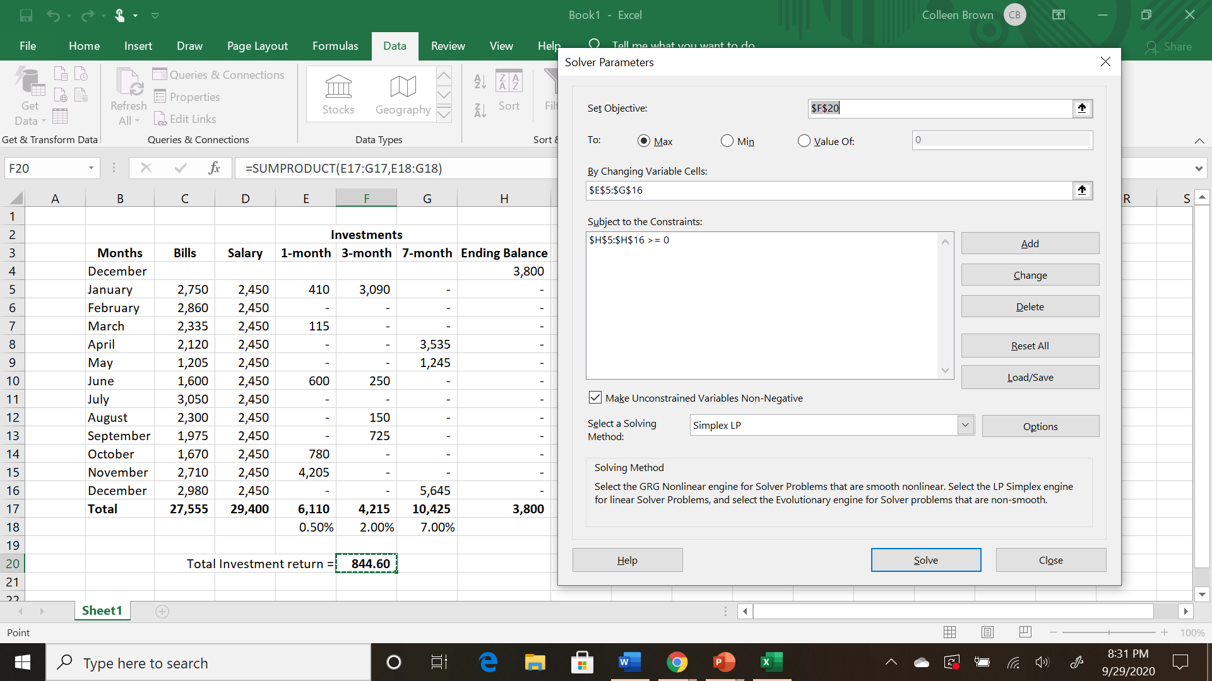

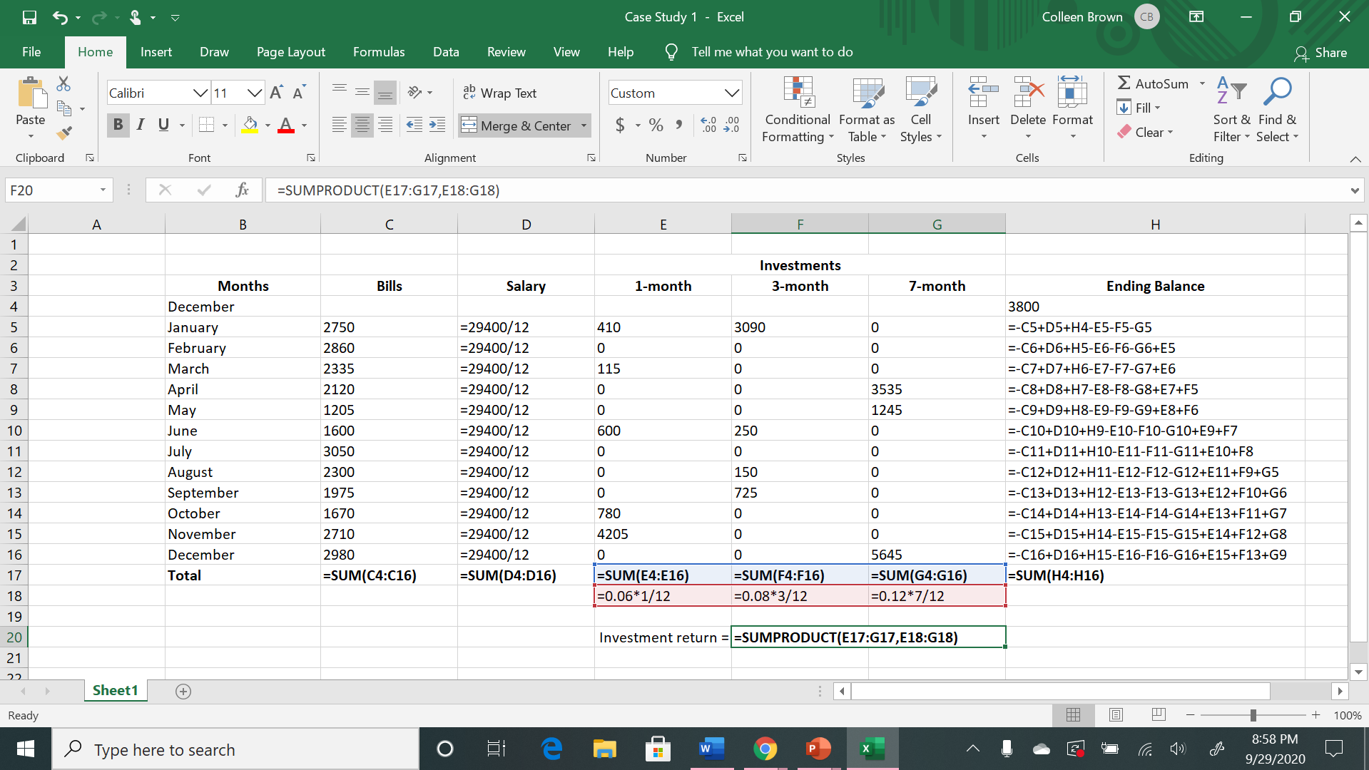

1. As shown in the screenshots above, this model helps Susan to get the maximum return as calculated at $844.60, with the 1, 3, and 7 month investments, and their respective interest rates. This model takes into account her bills, salary, and $3,800 left over cash to start the year. To maximize the return, Susan should be able to pay her bills, as well as make investments and end each month with $0 left.
2. Susan’s feasible budget would be her bills minus her salary ($2,750-$2,450), which would be $300.