**CEE 721/821 Environmental Sampling and Analysis**

**Homework 2**

**Fall 2020**

**BE SURE TO DESCRIBE ALL CALCULATION PROCESSES AND JUSTIFY ALL ANSWERS.**

1. (10 pts) A lagoon waste pit has the following historical data for the barium concentration based on a simple random sampling (n=4): 86, 90, 98, 104 mg/kg (the lower two thirds of lagoon). The regulatory threshold for barium is 100 mg/kg. The waste on this site was categorized to be hazardous, and therefore a more thorough sampling plan is needed. Determine the number of samples required so that the reported mean has a 90% confidence level.
2. (10 pts) Describe the special considerations and tools that can be used in taking water samples from: (a) flowing waters (rivers and streams), (b) static waters (lakes and ponds), and (c) estuaries.
3. (8 pts) Studies were conducted to test lead (Pb) concentrations in surface soils due to atmospheric deposition of emissions from a smelter. A total of 30 samples were collected, and the number of samples in each stratum was proportionally allocated based on the estimated percentage land area under the specified wind direction. The stratum weights and the resulting statistics of analytical results are shown below. Estimate the overall mean and standard deviation using the following equations.

$$\overline{x}=\sum_{k=1}^{r}{w_{k}{\overline{x}}_{k}}$$

$$s^{2}=\sum_{k=1}^{r}{\frac{w_{k}^{2}s_{k}^{2}}{n_{k}}}$$

|  |  |  |  |  |
| --- | --- | --- | --- | --- |
| Stratum (r=4) | Sample number (nk) | Mean (${\overline{x}}_{k}$) | Standard deviation (sk) | Stratum weight (wk) |
| Downwind clayed soil (k=1) | 15 | 86.0 | 8.0 | 0.5 |
| Downwind sandy soil (k=2) | 6 | 68.4 | 5.5 | 0.2 |
| Perpendicular wind clayed soil (k=3) | 5 | 53.5 | 3.5 | 0.17 |
| Perpendicular wind sandy soil (k=4) | 4 | 50 | 2.4 | 0.13 |
| Overall | 30 | ? | ? | 1.00 |

1. A former small pesticide manufacturing facility was surveyed for pesticide residues in surrounding soils. Historical data have shown that the pesticide is very stable in soil, concentration is in the range of 40-200 ppb with a standard deviation of 5 ppb.
   1. (6 pts) If an error level of ±2 ppb is acceptable, how many samples are needed to be 95% confident that the requirement is met?
   2. (6 pts) If an area of 1 km2 is to be surveyed, design the locations using the method of simple random sampling. Use Excel to generate random numbers and use the coordinate as shown below (i.e., (x=0, y=0) for the manufacturing facility; the range of x-axis for the whole site is from -500 to 500; same for the y-axis). Attach the random number from your Excel output and plot a x-y scatter plot showing the locations of all samples calculated from (a).

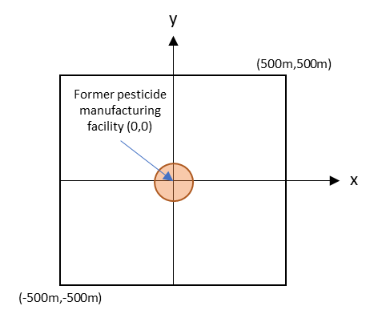

1. (10 pts) Suppose you are recently hired as an entry level Environmental Field Specialist in a new firm dealing with groundwater remediation where a sampling and analysis plan has not been developed. You are assigned as an assistant to a Project Manager for groundwater sampling, and are asked to do the office preparation for this sampling event. Make a list of items and information you may need in the field.
2. (6 pts) Describe the common way for preserving (a) water and (b) soil samples. Discuss the importance of preservation.
3. (6 pts) Explain why glass containers are generally used for organic compounds whereas PVC-type containers are used for inorganic compounds.

1. (10 pts) Three wells are located in x and y plane at the following coordinates: Well 1 (0,0), Well 2 (100m, 0), and Well 3 (100m, 100m). The ground surface is level and the distance from the surface to the water table in Well 1, 2, and 3 are in the order of 10.0m, 10.2m, and 10.1m, respectively. Draw the well diagram and determine the flow direction and the hydraulic gradient.
2. (8 pts) Refer to the document titled “EPA_Passive samplers for ocean sediments” under the Sampling Theory and Techniques Module on Canvas, discuss the differences between active and passive sampling as well as the advantages and disadvantages related to passive sampling.

**Lab 2 Questions:**

1. (5 pts) What were the quality assurance and quality control measures taken during this lab? (For those of you online you can deduce this through the lab handout)
2. (5 pts) Why is it important to measure combined chlorine, free chlorine, and total chlorine?
3. (5 pts) Calculate hardness for the following samples:

Table 1: Hardness as CaCO3 in three different tap water samples

|  |  |  |
| --- | --- | --- |
| **Item** | **Number of Drops** | **Hardness as mg/L as CaCO3** |
| *Sample Bottle 1* | 5 |  |
| *Sample Bottle 2* | 11 |  |
| *Sample Bottle 3* | 12 |  |

1. (5 pts) Discuss the importance of turbidity testing in environmental sampling and analysis.