Using the XHTML form, which requires three inputs for each category: Points Earned, Maximum Points Possible, and Weight as a percentage out of 100.

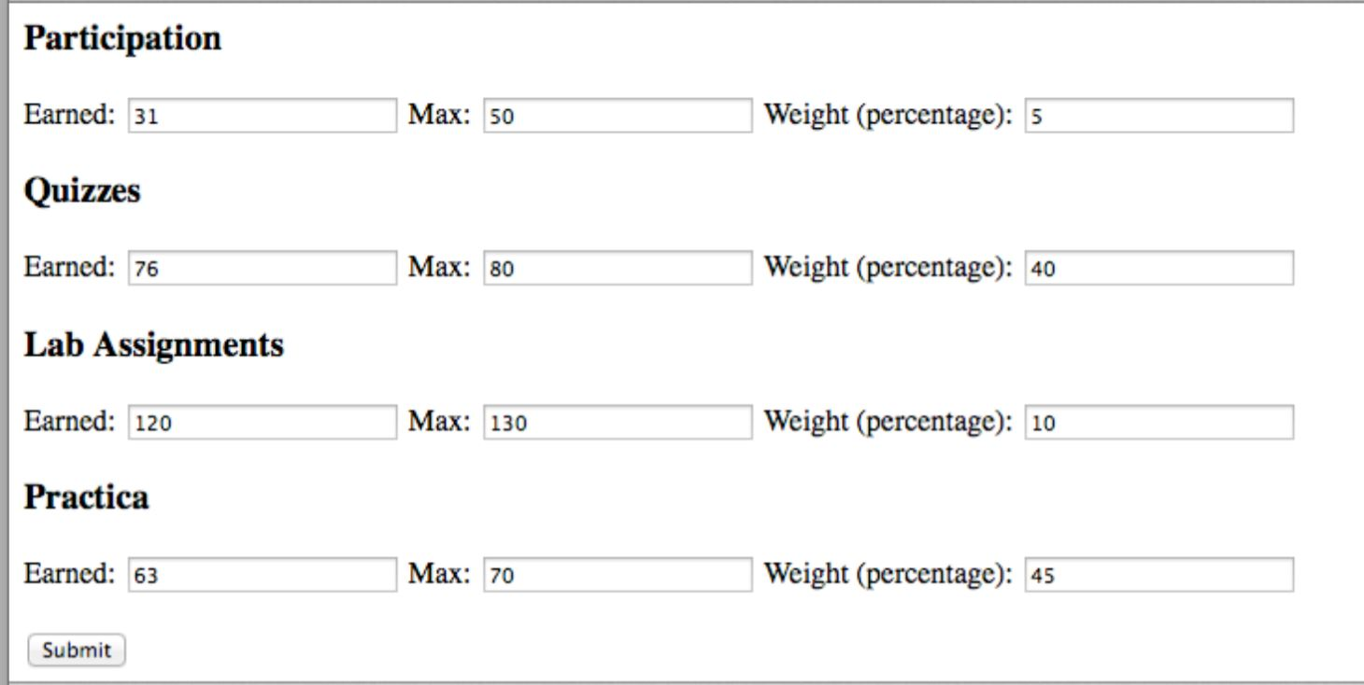

You will need to create two user-defined functions. The first function requires two parameters and should return the calculated percentage. The second function requires the calculated percentage along with the assigned weight. This function should return the weighted percentage

**Your .php file should calculate and output the following values:**

1. Percentage earned (for each grade component)

2. Weighted value earned towards the total grade (for each grade component)

3. Final grade percentage and letter grade

For the final letter grade, you should use the breakdown listed below. As the determination of the letter grade is simple, you can use advanced operators to determine the letter grade**. Decision structures should not be used.**

**Percentage Grade Category reference**

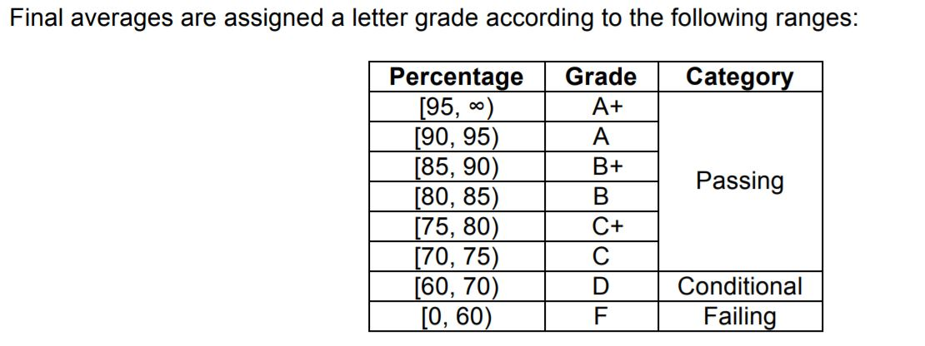

**Result should look like this**

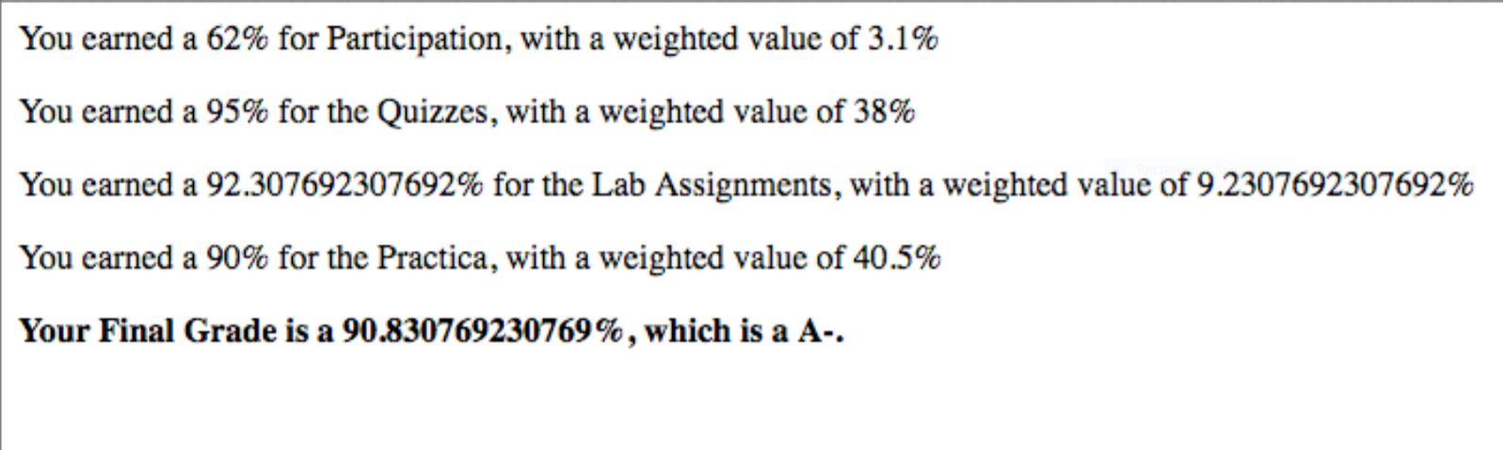

**Below is the XHTML form**

<div class="content">

<form action="test.php" method="post">

<h3>Participation</h3>

Earned: <input type="text" name="earnedParticipation" />

Max: <input type="text" name="maxParticipation" />

Weight (percentage): <input type="text" name="weightParticipation" />

<h3>Quizzes</h3>

Earned: <input type="text" name="earnedQuiz" />

Max: <input type="text" name="maxQuiz" />

Weight (percentage): <input type="text" name="weightQuiz" />

<h3>Lab Assignments</h3>

Earned: <input type="text" name="earnedLab" />

Max: <input type="text" name="maxLab" />

Weight (percentage): <input type="text" name="weightLab" />

<h3>Practica</h3>

Earned: <input type="text" name="earnedPracticum" />

Max: <input type="text" name="maxPracticum" />

Weight (percentage): <input type="text" name="weightPracticum" />

<br /><br />

<input type="submit" />

</form>

</div>