1. Find the forces in Columns 1, 2, 3, and 4 of the following structure. Assume that the average dead load and live load is 50 lb/ft2

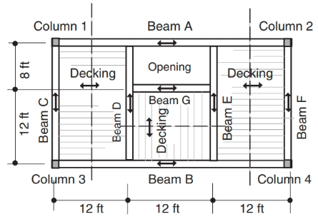

2. Determine the reactions to Beam D in the structure of Question 1. Assume that the average dead and live load is 50 lb/ft2.