Beers Law

## Objectives:

At the end of the experiment, students will:

* Be able to explain the relationship between concentration of a solution and absorbance
* Be able to create a calibration curve using Excel or other graphing program
* Be able to use a calibration curve to estimate and then calculate the concentration of a solution based upon a provided absorbance
* Be able to understand the relationship between a solution’s color and colors (wavelength) absorbed

## Introduction:

**Radiation** is defined as the different types of energy that exist within the universe. Each type of radiation has a specific energy, wavelength and frequency associated to describe the radiation. The list of radiations and their associated energies, wavelengths and frequencies is called the **Electromagnetic** **Spectrum**, seen below in Fig 1.

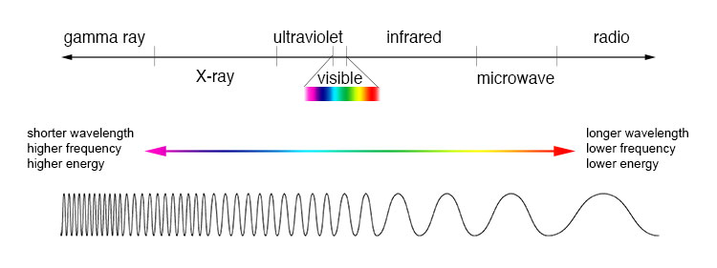

Figure : The Electromagnetic Spectrum. Source: https://imagine.gsfc.nasa.gov/science/toolbox/emspectrum1.html

In the different realms of science, different energies and wavelengths of radiation are used to better understand different structures, whether they are chemical (molecules) or biological (bones & tissues). For example, x-rays and gamma rays are commonly used in medicinal sciences to highlight different bodily structures for diagnoses; whereas in chemistry ultraviolet (UV) and visible lights are commonly used to help determine the concentration of a particular molecule within a solution.

When you look at a solution and you see a particular color, the color is due to the wavelength of light that the molecules in the solution absorb versus the wavelength that the molecules reflect. The **wavelength** of a particular radiation is defined as the distance between the peaks of consecutive waves of that light. When considering a molecule’s structure, the electrons within a molecule’s double bonds are responsible for absorbing radiation at a specific wavelength. A **spectrophotometer** is an instrument used to pass light of a specific energy, or wavelength, through a sample to measure how much light the molecules present within the solution absorb. All spectrophotometers contain a light source to produce the light, a grating to separate the light into individual wavelengths (think of a glass prism), a sample chamber in the path of the light, and a detector to determine absorption.

**Beer’s Law** is a relationship that relates the concentration of a molecule within a solution to the amount of radiation at a particular wavelength that is absorbed as described in Equation 1 below.

$$A= ε*c*l$$

Equation 1: Beer’s Law Equation

In Equation 1 above, A is the absorbance of the solution, ε is the molar extinction coefficient, c is the concentration of the solution in molarity, and l is the path length of light determined by the sample holder. This relationship seen in Beer’s Law is used to determine the concentration of a compound in solution, based upon the absorbance of the compound.

A **calibration curve** is a graph to show how an instrument’s response changes with respect to changes in concentration of the solute in the solution. Calibration curves are used to determine unknown concentrations of solutions based upon the response received from an instrument regarding a particular property, such as absorbance. For this experiment, a calibration curve will be created, showing how absorbance of a solution changes with changes in solute concentration. This calibration curve will then be used to estimate (by visual inspection) and calculate (using the equation of the trend line) the concentration of a solution based upon a provided absorbance value.

## Pre-lab Questions:

1) What is the equation for Beer’s Law and what do each of the symbols in the equation stand for?

2) What part of the molecule is responsible for absorbance?

3) What is the instrument that is used to measure the absorbance of a solution called and what are the basic parts of this instrument?

## Procedure:

1. Use the link provided below, or provided on Moodle, to open the Beer’s Law Lab Simulation Program:

<https://phet.colorado.edu/sims/html/beers-law-lab/latest/beers-law-lab_en.html>

Below is an image describing all of the controls that you will see on your screen. The ruler and detector can be moved around the screen by clicking and dragging. 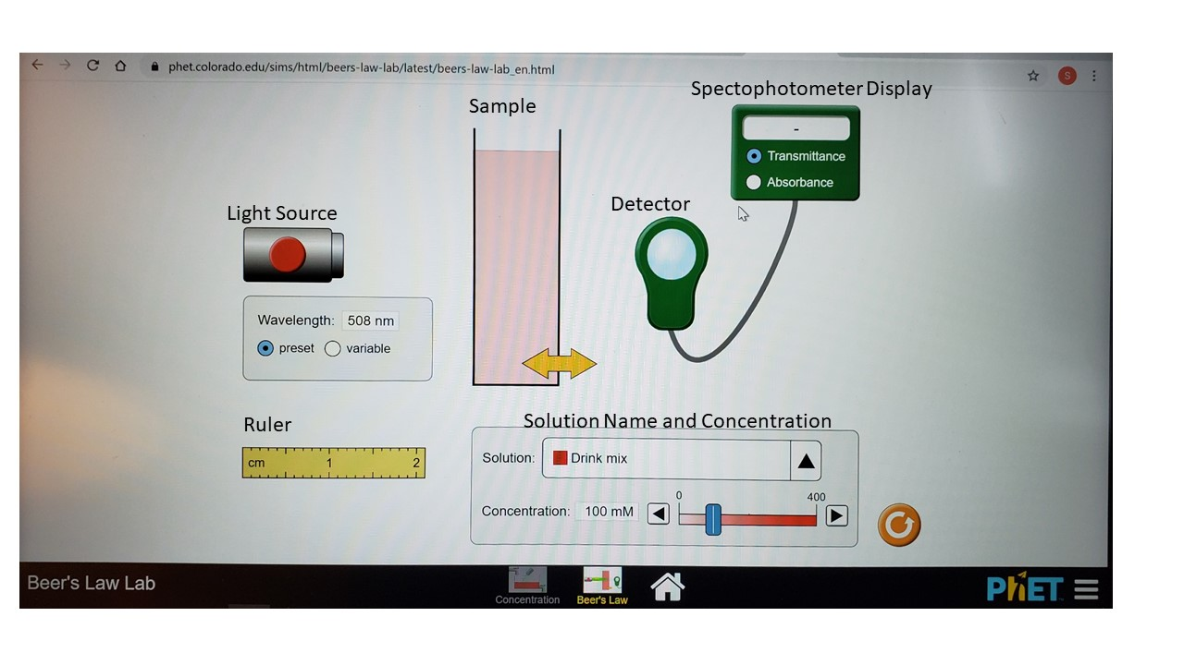

1. Using the ruler, measure the width of the sample chamber. Record this value below. Do not change the sample chamber width after this point.

|  |
| --- |
| Width of the sample chamber: |

1. Change the spectrophotometer display to absorbance and turn the light source on by clicking the red button on the light source.
2. From the solution drop down menu, choose the solution that your group is assigned to work with. Record your solution’s name, solution’s color, wavelength of light from the light source, and the color of the light leaving the light source in the spaces provided in Table 1 below.

Table : Solution and Light Information

|  |  |
| --- | --- |
| **Solution Name** |  |
| **Solution Color** |  |
| **Wavelength of Light** |  |
| **Color of Light** |  |

1. Using the dilution equation, volumes provided, and the stock concentration (maximum concentration) of the solution assigned, complete Table 2 below with concentration data. Be sure to include the units (mM or µM) of concentration in the header.

Table : Calculating Concentrations using Dilution

|  |  |  |  |
| --- | --- | --- | --- |
| **Water Volume (mL)** | **Stock Volume (mL)** | **Total Volume (mL)** | **Concentration of Solution (units = )** |
| 4 | 0 | 4 |  |
| 3.5 | 0.5 | 4 |  |
| 3 | 1 | 4 |  |
| 2.5 | 1.5 | 4 |  |
| 2 | 2 | 4 |  |
| 1.5 | 2.5 | 4 |  |
| 1 | 3 | 4 |  |
| 0.5 | 3.5 | 4 |  |
| 0 | 4 | 4 |  |

1. Below the solution drop down menu, you will see a concentration tool. This will allow you to increase/decrease the concentration by moving the blue toggle or by using the left and right arrows on the slide. Adjust the slide to the 9 concentrations calculated in Table 2 and record the concentration and absorbance data in Table 3 below.

Table 3: Absorbance and Concentration Data

|  |  |
| --- | --- |
| **Solution Concentration**  **(units = )** | **Absorbance** |
|  |  |
|  |  |
|  |  |
|  |  |
|  |  |
|  |  |
|  |  |
|  |  |
|  |  |

1. Create a graph of your data with the Solution Concentration as your x-values and the Absorbance as your y-values using Excel and obtain/display the equation for the best-fit line. Your graph should also include properly labelled axis and a title describing what information you are presenting.

If you are unsure how to make a graph, please see the link to a video below describing the step-by-step process to create a proper graph with a linear regression and labels.

<https://www.youtube.com/watch?v=dCF4Cwx-WXo&app=desktop>

1. Using your calibration curve, estimate the concentration of solution by “eyeballing” what the concentration would be if the absorbance of your solution is **0.75**. (Eyeballing means using your eyes to estimate from the graph what the concentration would be for a solution with the absorbance of 0.75) Record this estimated value below.

|  |
| --- |
| Concentration by estimation = |

|  |
| --- |
| Concentration by calculation = |

1. Using the equation of the trend line you obtained for your calibration curve (linear trendline of y=mx+b equation), calculate the concentration of the solution if the absorbance of the solution was **0.75**. Record this value below. Show your calculation in the space provided. (Hint: Review what your x and y-values correspond to, this will tell you where to plug the 0.75 into the equation and what variable you are solving for)

## Post Lab Questions:

1. Examine the color wheel below and each of the solution options provided in the simulator. Compare the solution color to the color of the light emitted by the source. What is the relationship between the color of the solution and the color of the light absorbed?   
   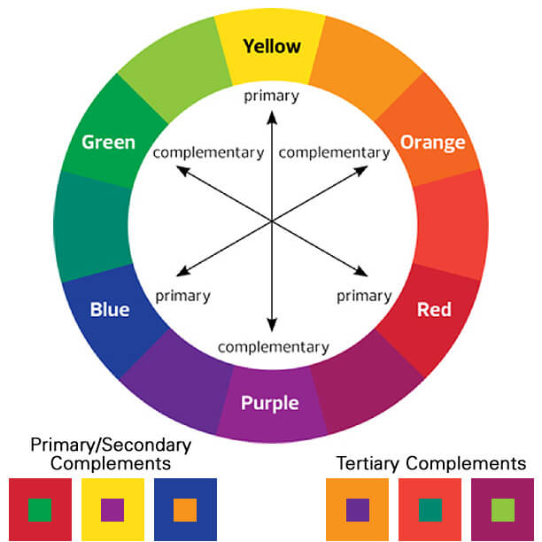
2. What is the relationship between Absorbance and Concentration according to the trendline your created?
3. Methylene blue is a compound used to treat methemoglobinemia, a condition resulting in decreased ability to perform oxygen transport throughout the body. You measured the absorbance of a methylene blue solution using a path length of 1 cm and received an absorbance of 0.357. If the extinction coefficient is 95000 M-1*cm-1 what is the concentration of methylene blue in your solution? Show your work.
4. In the experiment above, you determined the concentration of a solution using a calibration curve by two methods: estimation and calculation. Which of the methods do you think is more accurate and why?