

3

( 1 )

( 2 )

7

**10**

**TOTAL**

***5***

Page 1

Deanship of Graduate Studies (DGS)

Instructor’s Signature

03/10/2020

*Construction Scheduling and Cost Estimating*

( 01 )

DATE

SECTION

**Quiz (1) - (Fall / 2020)**

PLEASE READ CAREFULLY BEFORE PROCEEDING

**INSTRUCTIONS**

Time allowed : 1:00 Hours

**Student ID No.**

**Name:**

**MEM**

**ENGM-570**

COURSE CODE

▪

**Marks Obtained**

**No. of Question**

**Maximum Marks**

Make sure that you have enough time to scan and upload your solved papers.

▪

Cheating /Attempting to cheat in during exam will get you ZERO

▪

Write your name and ID on the top of this examination paper and on ALL answer booklets



**85**

**800**

**B**

**F**

**100**

**A, C**

**D**

**11**

**E**

**It is required to:**

**Critical Path =**

**Min.**

**=**

**PD**

•

***5***

Page 2

Deanship of Graduate Studies (DGS)

**Determine Float of each Activity**

•

**Determine Start and Finish Times of each Activity**

•

**Determine the Critical Activities**

•

**Determine the minimum project duration**

**60**

**450**

**D,B**

**100**

**60**

**C, E**

**G**

***Time***

***Time***

***Finish***

***Days***

***Rate***

***Start***

***Duration,***

***Float***

***Quantity***

**240**

**1000**

**--**

**A**

**construction project:**

**Draw Bar Chart Diagram (Gantt chart) considering the following data of a**

**Question (1): (3 marks)**

**MEM**

***Depends on***

***Activity***

***Production***

**C**

**1400**

**200**

**7000**

**600**

**A**

**A**

**B**

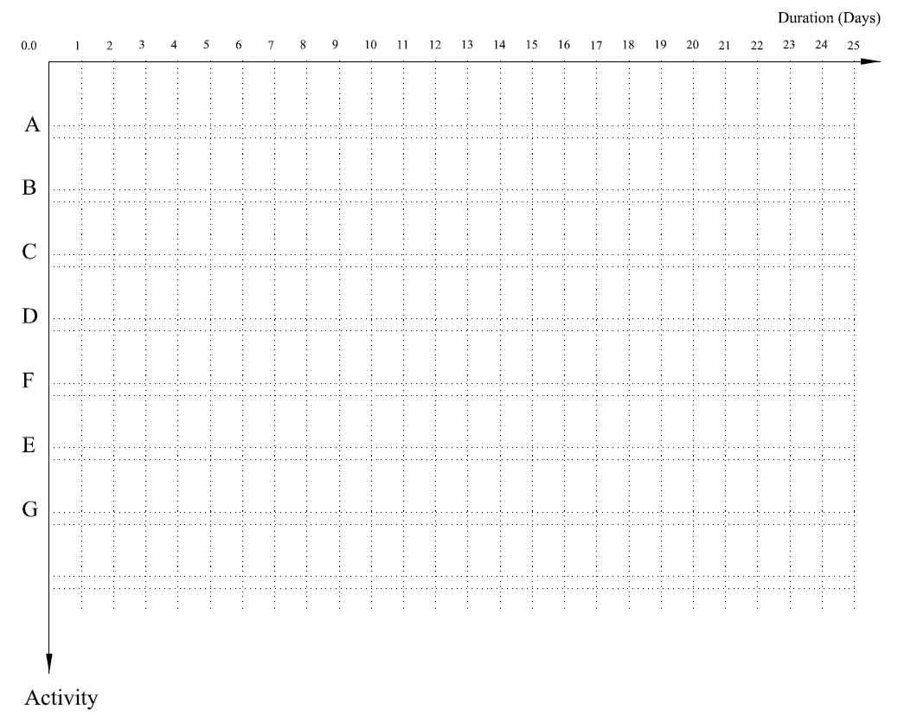

Deanship of Graduate Studies (DGS)

Page 3

***5***

**MEM**



**C,E**

**6**

**G**

**D**

**3**

**H**

**E**

**A**

**11**

**F**

Calculate ES, EF, LS, LF for each activity;

-

Highlight and Write the Critical Path;

-

Find activity total float;

-

Find activity free float.

-

Deanship of Graduate Studies (DGS)

Page 4

***5***

**F, G**

**2**

**N**

**G**

**4**

It is required to:

-

Draw Activity On Arrow “AOA” Network;

**Activity**

**Depends on**

**Duration, Days**

**A**

**B**

**5**

**B**

**MEM**

**Question (2): (7 marks)**

**Draw Arrow Diagram Method considering the following data:**

**D**

**B**

**4**

**C**

**A**

**8**

**--**

**6**



Deanship of Graduate Studies (DGS)

Page 5

***5***

**MEM**

***F.F***

***Activity***

***D***

***ES***

***EF***

***LS***

***LF***

***T.F***



**MEM**

***5***

Page 6

Deanship of Graduate Studies (DGS)