[https://www.seu.edu.sa/sites/ar/SitePages/images/logo.png](https://www.seu.edu.sa/sites/ar/Pages/main.aspx)

**College of Administrative and Financial Sciences**

**Assignment 1**

**Deadline: 10 /10/2020 @ 23:59**

|  |  |
| --- | --- |
| Course Name: Cost accounting | Student’s Name: |
| Course Code: ACCT 301 | Student’s ID Number: |
| Semester: 1 | CRN: |
| Academic Year: 1441/1442 H | |

**For Instructor’s Use only**

|  |  |
| --- | --- |
| Instructor’s Name: | |
| Students’ Grade: Marks Obtained/Out of | Level of Marks: High/Middle/Low |

**Instructions – PLEASE**

**READ THEM CAREFULLY**

* The Assignment must be submitted on Blackboard (**WORD format only**) via allocated folder.
* Assignments submitted through email will not be accepted.
* Students are advised to make their work clear and well presented, marks may be reduced for poor presentation. This includes filling your information on the cover page.
* Students must mention question number clearly in their answer.
* Late submission will NOT be accepted.
* Avoid plagiarism, the work should be in your own words, copying from students or other resources without proper referencing will result in ZERO marks. No exceptions.
* All answered must be typed using **Times New Roman (size 12, double-spaced)** font. No pictures containing text will be accepted and will be considered plagiarism).
* Submissions without this cover page will NOT be accepted.

Q1 Provide example of one Saudi Company and analyze the steps that the managers in this company can take to achieve its vision and use core competencies. **(1 Mark)**

Answer:

Q2 The following data were obtained from the accounting information system of Attawfik Corporation:

Units Total Cost

Month Produced

January 60 SAR1,533.4

February 50 1,300

March 80 2,000

April 30 833.5

a. Use the data for February and March and the two - point method to determine a cost function.

b. Use the high - low method to determine a cost function.

C. How do you think that a cost function may provide poor estimates of future costs?

**(1 Mark)**

Answer

**Q3 a. Analyze the following Graph and the breakeven point and discuss how this analysis is used for decision making?**

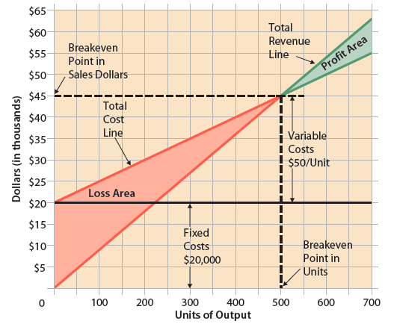

1. If fixed costs are $400,000, selling price per unit is $150, and variable cost per unit is $100, how many units must the company sell in order to earn a profit of $ 100,000?

**(1 Mark)**

Answer

**Q 4** Which types of companies would most likely use a process costing system and which types of companies would use job costing? Provide examples of two Saudi Companies.

Explain the methods with which the cost per unit will be calculated for each type of company using numerical example.

**(2 Marks)**

Answer