Question Completion Status:

QUESTION 1
Exercise 1:
Use a graph of (x−2)²=4sin(x) to find solutions to the equation valid to 2 decimal points:
enter the roots...

6 points

QUESTION 2
- Exercise 2:
Use the zooming technique to find solutions of 50 + sin(x) = 2x
which are valid to at least two decimal places.
Hint: Try to estimate the value of 50 + sinx. This will give you an idea in which x interval are the possible solutions!
enter a number...
6 points

QUESTION 3
Exercise 3a:
Folklore is that exponential functions grow faster than polynomial functions. Although true, you need to be careful about how you interpret this statement, as this exercise shows.
Consider the functions z₁=e^{x} and z₂=x⁴. Plot them together on the interval [0,4].
  - From their graphs, how can you determine which graph is the exponential and which is the polynomial
a |  | a. Exponential functions grow faster than polynomial functions
b |  | B. For different values of x, I can evaluate z₁, z₂ and determine which is larger.
c |  | C. polynomial functions grow faster than exponential functions
6 points

QUESTION 4
- Exercise 3b:
Find the value of x (to two decimal places) for the point of intersection by zooming on the zero of f(x)=e^{x}−x⁴. (or by zooming on the intersection point of the functions z₁=e^{x}, z₂=x⁴.)
6 points

QUESTION 5
- Exercise 3c:
On this graph, x⁴ is larger than e^{x} from the intersection point to x=4. Experiment to determine how large a value of x is needed for the exponential to catch up to x⁴. Then find the
second intersection point. (correct to three decimal places.) This one is larger than 4. In fact, you now have found two intersection points (x₁, y₁), (x₂, y₂). (where x₁ < x₂) Up to x₁ the
function e^{x} is bigger, from x₁ to x₂ the function x⁴ is the bigger. What happens after x₂?
What is the x-coordinate of the second intersection point?
enter a number...
6 points

QUESTION 6
- Exercise 3d:
What happens to the behavior of z₁ and z₂ after the second intersection point?
- they grow at the same rate
- x⁴ grows faster they grow at the same rate
- e^{x} grows faster, but for increasingly large values of x, x⁴ catches up to e^{x} again.
- e^{x} grows faster
6 points

QUESTION 7
- Vertical asymptotes can be a real impediment to finding roots, as this example illustrates.
Example 2:
Find any zeroes and the minimum value of the rational function
f(x) = (x+2) / x²
We first graph the function over initial interval [−10,10] producing Figure .
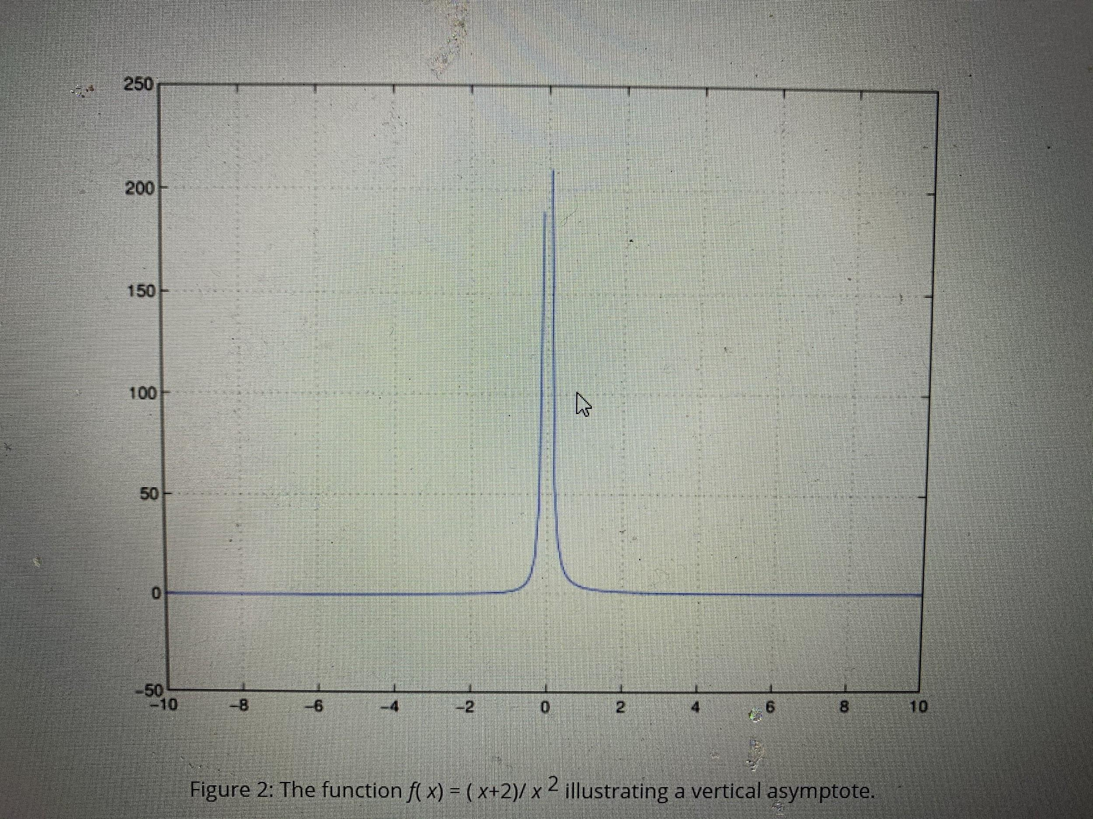
Figure 2: The function f( x) = ( x+2)/ x ² illustrating a vertical asymptote.
The figure illustrates that the vertical asymptote at x=0 gets in the way of finding the two answers we want-the zeroes and the minimum value. Let's try again using a little thought
before we chug ahead with the computer.
Recall that rational functions are 0 only when the numerator is, that is when x+2 = 0, or x=−2. The function goes from negative to positive there, so the minimum must be located to the
left of −2. As this function has a horizontal asymptote of y=0 there must be a minimum to the left of −2, and no minimum to the right of 0 where the function is positive. You'll do the
rest in the following exercise.
Exercise 4a:
  - Find the x-coordinate for where f(x)=(x + 2)/x² achieves its minimum value.
6 points

QUESTION 8
- Exercise 4b:
What sub-interval along the x-axis makes for a plot window diplsaying the most detail?
Which linspace is best?
- x=linspace(-10,-2);
- x=linspace(-5,1);
- x=linspace(-5,-3);
- x=linspace(-5,3);
6 points

QUESTION 9
- 3 Finding roots of polynomials
Polynomial functions are extensions of linear and quadratic functions : (a≠0)
f(x) = ax+ b(linear), f(x) = ax² + bx + c (quadratic)
For these two types of functions we can solve f(x) = 0 easily. For the linear case the single solution is −b/a. For the quadratic case the quadratic formula produces two answers. These answers are the roots of the polynomial.
The quadratic formula produces two roots, although many possible cases exist: two distinct real roots, double roots, or two complex-valued roots that come in conjugate pairs. There are always no more than 2 real roots.
A general polynomial of degree n may be written as
f(x) =a_{n}x^{n} + ₁x^{n-1}+ … + a₂x² + a₁x¹ + a₀
For an nth degree polynomial there are n, possibly complex, roots counting multiplicities. But they need not all be real roots. However, there is not always a formula for solving for these roots.
However, MATLAB has a built-in function, called roots, that numerically solves for the roots, which is faster and more accurate than the zooming technique. To use roots, you must code the polynomial f(x) like a vector. We take each coefficient (there are n+1) and enter them in order as follows:
The polynomial f( x) is represented with
>> p = [ a_{n} a_{n-1} … a₂ a₁ a₀]
Then the polynomial equation f(x)=0 is solved with the command
>> roots(p)
The only subtlety is that we don't usually write the terms whose coefficients are 0, but we must do so when entering in the polynomial into MATLAB. So, for instance
[3 2 1] represents f(x) = 3x2 + 2x + 1,
[3 2 1 0] represents f(x) = 3x3 + 2x2+ x,
[3 2 0 1] represents f(x) = 3x3 + 2x2 + 1, and
[3 0 0 2 1] represents f(x) = 3x4 + 2x + 1.
Example 3:
Use the roots function to find the roots of f(x)=2x³+6x²−4x−5.
>> p = [2 6 -4 -5] p = 2 6 -4 -5 >> roots(p) ans = -3.3732 1.0675 -0.6943
We get 3 real roots. We could verify this by plotting the polynomial over the interval [−4,2] and observing the graph crosses the x axis three times. Instead, we illustrate that these are roots, by evaluating the polynomial at these values:
>> x = roots(p) % store the values
>> 2*x.^3 + 6*x.^2 -4*x -5 % evaluate the polynomial for roots
ans = 1.0e-13 * -0.3197 0.0444 0
These values are very close to 0, as they are multiplied by 1.0e-13. This is MATLAB's scientific notation for 10⁻¹³.
Exercise 5a:
  - Let f(x)=x³−7x²+2x+9. Solve the cubic equation f(x)=0. Find all of its roots correctly up to 4 significant digits.
- 6.6 , 1.1 -0.7
- 6.4766, 1.4692, -0.9458
- 0.0010, 1.0100, 7.5902
- 6.5806 , 1.1062, -0.6868
- 6.7053 , 1.3259 , -0.8259
6 points

QUESTION 10
Exercise 5b:
Now find all solutions to x³+2x+4=0 (Note that the coefficient of x² is now 0).
- 1.8230, -1.8230, -1.3283
- 0.6641, -0.6640, -1.3283
- 0.5898 ±1.7445i, −1.1795
- 1.8230 ±0.6641i , -1.3283
6 points

QUESTION 11
- This last exercise illustrates that both means of finding zeroes of functions can be useful.
Example 4:
The flight of an arrow through space can be modeled with or without air resistance. How do the models differ?
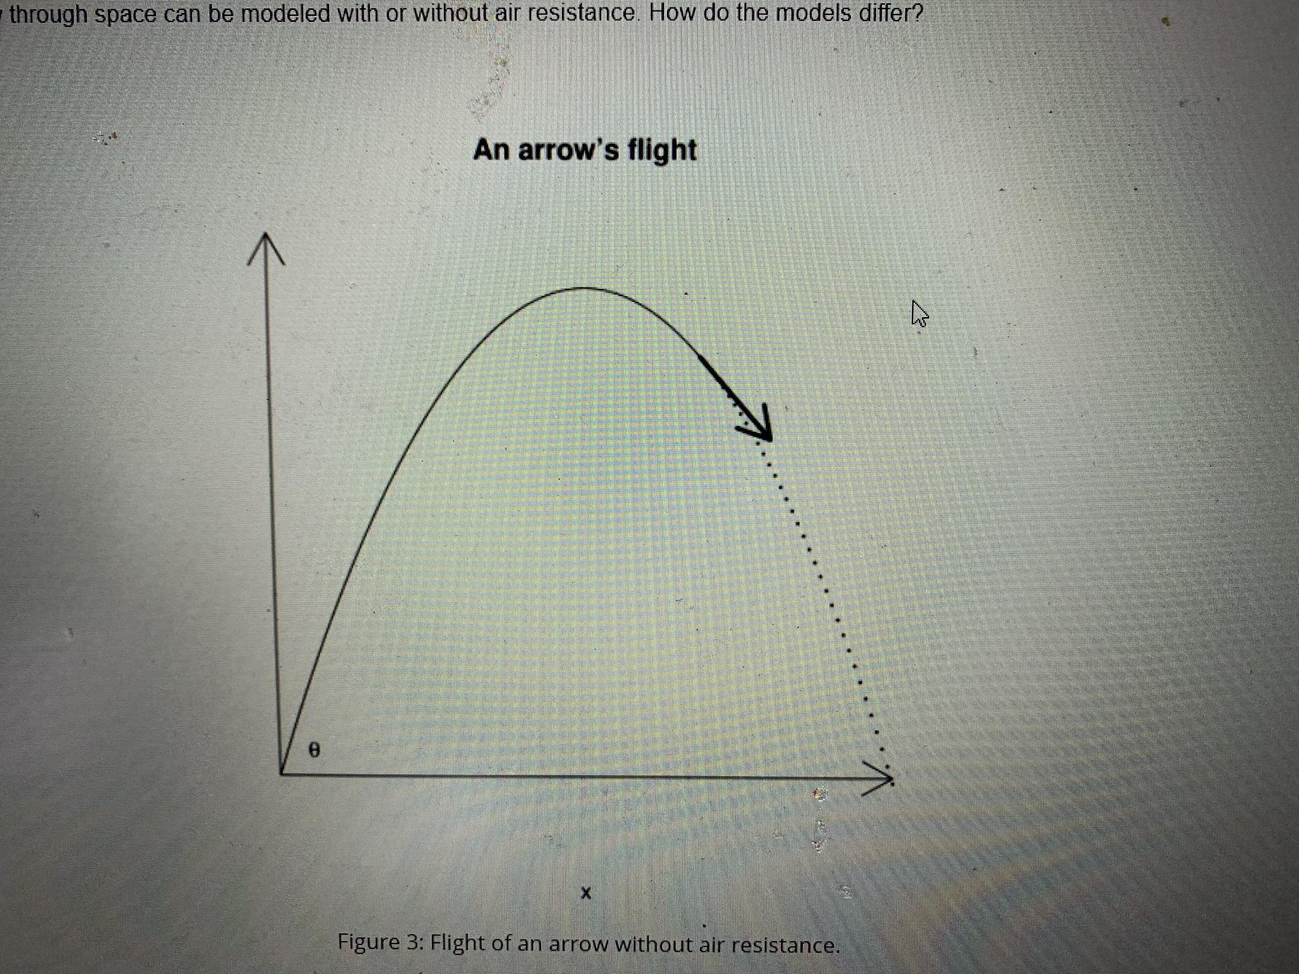
Figure 3: Flight of an arrow without air resistance.
When an arrow encounters no air resistance the laws of projectile motion from high-school physics apply. Using x for the horizontal distance traveled, f(x) for the height of the arrow when it is x units away, and θ for the initial angle, we have this model for the trajectory of an arrow without air resistance:
When there is a drag on the arrow proportional to its velocity (k is the proportion factor), the height of the arrow is given by:
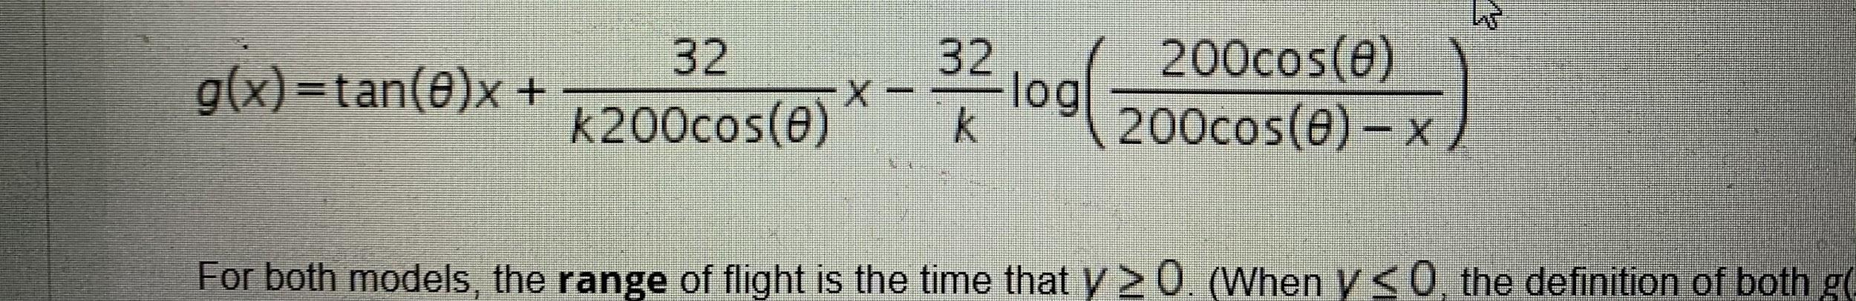
For both models, the range of flight is the time that y ≥ 0. (When y ≤ 0, the definition of both g(x) and f(x) should be set to 0.) The range can be written as [0,b].
First, we investigate an arrow's flight without wind resistance.
Exercise 6:
  - Let 𝜃= π/4 . Look carefully at f(x), it is a quadratic polynomial in x. Rewrite f(x) so that the coefficients appear as (careful with the scientific notation)
  - f(x) = ax² + bx + c
What are the values of a, b and c?
type the three values in decimal form, separated by commas
6 points

QUESTION 12
- Exercise 6b:
Use your previous answer and the roots function to find the range of the arrow when shot at an angle of 𝜃= π/4
(By range we mean the horizontal distance between where the arrow was launched, i.e., the origin, to the spot it lands on the ground --
the first positive x-intercept of the function.) This can be accomplished by use of the roots command, and confirmed by visual inspection of the graph.
6 points

QUESTION 13
- Next, we consider the model with wind resistance. To keep matters simple, we assume k = 1/2. Then our formula for the trajectory when θ = π/4 becomes, in MATLAB,
>> theta = pi/4;
>> k = 1/2 ;
>> a = 200*cos(theta);
>> b = 32/k;
>> g = (tan(theta)+ b/a)*x - b*log(a ./(a-x));
provided you have defined values for x.
Exercise 7a:
    - Plot various graphs of the g(x) until you find the range of g. Enter this value with at least 1 digit to the right of the decimal point.
(Remember, arrows don't bounce up - this mathematical model is only valid until the arrow first hits the ground.)
6 points

QUESTION 14
- Exercise 7b:
Now make a plot containing the trajectories of both models. Label the individual plots.
  - Attach File
10 points

QUESTION 15
- Exercise 7c:
From your graph estimate the maximum height of the arrow if there is no wind resistance.
6 points

QUESTION 16
- Exercise 7d:
From your graph estimate the maximum height of the arrow if there is wind resistance.
6 points

