**Part 1: Defining your problem**

1. Describe the domain and the scope of your project
   1. **Domain:**
      * The domain is an educational platform since it will be utilized to view and manage possible and current schedules.
   2. **Scope:**
      * The scope is a university because it will be used by instructors and students in the course registration process. This system will be designed to maximize the efficiency and user satisfaction needed for a course registration system.

1. Describe the problems you would like to address in your project (up to five), and why (your motivations and rationale to select those problems). State your goals, specific aims, and purpose (general examples: to support a given activity, to improve a metric, to automate a set of services).
   1. **Problems:**
      * The current registration system has some flaws affecting the user satisfaction. The first issue includes the display being too cluttered and the layout not aligning with the scheduling/planning system making it harder to adjust to the new layout. The search function is also cluttered and makes it hard to view classes available for selection. Students are also unaware of the availability in a course section while planning their schedules. Students should be able to see how many students have put the course section in their scheduled plan. The last issue includes the system crashing during registration time slots making it hard to select the classes a student has planned for.

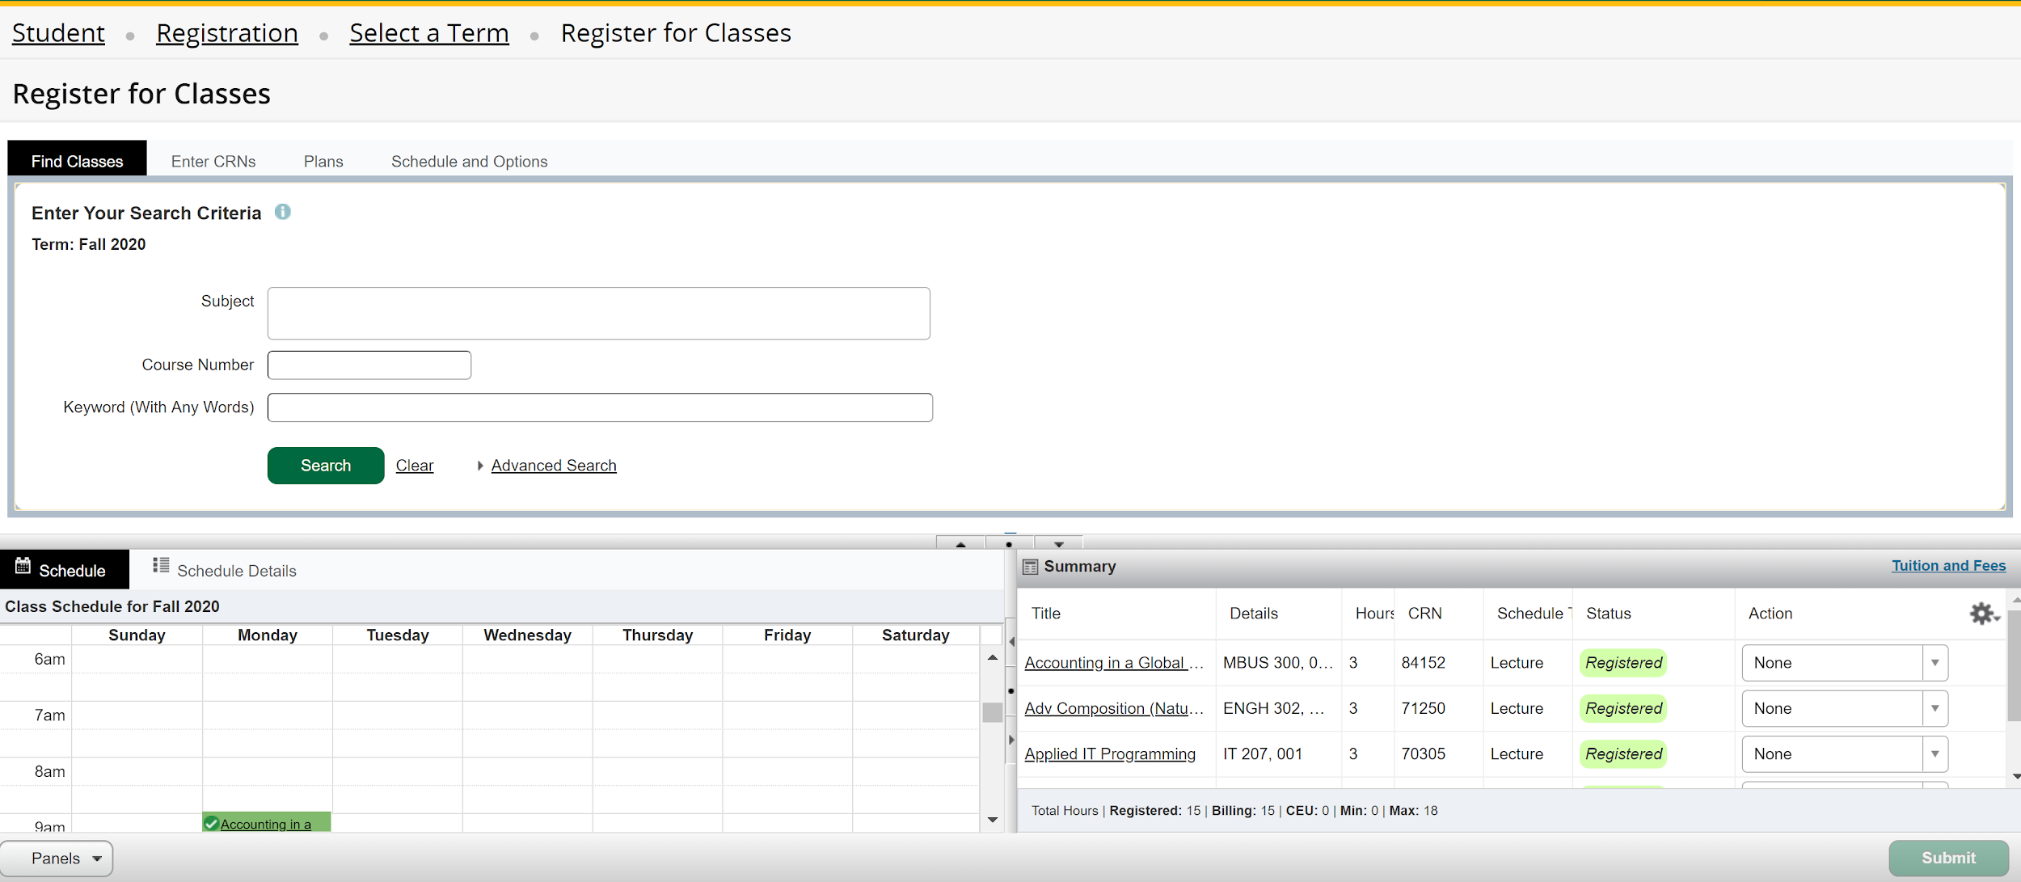

* 1. **Motivations:**
     + The motivations of our system include increasing user satisfaction by providing a simpler approach to course registration as well as improving usability of the system.
  2. **Goals:**
     + The goals of the system are to simplify the registration process, provide a combined planning and registration system, and decrease registration time.
  3. **Specific aims:**
     + Our goal is to create a new registration system that is simple, easy to use, and effective for students to view and select courses. This can be accomplished by reorganizing how courses, departments, and course schedules are sorted and displayed. This is necessary because signing up for classes is a difficult and stressful process for students to begin with and they should not be burdened by delayed registration or interaction complexities.

1. Formalize the definition of the problems you plan to work on (provide three to five examples). Use tables to define the problems, including a brief description of: statement, issues, objectives, and requirements.

|  |  |  |  |
| --- | --- | --- | --- |
| **Statement** | **Issues** | **Objectives** | **Requirements** |
| Students need to be able to register for their required courses | Layout is confusing and too complex | Create a useful and effective layout while promoting simple navigation and usage | Users will be able to easily search, register, and plan for courses through the system |
| Students need to be able to manage their schedules | Complex layout is displayed | Allow students to easily manage their schedule through a simple interface | Users will have access to a simple layout making management of courses simple |
| Students need to be able to effectively and easily plan for future schedules | Planning system is currently not the same layout as the registration system | Allow students to plan and register for courses using the same interface/layout | Have access to a system that combines the planning and registration interfaces to provide easy navigation and use |

|  |  |
| --- | --- |
| Complex Design for Registration - Slows down registration speed | The system will use the same layout for scheduling and registration, allowing more time to be spent selecting classes rather than figuring out the registration system’s layout. |
| Not knowing if a Student will get into a Specific Class Section | Many students rush to registration during their time slot in an attempt to get a seat not knowing how many students are trying to join the selected section. The system will display the number of students that have placed this course section in their planned schedule. |
| Students not able to get into their selected course due to high traffic causing a system crash or delayed registration | Students complain about needing to frantically select a new schedule due to not getting their planned schedule because of high traffic during the time slots causing only a few to get in. The system will allow students to view details about who is selecting each section for their class to hopefully relieve some stress about the traffic delaying registration. |

**Part 2: Defining your solution**

1. Define the concepts involved in your solution:
   1. Who are the stakeholders involved (personnel, staff members, employees, etc.)? What are their main roles, relationships, and set of activities performed?

|  |  |  |  |
| --- | --- | --- | --- |
| **Stakeholders** | **Main Roles** | **Relationships** | **Activities** |
| GMU Students | * Signing up for courses using their CRN code * Making sure they meet all prerequisite classes before signing up (to avoid getting an error) * Students need to be able to manage their class schedule as they pick their classes * Students need to be able to see how many spots are left for a specific class | Students need to sign up for their class correctly in order to be enrolled in them. Students need to complete registered courses for their degree. | * Class registration * Student must be enrolled in their selected course * Students need to make sure they are on the right track for graduation |
| GMU Instructors | * Allow professors to know how many students are in their class, and how many spots are left | Instructors require a certain number of students in their classes in order to be able to teach the course. | * Having a limit to how many students can enroll in the class |

* 1. What are the components involved in your system (e.g. reports, machines, documents, processes)? Provide a general description, list and define each item, use a context-level data flow diagram and level 0 to model these components. Include also their relationships (input and output data from each component).
     + The components involved in the registration system include a student and course database/record to store information about each aspect involved and their updates. It will also utilize processes such as identifying courses, checking the course availability, configuring schedules, and confirming the course selection. These processes will start at the student and end with the registrar to update information regarding the course and students in their respective systems.

**Data Flow Diagrams**

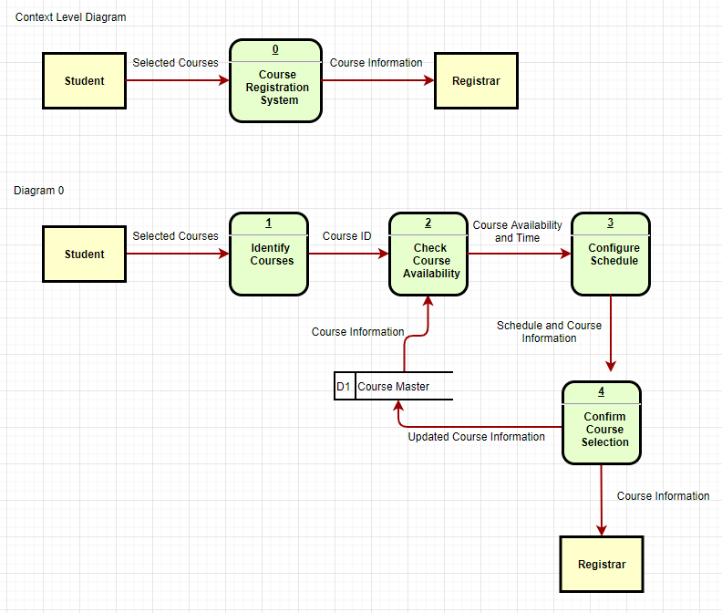

* 1. List at least 10 use case scenarios to exemplify how a given user can interact with the system you are proposing in your project (i.e. what are the features and functionalities available in your project for specific actors). Use a table to specify the use case scenarios.

|  |  |
| --- | --- |
|  | **Use Case Scenario** |
| **1** | The student can search for classes by class name, CRN number, or professor. An instruction icon may be inserted next to the search button to assist the student if there is confusion on how to search. |
| **2** | The student can add or drop classes through the use of an add/drop button. An instruction icon may be inserted next to the button to assist the student if there is confusion. |
| **3** | The student can run the proposed plan/schedule through a prerequisite check by degree works that will determine a student’s eligibility to take the courses prior to registering. The student can view the grade requirements and credit information as well. |
| **4** | If the student comes across a registration/override error, the student can email his/her advisor within the system instead of doing it externally. |
| **5** | The student will be able to view information about a class in detail; the professor, sample class syllabus, class seats, location, and waiting list information will all be listed clearly. |
| **6** | The student will be notified with an error/pop-up message if he/she attempts to add a class that may result in a schedule conflict. |
| **7** | The student will be able to clearly navigate between all of the registration system’s features. All features will be clearly labeled and organized for easy accessibility. |
| **8** | The student will be able to see how many students currently have the selected class in their registration list. |
| **9** | The student will be able to register for lecture + lab classes at the same time. For example, if a lecture requires a lab, lab options that do not conflict with the student’s schedule will be listed, and the student will be able to register for both at once. |
| **10** | The student will only have to press register once and the system will web-register the student free from any lag or loading time. |

* 1. Define a workload table to compare how your proposed solution improves the current practices

|  |  |  |
| --- | --- | --- |
| **Function/Process** | **Existing System** | **Proposed System** |
| Current Registration System | Slow/ affects the registration process | Efficient and error free |
| Registration process Layout | Confusing and cluttered interface; divides the screen into multiple sections | Straightforward layout divided into sections and tabs |
| Schedule to access classes/course | Separate interface for planning schedules | Directly access a user-friendly scheduling interface |
| Assessment of error | Students notified of error, but given no suggestions | Students will be alerted and given suggestions through a quick assessment process |
| Registration Navigation | Cluttered search interface making it hard for students to view course information | Allows students to navigate throughout the system easily and effectively |
| Loading Time | Takes more than one minute | Free from loading and lagging time |

* 1. Describe a set of requirements for hardware, software and personnel (at least three for each) needed to implement your solution. Justify your choices.
     + **Software:**
       1. Planning and Registration Software
          1. Will be used for planning ahead and viewing possible schedules as well as registering for courses
       2. Appropriate Operating System
          1. Users need to have Windows, Mac, or Linux
       3. Appropriate Web Browsers
          1. Users need to have Firefox, Google Chrome, or Microsoft Edge
     + **Hardware:**
       1. Students and Faculty need to have device access
          1. Utilize a mobile or desktop device for the service
       2. Server for Student Information
          1. Need to have adequate storage space for student information on a server
       3. Server for Course Information
          1. Need to have adequate storage space for course information on a server
     + **Personnel:**
       1. Web Developer
          1. To make the website aesthetically pleasing and easy to navigate
       2. Security Expert
          1. To handle security matters
       3. IT Support
          1. Will help resolve technical issues on the system

**Part 3 Preliminary Analysis of your solution**

1. Critically analyze the solution proposed:
   1. What are potential risks involved in the implementation of your project? Use a Fishbone diagram to provide examples of potential risks. Include at least three different factors (e.g.: quality, time, costs, etc.) and two examples for each factor (e.g.: the performance is too slow, the time for completion of each activity is underestimated, the budget for programmers is insufficient).

