Name: ___________________________ Organelle Quiz (15 pts)

**Multiple Choice**

*Identify the letter of the choice that best completes the statement or answers the question.*

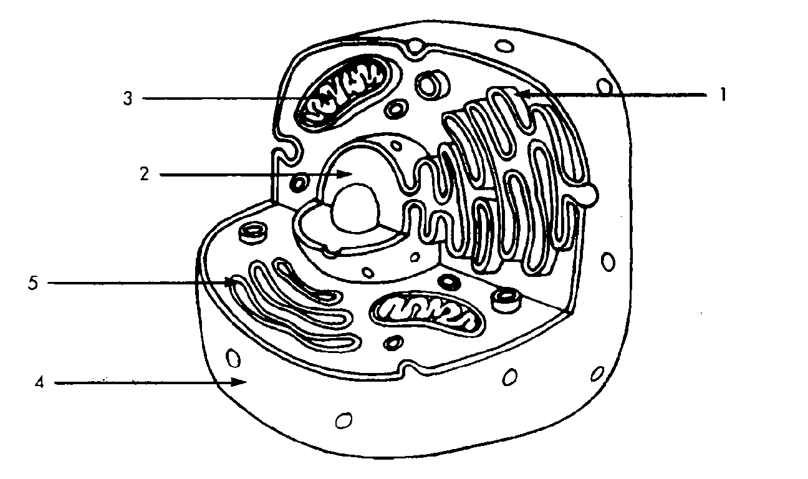

1. Refer to the illustration above. In eukaryotic cells, mitochondria are found in structure
2. 1 b. 2 c. 3 d. 5

1. Refer to the illustration. Structure 5 is
2. The endoplasmic reticulum
3. A Golgi apparatus
4. A mitochondrion
5. The nucleus
6. The plasma membrane (or cell membrane)
7. Is rigid.
8. Allows all materials to pass through.
9. Has proteins that move around.
10. Is made of phospholipids, DNA and carbohydrates.
11. Cyanide binds to at least one molecule involved in producing ATP. If a cell is exposed to cyanide, most of the cyanide will be found within the
12. Mitochondria b. Ribosomes c. Golgi apparatus d. Lysosomes
13. Which structure modifies, stores and sends various molecules off to other cells?
14. Endoplasmic reticulum
15. Golgi apparatus
16. Ribosomes
17. Vesicles
18. Nucleolus
19. The subcellular component that is surrounded by a double membrane is _______.
20. Chloroplast b. Ribosome c. Lysosome d. Nucleus
21. The main difference between the smooth ER and the rough ER is
22. The smooth ER is connected to the nucleus while the rough isn’t.
23. The smooth ER lacks ribosomes while the rough ER has them.
24. The smooth ER works alone and the rough ER works with the Golgi.
25. There is no difference really, its just a matter of where they are located in the cell.
26. Which of the following makes ribosomal RNA and subunits of ribosomes?
27. Nucleolus b. Nuclear envelope c. Golgi apparatus d. ER
28. A cell has been busy and has produced lots of waste and carbon dioxide. Which organelle would these byproducts be found in?
29. Lysosomes b. Golgi apparatus c. Smooth ER d. Vacuoles
30. Complete the analogy mitochondria:power plant, vesicles: _________?
31. digestion b. Long term storage c. transport d. Lipid synthesis
32. If a prokaryotic cell needed to be mobile it would probably have at least one
33. flagella b. thylakoids c.cristae d. Contractile vacuole
34. A certain kind of bacteria takes the sun’s light and converts it into sugar and oxygen. This bacterial cell would have many
35. cilia b. chloroplasts c. matrices d. Nuclear pores
36. What is the most likely pathway taken by a newly synthesized protein that will be secreted by a cell?
37. ER→Golgi→nucleus
38. nucleus→ER→Golgi
39. ER→Golgi→vesicles that fuse with plasma membrane
40. ER→lysosomes→vesicles that fuse with plasma membrane

*Use the following information to answer questions 14 and 15.*

A group of young biologists were given the task of labeling unmarked microscope slides that were discovered in a lab drawer. The previous researcher in the lab had studied a number of different types of plants, animals, bacteria and viruses. They first made observations using a microscope, looking for key components of a cell, and compiled the data in the table below. Answer the next two items based on your evaluation of their data.

|  |  |  |  |  |
| --- | --- | --- | --- | --- |
| **Structure** | **Slide A** | **Slide B** | **Slide C** | **Slide D** |
| Chloroplast | X |  |  |  |
| Vacuole | X |  |  | X |
| Ribosome | X | X |  | X |
| Mitochondria | X |  |  | X |
| DNA | X | X | X | X |
| Endoplasmic Reticulum | X |  |  | X |
| Cell wall | X | X |  |  |
| Golgi complex | X |  |  | X |
| Plasma membrane | X | X |  | X |
| Nucleus | X |  |  | X |

14. Which slide contains plant cells?

1. A b. B c. C d. D e. All of the above

15. Which of the following statements is false?

1. Slides A and D are eukaryotic because they contain mitochondria.
2. Nucleus are present in all living organisms so Slide B and C must not display a living thing.
3. Slide D could be an animal cell because of its organelles.
4. Slide B is probably a prokaryotic cell because of its lack of organelles and other subcellular components.