October 2020

Chemistry 141

Practice Exam (test 3)

Name: __________________________

1. In this question, you should think about the differences between real gases and ideal gases:
   1. Match the two curves in the plot below to 200K and 1000K for a gas.
   2. At low temperatures, which of the following **best** describes the behavior of gases? CIRCLE ANSWER.
      1. At low temperatures, gases behave ideally and PV/nRT is approximately equal to 1.
      2. At low temperatures, the size of gas molecules becomes important and PV/nRT becomes less than 1.
      3. At low temperatures, gas molecules have a greater probability of attraction, and therefore causes less collisions with the container walls.
      4. At low temperatures, the average kinetic energy is lower, so gases behave more ideally.
   3. Circle the image below which most accurately would portray what you would expect to see at ***high*** pressures in a gas container. The red spheres are individual gas molecules in a container. *Explain your choice*!

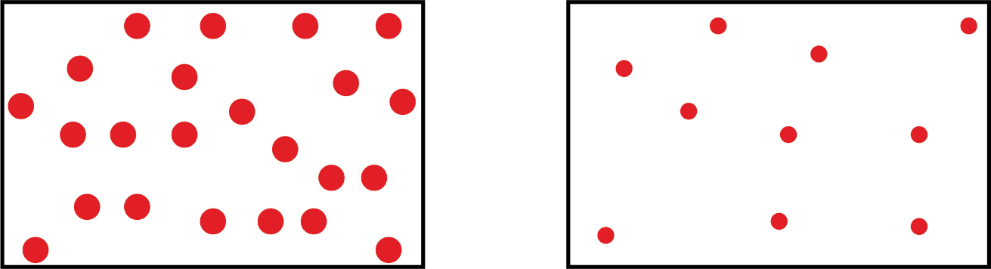

Explanation:

1. Consider a gas mixture of 2.5 moles of argon (Ar), 5.0 moles of neon (Ne), and 2.5 moles of helium (He). The three gases were in a 4.75 L container at 298K. What is the **total pressure** of the mixture and the **partial pressure of neon (Ne) gas**? Assume ideal gas behavior.
2. A sample of helium (He) gas was expanded from 2.2 L initially at STP to 2.9 L. After expansion, the final temperature of the gas increased 25°C. What is the final pressure of the gas?
3. Look at the graph below and think about Kinetic Molecular Theory to answer the following questions:

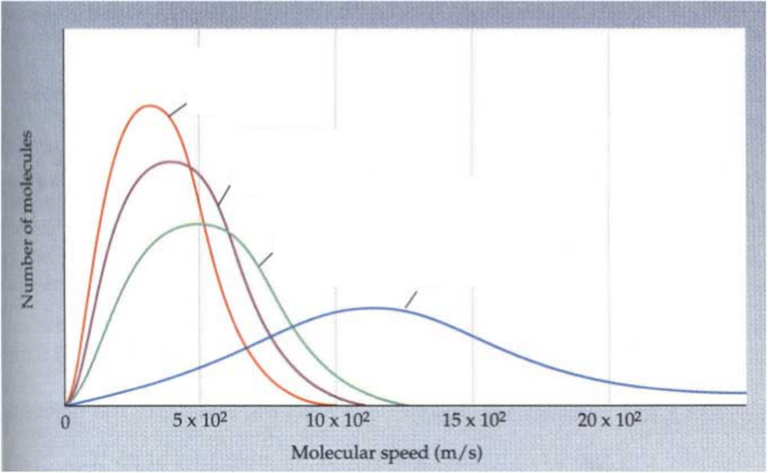

* 1. In the graph above, label each curve above as O2, N2, H2O, or He.
  2. Calculate the **average kinetic energy** of He gas at 298K in J/mol.
  3. Will the average kinetic energy of O2 be smaller, larger, or the same as He at 298K?

1. 4 points: At STP, a sample of argon (Ar) gas occupies 103 L. Determine the mass of argon (Ar) gas in this sample.
2. Let’s think about calorimetry in this question.
   1. What would you predict the final temperature to be if you mixed **75** grams of hot water at **80 °C** with **10** grams of room temperature water at **20 °C** in a coffee cup calorimeter? Assume no heat is lost to the calorimeter.
      1. Between 20 °C and 40 °C
      2. Between 40 °C and 60 °C
      3. Between 60 °C and 80 °C
      4. Greater than 80 °C
   2. If you want to warm your dorm room by taking 10 kg of a heated substance at 90°C into it, which one of the following would be the best choice (no calculation should be needed)?
      1. Iron (Cp = 0.450 J/g*K)
      2. Gold (Cp = 0.129 J/g*K)
      3. Granite (Cp = 0.79 J/g*K)
      4. Water (Cp = 4.18 J/g*K)
   3. The enthalpy of solution for dissolving lithium hydroxide (LiOH) in water is approximately -25 kJ/mol. When you dissolve ~ 2 grams of LiOH in ~ 30 mL of water, would you expect the water temperature to increase or decrease without doing any calculation? **Explain why.**
   4. What quantity is kept constant in coffee-cup calorimetry? _____________
   5. What quantity is kept constant in bomb calorimetry? ____________
3. In a coffee cup calorimetry experiment, a 45.00 g piece of a metal at 86.0 °C was placed into 130.00 g of water with an initial temperature of 20.0 °C. If the final temperature of the water was measured to be 24.0 °C, what is the specific heat capacity of the metal? The specific heat capacity of water is 4.184 J/(g°C).
4. What is **q of the surroundings** if q of the system is +275 J?
5. Explain why sand heats up faster than water does at a beach. Use heat capacity in your answer.
6. 1.45 g of benzoic acid (C7H6O2) was combusted in a bomb calorimeter and the temperature of the water increased by 12.2 °C. The heap capacity of the calorimeter including the water was determined to be 4465 J/°C. M = 122 g/mol for benzoic acid.
   1. How much heat did the surroundings gain?
   2. How much heat was released by the combustion of benzoic acid?
   3. What is the enthalpy of combustion (ΔHm) of benzoic acid?
   4. Is this reaction exothermic or endothermic (no explanation)
7. A 2.00 L container holds a mixture of two gases at 33°C. If the partial pressures of the two gases are 0.421 atm and 0.885 atm respectively. If 0.250 moles of a third gas is added with no change in volume and temperature, what will the new final pressure be?
8. Many people with asthma need to use an inhaler. Suppose that your inhaler holds 3.00 g of vaporized albuterol in 0.157 L at 328K. If the vaporized albuterol has a pressure of 2.22 atm, what is the molar mass of albuterol?
9. Ideal Gas relationships.
   1. If a 0.500 L container of a gas has a pressure of 1.25 atm, what will the pressure of the container be if the gas is compressed to 0.400 L? Clearly state what quantity or quantities you assumed were held constant.
   2. Explain why your answer above makes sense on the molecular level (i.e. – why does the change in volume increase or decrease the pressure?).
10. What volume of carbon dioxide will 3.26 g of calcium carbonate produce at 27°C and 1.22 atm according to the following reaction:

CaCO3 (s) + 2HCl (aq) 🡪 CaCl2 (aq) + H2O (l) + CO2 (g)

1. Determine ΔH of the following reaction using reactions a, b, and c below:

NO + O 🡪 NO2

* 1. 2O3 🡪 3O2 ΔH = -427 kJ/mol
  2. O2 🡪 2O ΔH = 495 kJ/mol
  3. NO + O3 🡪 NO2 + O2 ΔH = -199 kJ/mol

*Don’t forget to review worksheet #9, problem 11