# Thin Layer Chromatography (TLC) Virtual Lab (20 Points)

# Part 1

Thin layer chromatography (TLC) is a simple and relatively fast analytical tool that is used to determine the number or identity of compounds in a mixture. It can also measure the extent of a reaction or measure the relative polarity of a molecule. A TLC plate is a sheet of glass that is coated with a thin layer of adsorbent such as silica (or occasionally alumina). A small amount of the mixture to be analyzed is placed or spotted near the bottom of this plate. When monitoring reactions, it is common to place the starting materials on one side of the plate (or in the left lane) and the reaction mixture in the right lane. The TLC plate is then placed in a shallow pool of a solvent (20% ethyl acetate/hexanes in part 2) so that only the very bottom of the plate is in the liquid. This solvent, or the eluent, is the mobile phase, and it slowly rises up the TLC plate by capillary action.

As the solvent moves past the spot that was applied, it carries the spotted mixture up the plate where a competition occurs between the solvent carrying the mixture and the silica on the plate. Since the silica adsorbent is polar, polar molecules in the mixture will rise very little up the plate, but nonpolar molecules will have little attraction to the silica and will consequently rise to the top. Molecules of intermediate polarity will stop somewhere in between these two extremes. When the solvent has reached the top of the plate, the plate is removed from the solvent, dried, and then the separated components of the mixture are visualized by exposure to a UV lamp. The positions of each spot on the TLC plate are identified and recorded by assigning *Rf* values from 0.0 to 1.0, where a 0.0 indicates the spot is at the bottom of the plate and a 1.0 indicates the spot is at the top.

In this part of the experiment you will complete the NC State Virtual Lab 1: Thin Layer Chromatography (TLC).

[https://go.ncsu.edu/vrlab-tlc](https://www.google.com/url?q=https%3A%2F%2Fgo.ncsu.edu%2Fvrlab-tlc&sa=D&sntz=1&usg=AFQjCNEkrBpz7O545Cjz_aQmxZxUU7ClGw)

You can also watch the videos on YouTube <https://go.ncsu.edu/vrlab-tlc-captions>

You can add subtitles and speed up or slow down YouTube videos by clicking on the settings gear on the bottom right side of the video. Change the playback speed as desired.

1. Which of the compounds listed in the video would best be described as non-polar? (1 pt)

2. Which of the compounds listed in the video would best be described as polar? (1 pt)

3. Explain how TLC separates compounds? (2 points)

4. List the compounds that were found in spinach juice and their Rf values? (2 points)

5. Which compound has a higher Rf value beta-carotene or chlorophyll A? Explain your answer by discussing the molecules functional groups and polarity. (1 point)

5. How would the Rf values for the spinach extract change if the solvent in the developing chamber was more polar? (1 point)

# TLC Part 2

In this assignment, you will be guided through the steps of a simple esterification reaction as a demonstration of how to use thin layer chromatography as a tool to monitor a reaction until it reaches completion. This assignment will also serve as a tutorial to teach you how to utilize the various parts of the Beyond Labz organic simulation that will be used in later assignments.

*Reaction Intro:* The aromas of many fruits and flowers are due to esters. The ester that will be synthesized in this virtual experiment, 3-methylbutyl phenylacetate, is naturally occurring in peppermint oil. It does not smell like peppermint but it has a sweet, pleasant odor. Esters can be formed by combining a carboxylic acid and an alcohol in the presence of a strong acid catalyst, such as sulfuric acid. In this virtual lab, 2-phenyl acetic acid and 3-methyl-1-butanol will react to form 3-methylbutyl phenylacetate. The overall reaction scheme is shown below. This experiment is meant to introduce you to Thin Layer Chromatography, the Beyond Labz platform, and provide you with an example of how to set up your laboratory notebook.

Purpose: The purpose of this experiment is to synthesize 3-methylbutyl phenylacetate by combining 2-phenylacetic acid and 3-methyl-1-butanol in diethyl ether solvent and using concentrated sulfuric acid as a catalyst. The reaction will be heated under reflux and the progress of the reaction will be monitored using thin-layer chromatography (TLC). Once the TLC shows that the reaction is complete, the reaction will be quenched by adding aqueous base NaOH, and the product will be separated from the reaction mixture using liquid-liquid extraction.

*Reaction:*



*Techniques:* Heating under reflux, thin-layer chromatography, liquid-liquid extraction, rotatory evaporation (use the video links to have a better idea of what these techniques look like in a non-virtual lab)

*The Virtual Lab:*

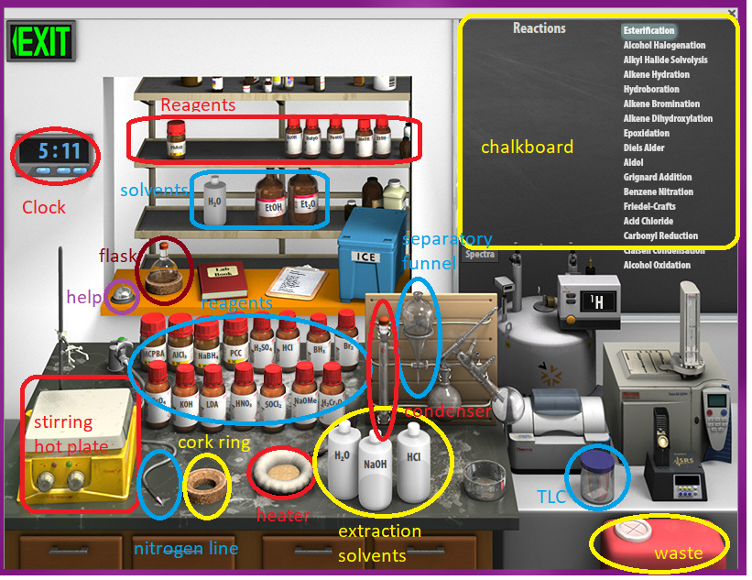

*Virtual Lab Instructions* (video instructions also available). Help is available by clicking on the bell on the stockroom counter.

1. Start *Virtual ChemLab Organic* and select *Using Thin Layer Chromatography* from the list of assignments. The lab will open in the Synthesis laboratory, and you should see a lab bench containing reagents on the back of the bench, aqueous reagents on the right, an equipment rack containing necessary laboratory equipment, a red disposal bucket for cleaning up the lab, and the organic stockroom in the back. Other pieces of laboratory equipment will be used in other assignments.
2. You will find a round bottom flask located on the stockroom counter. Select the starting materials for the reaction by first clicking on the bottle containing 2-phenylacetic acid (PhAcOH) and dragging and dropping the scoop on the mouth of the flask. Now do the same for 3-methyl-1-butanol (PentOH) except this time a syringe will be used since this starting material is a liquid. Note the bottle labels are small, but you can see the full name and structure of each starting material by hovering over the bottle. Now click on the flask and drag it to the stir plate on the lab bench. It should snap into place when you are at the right location.
3. The round bottom flask containing the two starting materials should now be on the stir plate. The two starting materials should be listed on the chalkboard, and hovering over the listed starting materials will display their structures on the chalkboard. Help on using *Virtual ChemLab Organic* can be found by clicking on the bell on the stockroom counter.
4. In order to perform an esterification reaction, sulfuric acid (H2SO4) must be added to the starting materials. This is done by clicking on the H2SO4 bottle on the reagent shelf on the back of the lab bench and dragging the syringe to the round bottom flask. The acid can also be added by double-clicking on the H2SO4 bottle. The chalkboard should now show that the acid has been added to the reaction mixture.
5. Before the reaction can be started, we must be able to heat the reaction mixture so the reaction can proceed at a suitable rate. This is done by adding a heating mantle to heat the reaction mixture, adding a condenser so the mixture can be refluxed, and then adding nitrogen gas to maintain an inert atmosphere and to prevent pressure buildup. Click on the *Heating Mantle* and drag it to the round bottom flask to place it on the stir plate. Now click on the *Condenser* from the equipment rack and drag it on top of the round bottom flask. Finally, click on the nitrogen gas hose to the right of the stir plate and drag and drop it on top of the condenser.
6. Next perform a TLC measurement by clicking on the TLC jar located in front of the analytical equipment and dragging and dropping the TLC plate on the round bottom flask. A window should now open showing the TLC results. In the starting material lane (the left lane) you should see two large spots near the bottom and in the reaction lane (the right lane) you should see the same two spots. Click save to save the TLC plate to your lab notebook.
7. Click on the red lab notebook which is on the back bench. You should see the TLC plate that you saved. Next to the TLC link, type the time shown on the clock and Time = 0.
8. Now click on the *Stir/Hot Plate* button to start the reaction. You should see the reaction mixture stirring in the round bottom flask.
9. Now perform a new TLC measurement on the reaction mixture. And save the TLC to your notebook and note the clock time and reaction time in minutes. Then close the TLC window. Note: each time you drag a TLC plate to the reaction it will automatically add 5 minutes to the clock time. This is because taking a running TLC plate takes ~5 minutes.
10. Now advance the reaction forward 5 minutes by advancing the time on the laboratory clock. This is done by clicking on the appropriate button under the minutes, tens of minutes, or hours digits on the clock. Now perform a new TLC measurement on the reaction mixture. The reaction time should be ~15 minutes.
11. Close the TLC window again and now advance the laboratory time forward in 10-minute increments until all of the starting materials have been consumed. You will need to monitor the reaction with TLC measurements until you observe that the starting materials have been consumed. Take a TLC and save it to your notebook every 10-15 minutes.
12. When a reaction is complete, the reaction mixture is rinsed or “worked up” by adding an aqueous reagent of an appropriate pH to the reaction mixture in a separatory funnel. After you shake the funnel to thoroughly rinse the reaction mixture, the water-soluble products will be in the aqueous phase and all others will be in the organic phase. Click on the separatory funnel on the equipment rack and drag it to the round bottom flask. The reaction mixture should now be in the funnel. Now select the NaOH aqueous reagent and drag it to the top of the funnel to add it. There will now be two layers, the top being the organic phase and the bottom the aqueous phase. Click on the organic phase to extract the product and drag it to the cork ring on the lab bench. Perform a TLC measurement on the solution in the flask to confirm that it is the same product that was produced in the reaction.
13. Download your lab notebook which includes all of your TLC plates and times as a PDF file. Open your lab notebook and click File then Export PDF. Save the file as “TLC lab” and include your name. Put this file in the dropbox folder with the answers to the questions. If your notebook is missing information you will lose points. (2 points)

**Questions**

Question 1. Why are the spots the same for both the right and left lanes of the TLC plate at Time = 0? (1 point)

Question 2. Which spot is 3-methyl-1-butanol and which one is 2-phenylacetic acid? Explain how you know this based on polarity. (2 points)

Question 3. What is the new spot that appears during the reaction? (1 point)

Question 4. What has happened to the size of the starting material spots after ~20 minutes? Why? (1 point)

Question 5. How much time did it take to complete the reaction? Explain how you know this. (1 point)

Question 6. Calculate the Rf values for 2-phenylacetic acid, 3-methyl-1-butanol and the both starting materials and the product? Which starting chemical spot is and which one is? (2 points)

Question 7. What can you say about the relative polarities of the starting materials and the product using the Rf values? Explain this by discussing the functional groups on each structure. (2 points)