Experiment 5: Power Splitters using strip-line circuits

Aim: To simulate the microwave performance of several microstrip circuit power splitters using Puff software (free download from http://www.qsl.net/yo4hfu/PUFF.html Please see the download instruction sheet) and to become familiar with the operation of a Vector Network Analyser (VNA) to measure the scattering parameters of a four port network.

Covid19 Version
References:
Ulaby, F., Michielssen, E., and Ravaioli, U., 2010. Fundamentals of Applied Electromagnetics, 6th ed., Pearson Prentice Hall. (CD required)
Cheng, D.K. 1989. Field and Wave Electromagnetics, 2nd ed. Addison Wesley
Wedge, S.W., Compton, R., and Rutledge, D., “Puff: Computer aided design for microwave integrated circuits”. http://people.virginia.edu/~rmw5w/Puff%20manual.pdf

The equation numbers in this experiment correspond to the equations in the textbook Ulaby.

Introduction:

Power splitters and power combiners are important building blocks in microwave circuits. In this experiment you are required to design a well-matched power splitter using microstrip technology. You are then asked to measure the response (i.e. the scattering parameters) of a four port directional coupler using a vector network analyser.

The characteristics of a microstrip line are outlined in Ulaby section 2-5 pages 75-78. The quarter wavelength transformer matching technique is described in example 2-10. You should read these sections become coming to the laboratory.

For a 2 port (= 2 terminal) network, the scattering parameters S₁₂ and S₁₁ are defined in terms of the transmission τ and reflection coefficients Γ respectively providing the ports are terminated with transmission lines or loads which have the same characteristic impedance Z₀ as the device. We can write the scattering parameters as:
$\begin{aligned}S_{\text{12}}=\text{20}\text{log}(|τ|) \\ S_{\text{11}}=\text{20}\text{log}(|Γ|)\end{aligned}$
where
$τ=\frac{2Z_{L}}{Z_{L}+Z_{0}}$ (8.12b)
and $Γ=\frac{Z_{L}−Z_{0}}{Z_{L}+Z_{0}}$ (2.59)

In a 4 port directional coupler shown in Figure 1 (a 4 port device), there are additional scattering parameters such as S₁₁, S₁₂, S₁₃, S₁₄, S₂₁, S₂₂ etc.

Port 1
Port 3
Port 2
Port 4
λ_{g1}/4
Z₀₁=(50/√2) Ω
λ_{g}/4
Z₀=50 Ω
λ_{g1}/4
Z₀₁=(50/√2) Ω

λ_{g}/4
Z₀=50 Ω

Figure 1: Four port directional coupler. Note that the impedance of two sides of the square Z₀₁ are different to the other two sides Z₀.

The characteristic impedance of the ports is 50 ohms. The signal input at port 1 is split between port 2 (transmitted port) and port 4 (coupled port). At port 3 (isolated port), the signal from the left arm is λ_{g}/4 in additional to the connecting paths, and the signal from the right arm is 3λ_{g}/4 and so the signal cancels. Ideally there is no output at port 3 for an input at port 1. The device is symmetric and so this is true for all port combinations. An ideal directional coupler should have the following characteristics at the desired frequency for an input into port 1:

S₁₁ very small (large negative value means a good match to Z₀)
Isolation coefficient – S₃₁ is very small (large negative value)
Coupling coefficient - S₄₁ is intermediate (sampled port)

The simulations are based around PUFF software from Caltech. You will design and assess the behaviour of a number of simple strip line passive circuit elements. In particular, you will design a power splitter circuit at 1.2 GHz which would allow one to sample some of the signal from port 1 at port 4. The last page contains a brief summary of some common Puff instructions. A complete list of instructions can be found in the Puff manual http://people.virginia.edu/~rmw5w/Puff%20manual.pdf.

The splitter circuit consists of a 50 Ω input at port 1 and three 50 Ω outputs from a Tee junction. As every change in impedance along the line results in a reflected signal it is necessary to reduce these reflections through a quarter wavelength transformer. If the microstrip line impedance Z₀ is 50Ω and the load is Z_{L}, then a 90 degree (quarter wavelength) transformer must have a characteristic impedance Z₀₂ calculated by the equation

$Z_{\text{02}}=\sqrt{Z_{0}Z_{L}}$ (1)

The coupler circuit you will design consists of four 50 Ω ports (see Figure 1). The horizontal sides of the square have a characteristic impedance of Z₀/√2 and the vertical sides are 50 Ω. The procedure is laid out in the experimental section of these notes.

The relationship between the width of a microstrip line W, its length l and characteristic impedance Z₀ is quite complicated (see Ulaby Figure 2-11). The PUFF software takes this into account so it is possible to investigate the relationship between these parameters using the program and compare with the relationships given in Ulaby. Note that F10 gives the PUFF help menu.

PRE-LABORATORY EXERCISES:

Q5.1 A 50Ω transmission line is split into three 50Ω lines. Calculate the input impedance at the junction.

Calculate the voltage reflection coefficient, VSWR and S₁₁ in dB for a line of characteristic impedance 50 Ω terminated in this junction. Is the reflection coefficient a complex number? Explain your answer.

Q5.2 Using your results from (Q5.1), calculate the characteristic impedance of the quarter wavelength transformer Z₀₂ using equation 1. Note that one quarter wavelength is 90 degrees. This information is used in part (a) of this experiment.

Q5.3 If port 1 is perfectly matched using the transform, calculate the output power at ports 2, 3 and 4. They should be the same. Why is this different to your answer in Q5.1?

EXperimental PROCEDURE

- Quarter wave transformer matching 50 Ω line to a 3 port splitter.

Start PUFF and in the DOSBOX window construct the following circuit board using the F4 window:

Zd 50.0 Ω
fd 2 GHz
er 4.8
h 1.6 mm
s 100 mm
c 50 mm
Tab microstrip

In the parts menu (F3) add the part: tline 50 Ω 90°. In the layout (F1) add the 50 Ω 90° tline starting at port 1 (shift 1). Split this line into three 50Ω lines and the connect each arm in ports 2, 3 and 4. Note the S₁₁ (range +5dB to -50 dB) over the frequency range 0.2 to 4.2 GHz and compare this with your result in Question 5.2. Now add your quarter wavelength matching element to the parts menu calculated in pre-laboratory question (2). (Note that λ_{g} = 360 degrees). Add this part to the circuit. Test this circuit. Note the value of S₁₁ at 2 GHz. If the result is not what you expect, then repeat your calculation.
Note that you can change the number of frequency points, the scattering parameters, and the scale on the plot using F2 and the down arrow through to the plot axes.

Note the values for S₁₁, and the output power levels S₂₁, S₃₁ and S₄₁ at the resonant frequency (i.e. minimum S₁₁). The bandwidth Δf is the frequency range with S₁₁ < -10 dB. Record the bandwidth as a percentage of the centre frequency f₀. Calculate the quality factor Q = f₀/Δf.

Is S₃₁ = S₁₃ value? Comment on your answer.

Modify your circuit to ensure that the output phase of the two ports are identical and the third port is 45° out of phase with ports 2 and 3. Sketch your circuit and explain what changes you had to make.

- Strip line characteristics.

Determine the length and width in mm of an unterminated section of microstrip line having a nominal value 50 Ω and 90°. Systematically change the characteristic impedance of the stub from 10 Ω to 90 Ω and plot the impedance versus s = line width (Note that the substrate thickness h = 1.6 mm). (Use the Parts Window F3 ‘=’ to obtain width of the lines). How does this compare to Ulaby Fig 2-11 p. 76?

From your graph determine the line width for your quarter wave transformer line impedance and compare with your PUFF calculated value.

- Four port directional coupler (Branch line coupler).

Set your design board in the F4 window to the following parameters
Zd = 50 Ω
fd = 1.3 GHz
er = 4.6
h = 1.6 mm
s = 200 mm
c = 600 mm

Design the 4 port coupler shown in Figure 1, by first creating the square in the centre of your design space and then connecting to the four ports using 50 Ω lines and then the port numbers.

You should change the frequency range to run between 0.7 to 1.4 GHz using the keyboard down arrow in F2. Run the plot over the pre-defined frequency range. Save the data file to USB using the control S command. Plot all four scattering parameters using Excel.

Write down the specifications (including the 10dB bandwidth) for this coupler. Write down the coupling factor k = S₄₁ and the isolation = S₃₁.

Revise the circuit to terminate port 2 with a 150 Ω lumped impedance (lumped 150Ω 20 mm) terminated in an earth. Note the change in the port 2 output and explain the change in ALL output ports.
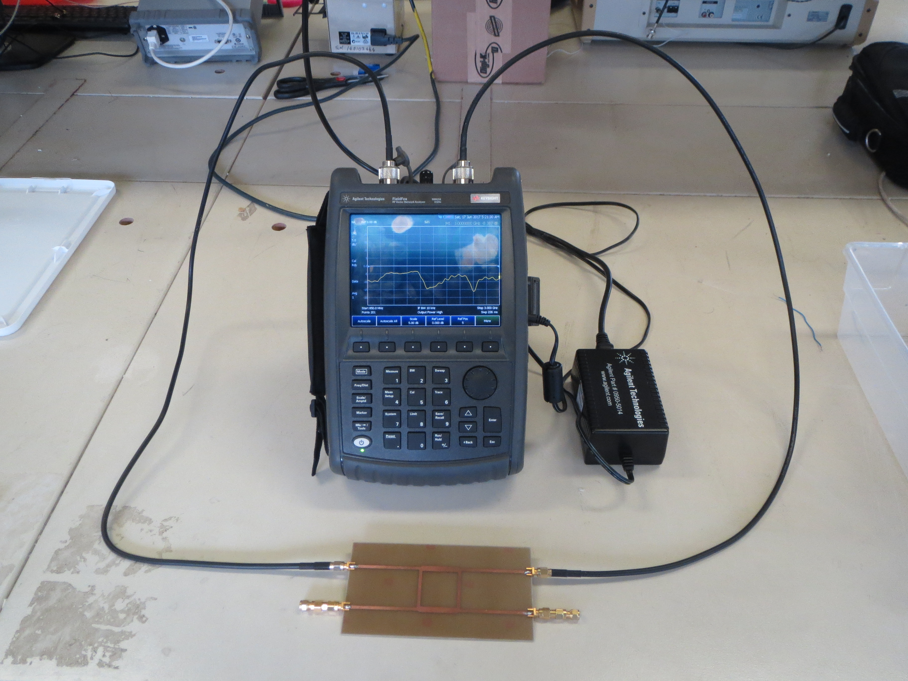
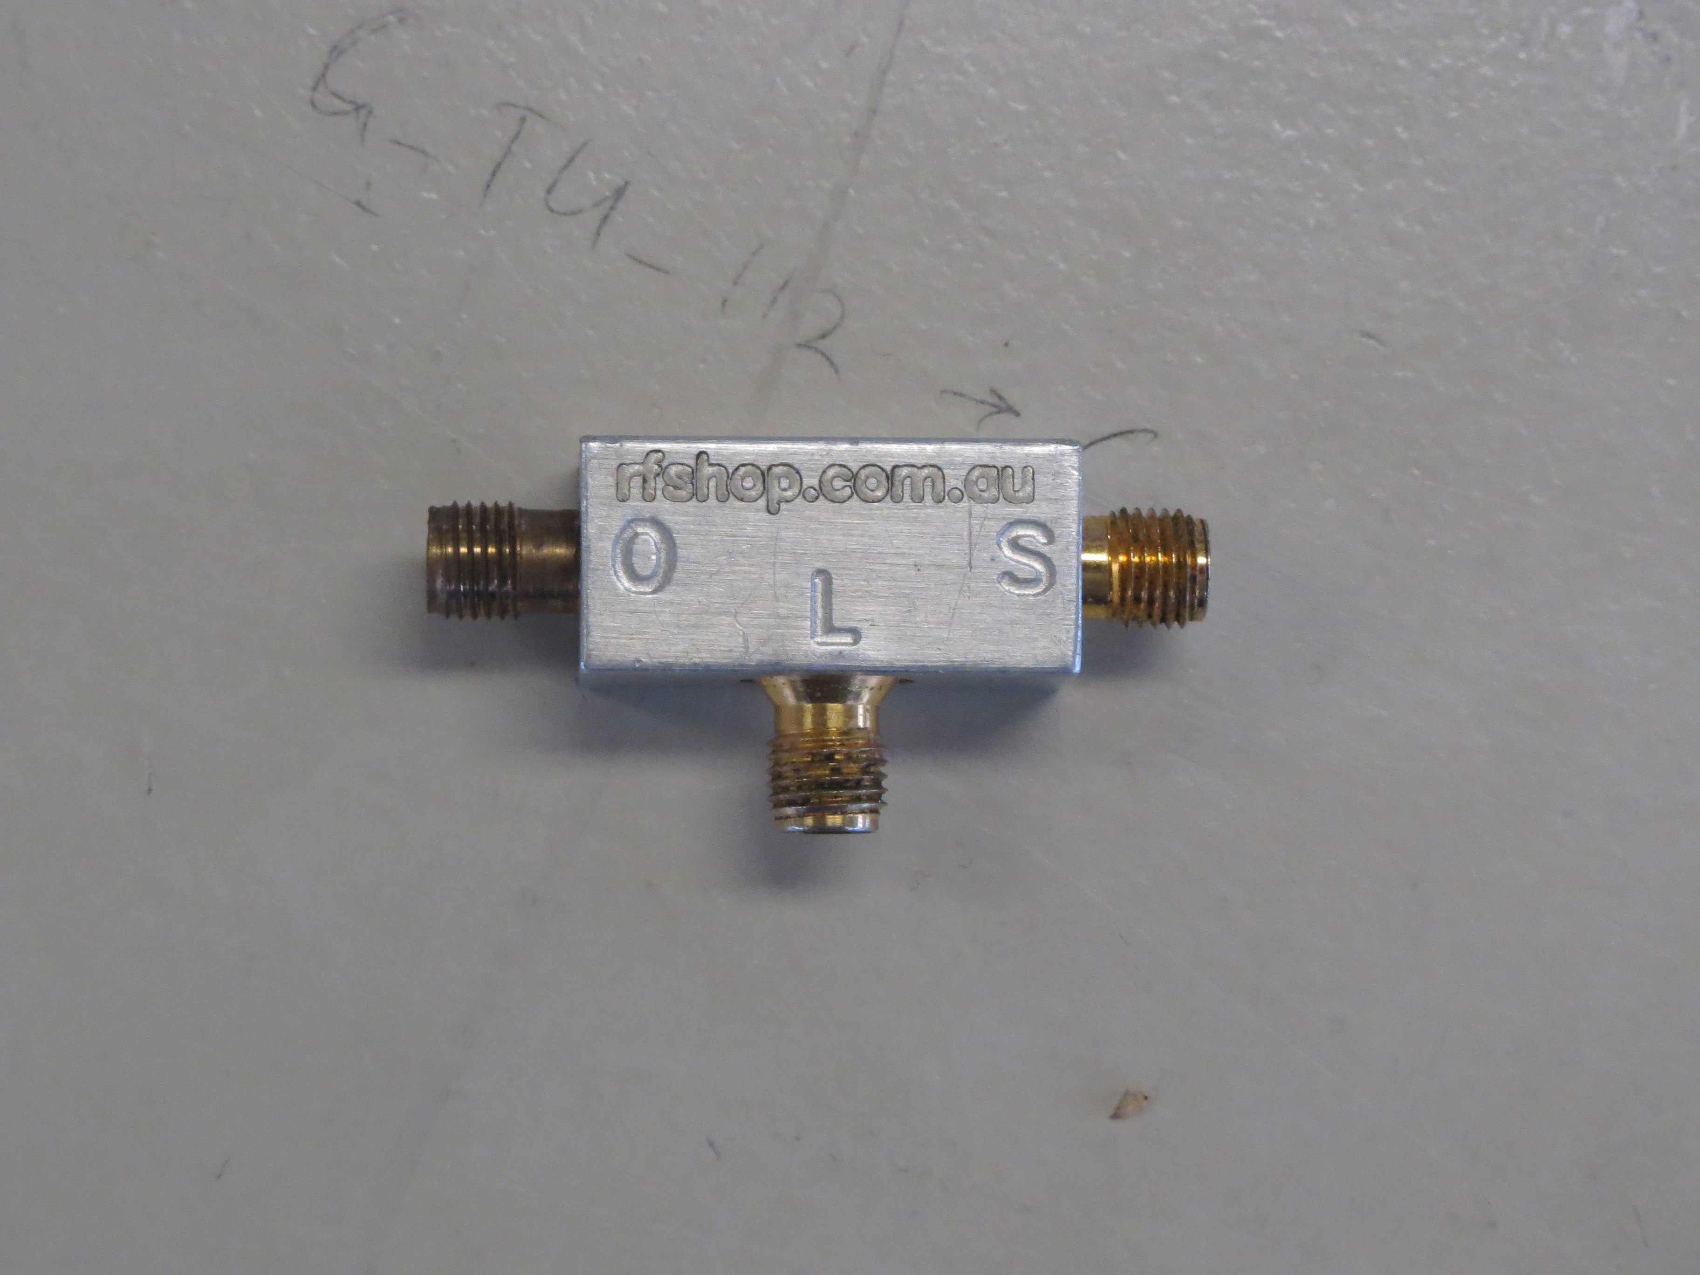

Figure 2: Left: The vector network analyser (VNA) is connected to the 4 port coupler. All ports of the coupler must be connected to a 50Ω termination, either a 50Ω cable or a 50Ω coaxial load. Right: The calibration standard with O (open circuit), L (50Ω load) and S (short circuit) ports.

- Network Analyser (Fieldfox) measurements (Results files are attached)

Complete a mechanical calibration using the three port (O = open circuit, S = short circuit and L = matched load). This is a front panel selection on the VNA. Use the other calibration and use the through connector to join the two cables.

Assemble the measurement system shown in Figure 2. Use the VNA, measure the four scattering parameters (S₁₁, S₂₁, S₃₁, and S₄₁) of the 4 port coupler provided (quadrature hybrid coupler) using the minimum S₁₁ frequency as the reference frequency. Note that you must carefully terminate every port with either a 50 Ω cable or a 50 Ω matched load. The network analyser has a USB port to save each file as a *.csv file which can be read into excel. Save all four files to your USB.

Convert your files to dB and plot all four results S₁₁, S₁₂, S₁₃ and S₁₄ on the same axes. What is the centre frequency and bandwidth of the coupler based on the S₁₁ measurement? Note ALL parameters at the centre frequency (S₁₁ minimum).

Complete the following table:
 | S₁₁ | S₁₂ | S₁₃ | S₁₄ | f₀ | Δf | Q
Puff design
Measurements

Comment on your results (i.e. Are the results similar? What is the loss in the circuit?).

POST-LABORATORY EXERCISES:

Q5.4 What is the difference in the S₁₁ for a load impedance of 150Ω open circuit and a load impedance of 150Ω earthed? Explain your answer.

Q5.5 Sketch a 5 port microstrip divider circuit which is matched to a 50Ω load. Note the expected power output in dB of the loss-less divider and the impedance of the matching transformer line.

Puff Instructions:

On the computer go to the start menu and type puff
The DOS window appears and now type puff 50ohm
The Pugg screen has four windows and you can move between the windows is the function keys on your keyboard. (Note that the mouse does not function in Puff)

Function key | Puff Window
F1 | Layout - where you can add parts from the parts list for your circuit design using the parts list a, b, c, etc and the arrow keys.  Typing 1 or 2 or 3 or 4 makes a connection to the port.  Typing shift 1, or 2, or 3 or 4 moves the cursor to that port.  Shift-arrow erases the component.  Ctrl-e erases the complete design.
F2 | Plot – where you can change the number of calculation points and activate the plot showing the frequency response. You can also change the |S| and f GHz axes of the plot (including S11, S21, S12, S31 etc …  Pgup and Pgdn moves the marker across the plot so you can read the value at that frequency from this window.  ctrl-s save the file  ctrl-r read the saved file
F3 | Parts – where you can add parts including lumped impedances and transmission line sections of various phase length (in degrees) and characteristics impedance in ohms). Alt-d gives degrees and Alt-O gives ohms
F4 | Board - allows you to change the size of the circuit board, the centre frequency, the board thickness, the relative permittivity etc

The complete list of instructions is available at:
http://www.qsl.net/yo4hfu/Files/PUFF/Puff_Handbook.pdf

