- Transcribe the following using a close transcription. Identify primary stress in each word as well as nasalization, flapping, aspiration. For b do BOTH a phonemic and a phonetic transcription.
  - morphemic
  - paucity
  - variational

2. Draw trees of these sentences and explain how the NP’s receive case.

- Many students believe that this class is daunting.
- The students in the back of the class finished the exam with ease.

- Please complete phonology problem 24, page 267, in the 11th edition of the Fromkin and Rodman text. The problem is on Japanese vowel devoicing. You can write the rule in everyday English—you do not need to use formal notation.
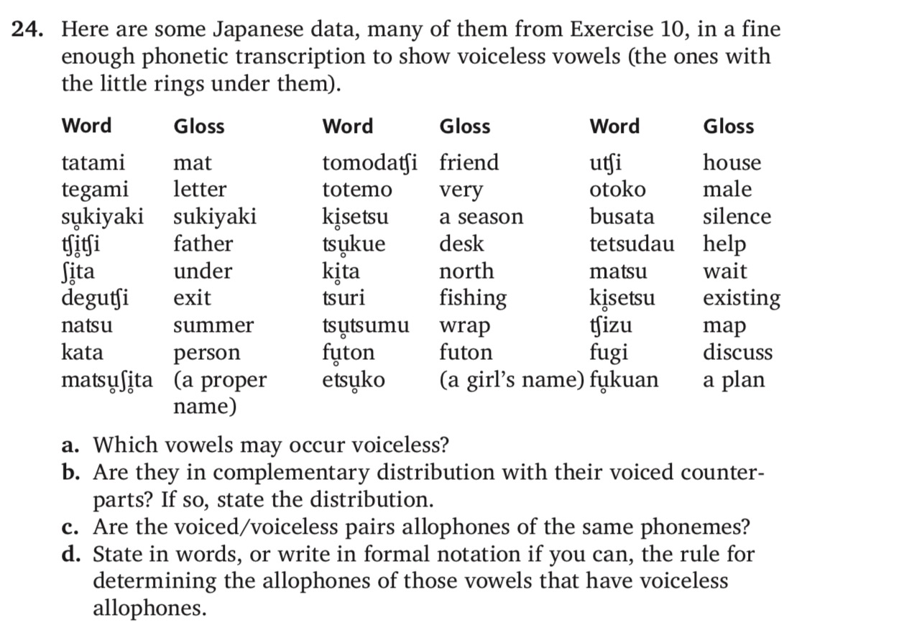

- Explain the theory of x bar syntax. Do not copy from the text but use your own words. (One or two paragraphs)

