COMP 2313 DATA STRUCTURES CODE ASSIGNMENT

|  |  |
| --- | --- |
| ***Assignment Name:*** *Printing odd numbers* | ***Student Name :****John Doe* |
| ***Assignment Date:*** *9/4/2020* | ***Student id :*** *123* |

# Problem

Printing odd numbers in an integer array.

# Challenges

* Finding pattern to find odd numbers
* Accessing elements
* Iteration

# Code



# Pseudo Code

Initialize int array with random int numbers

for (index=0 to last index)

if (current%2 not equal to zero)

print current element

# UML Diagram

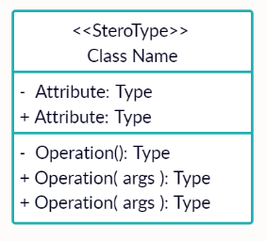

# Outputs

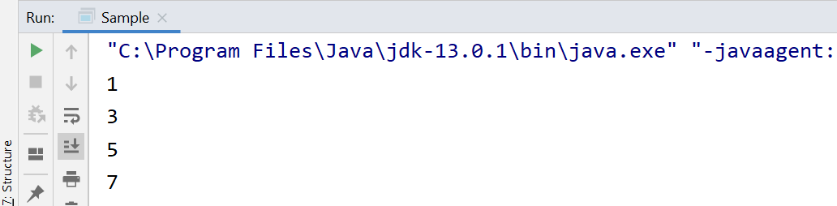

Figure Output Screen of the Odd Numbers Question

# REPL.IT LINK

[https://repl.it/repls/CarefulWretchedRuntimelibrary#Main.java](https://repl.it/repls/CarefulWretchedRuntimelibrary%23Main.java)