The Amazon of Innovatio n
On Cyber Monday, December 1, 2014, Amazon.com customers ordered more than 18 toys
per second. And almost 60 percent of Amazon’s holiday shoppers bought gifts using a mobile
device. This contributed to a 20 percent increase in Amazon’s total annual sales of $89B.
Amazon’s last order for the holiday season was placed on December 24 at 10:24 PM and
was delivered at 11:06 PM just in time for Christmas.
You may think of Amazon as simply an online retailer, and that is indeed where the
company has achieved most of its success. To do this, Amazon had to build an enormous
supporting infrastructure—just imagine the information systems and fulfillment facilities
needed to ship 36.8 million items on a single day. That infrastructure, however, is needed
only during the busy holiday season. Most of the year, Amazon is left with excess infrastructure
capacity. Starting in 2000, Amazon began to lease some of that capacity to other companies.
In the process, it played a key role in the creation of what are termed cloud services,
which you will learn about in Chapter 6. For now, just think of cloud services as computer
resources somewhere out in the Internet that are leased on flexible terms.
Today, Amazon’s business lines can be grouped into three major categories:
• Online retailing
• Order fulfillment
• Cloud services
Consider each.
Amazon created the business model for online retailing. It began as an online bookstore,
but every year since 1998 it has added new product categories. The company is involved in
all aspects of online retailing. It sells its own inventory. It incentivizes you, via the Associates
program, to sell its inventory as well. Or it will help you sell your inventory within its
product pages or via one of its consignment venues. Online auctions are the major aspect
of online sales in which Amazon does not participate. It tried auctions in 1999, but it could
never make inroads against eBay.
Today, it is hard to remember how much of what we take for granted was pioneered
by Amazon. “Customers who bought this, also bought that”; online customer reviews;
customer ranking of customer reviews; books lists; Look Inside the Book; automatic free
shipping for certain orders or frequent customers; and Kindle books and devices were all
novel concepts when Amazon introduced them
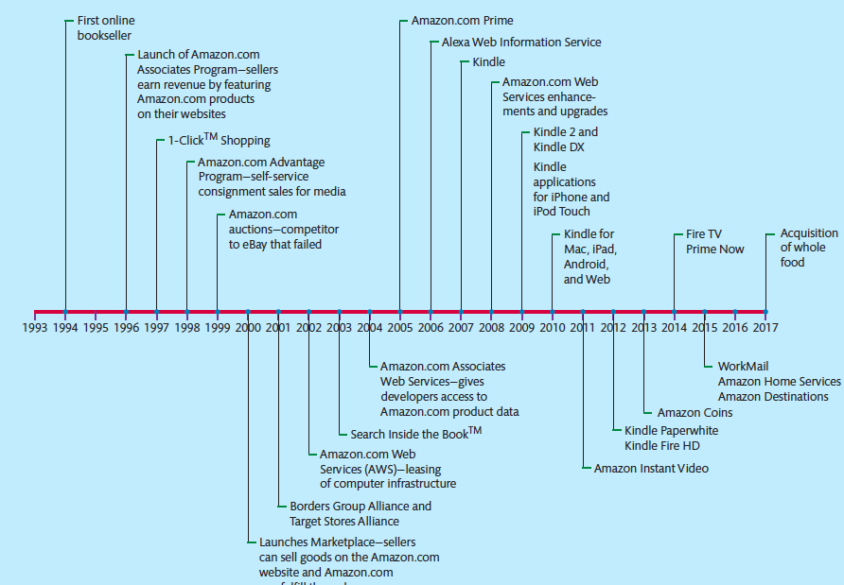
Amazon’s retailing business operates on very thin margins. Products are usually sold at a
discount from the stated retail price, and 2-day shipping is free for Amazon Prime members
(who pay an annual fee of $99). How does it do it? For one, Amazon drives its employees
incredibly hard. Former employees claim the hours are long, the pressure is severe, and the
workload is heavy. But what else? It comes down to Moore’s Law and the innovative use of
nearly free data processing, storage, and communication.
In addition to online retailing, Amazon also sells order fulfillment services. You can ship
your inventory to an Amazon warehouse and access Amazon’s information systems just as if
they were yours. Using technology known as Web Services, your order processing information
systems can directly integrate, over the Web, with Amazon’s inventory, fulfillment,
and shipping applications. Your customers need not know that Amazon played any role at
all. You can also sell that same inventory using Amazon’s retail sales applications.
Amazon Web Services (AWS) allow organizations to lease time on computer equipment
in very flexible ways. Amazon’s Elastic Cloud 2 (EC2) enables organizations to expand and
72 P a r t 1 Why MIS?
contract the computer resources they need within minutes. Amazon has a variety of payment
plans, and it is possible to buy computer time for less than a penny an hour. Key to
this capability is the ability for the leasing organization’s computer programs to interface
with Amazon’s to automatically scale up and scale down the resources leased. For example,
if a news site publishes a story that causes a rapid ramp-up of traffic, that news site can,
programmatically, request, configure, and use more computing resources for an hour, a day,
a month, whatever.
With its Kindle devices, Amazon has become both a vendor of tablets and, even more
importantly in the long term, a vendor of online music and video. And to induce customers
to buy Kindle apps, in 2013 Amazon introduced its own currency, Amazon Coins. In
2014, Amazon opened a 3D printing store from which customers can customize their own
toys, jewelry, dog bones, and dozens of other products. It also made a push to provide video
services by introducing Fire TV
In 2015, Amazon introduced WorkMail, a potential cloud-based replacement for Microsoft
Exchange. It also introduced Amazon Home Services (local professional services),
Amazon Destinations (travel site), and Amazon Dash (a one-button reordering device).19
Finally, Jeff Bezos announced in 2014 that Amazon was experimenting with package
delivery using drones, a service called Prime Air.20 In March 2015, the U.S. Federal
Aviation Administration gave Amazon permission to start testing its drones in the United
States.21 It seems likely drone delivery is something that will happen in the future given
the services Amazon.com is currently offering.

Question
1 Summarize the advantages and disadvantages for brick-and-mortar retailers to sell
items via Amazon.com. Would you recommend that they do so?
2. Amazon has a well designed app to offer sales and payment services to its customers. However, using outbound logistics, delivery service tends to be hit and miss depending on whether a customer is available at the destination to receive a package or not.Think of and describe how an information system could be designed and utilized by Amazon (possibly, but not necessarily, in conjunction with delivery companies) in a new and innovative way to increase the chances of customers receiving orders on first delivery attempt.

