QUESTION 1
- When using binary or multinomial logistic regression, both ordinal and nominal categorical independent variables are treated the same because they are all converted into binary dummy variables.
True
False
1 points

QUESTION 2
- Suppose that logit(p) = 0.53+0.24x1. What is the probability p when x1=10.
0.95
0.54
0.23
None of the above
1 points

QUESTION 3
- 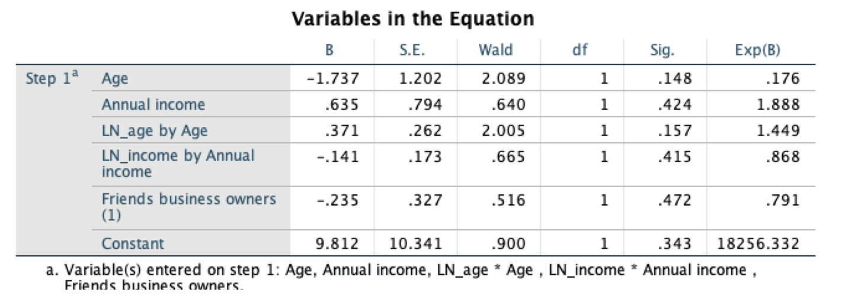
Based on the table above, which of the following variables are linearly related to the logit of the dependent variable
Age and Income
Age, Income and Friends business owners
Age only
Income only
1 points

QUESTION 4
- When running multinomial regression, the categorical independent variable should be
put in the model as factors
put in the model as covariates
either is ok so long as the variable type for the variable is correctly set
SPSS determines the variable type automatically based on stored values
1 points

QUESTION 5
- 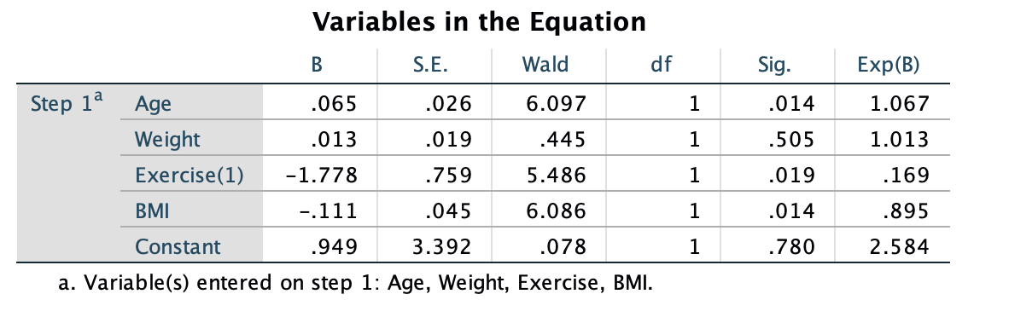
The table shows the logit regression for predicting the chance of getting diabetes. Based on the results, which of the following will increase the chance of getting diabetes?
increasing age, increasing weight, and increasing BMI
increasing age and increasing weight
increasing BMI
increasing age and increasing BMI
1 points

z

