1. Disruptive innovation and ambidexterity (Connect, Perform)
Complete the following sentence with the correct term related to innovation.
Engaging in innovation requires a looser structure, while implementing new ideas requires a more rigid structure. Organizations can meet both needs by using .
Read the case study below and then answer the question.
Management at Work
Newspapers are under tremendous pressure to stay relevant as people increasingly turn to the Internet for news and feature articles. In response, many newspapers have enhanced their websites by adding more content, including podcasts, videos, and reporters’ blogs, and publishing breaking news on their websites well before the next edition of the newspaper goes to press. They then sell advertising on the website, and some put content behind a “paywall,” requiring users to purchase access through a subscription. For the most part, growth in revenues from online advertising and subscriptions has not offset losses of revenues from the print edition.
Ironically, as newspapers join the many other media companies that publish journalism online, there is that much more reason for people to cancel their subscriptions to the hard-copy edition and read the paper online. The newspaper companies are thus fueling the very trend that is leading to their demise.
Over the last year, the Central Times publishing company has invested heavily in its online presence. Its subscriptions manager recently surveyed people who had let their subscription lapse in the previous six months. Of those who responded, 86 percent said they no longer subscribe because they read the paper online. In response to the survey results, the publisher calls the editor in chief into her office and says, “Jax, I want you to pull together a cross-functional team that will prepare the paper to go entirely online within two years. Put them in the wing of the building we don’t use anymore since we had to let a third of our reporting staff go. They’ll report directly to you.”
If the publisher of Central Times wanted to use reverse innovation to increase profits, what might she do?
Figure out a way to print and distribute a very inexpensive newspaper that people want to read in Haiti, then use the same technology and processes to revamp Central Times in the United States
Gradually reduce the size and coverage of Central Times while developing another business, such as book publishing, and then ending the newspaper
Benchmark best practices at newspapers that are facing the same competitive pressure from the Internet but have maintained their profits
Exactly what she is doing: appoint a cross-functional team to operate independently from the rest of the company so the newspaper can

2. Innovation strategies (Connect, Perform)
Complete the following sentence with the correct term.
Taco Bell and McDonald’s are considering adding kiosks in restaurants for customers to place their orders. This will hopefully make the ordering process more efficient and increase accuracy.
Use your knowledge of innovation strategies for new products and technologies to choose the three labels missing from the following diagram.
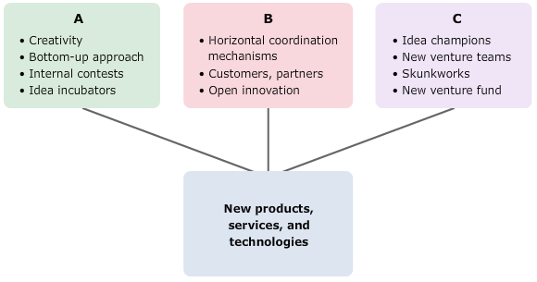

Source: Adapted from Reinmoeller, P., & van Baardwjk, N. (2005, Summer). The link between diversity and resilience. MIT Sloan Management Review, 61–65.
A.
B.
C.

© Shutterstock Images
Management in Life
Lizette’s term paper for her marketing class deals with the product development process. Lizette has decided to use some of her knowledge from her management class to write the paper, and she’s collected a number of examples of different innovation strategies.
Which of the following examples involve an exploration strategy? Check all that apply.
Douglas Hart, a professor of mechanical engineering at MIT, was able to develop his concept for a 3-D hearing aid scanner at the Deshpande Center for Technological Innovation. The center serves as an idea incubator to help academics pursue creative endeavors.
Stamen Design is a design and technology studio that uses mapping and data visualization tools to present information in fresh and exciting ways. Creativity is a way of life for its designers, and the company is willing to pay what it takes to hire only the most innovative designers on the market.
Apple solicits iPhone applications from hundreds of different organizations. Some of the more unusual apps include one from a Massachusetts police department that identifies offenders via photos and another from iHandysoft that turns an iPhone into a carpenter’s level.
Mozilla (creators of Web browser Firefox and e-mail client Thunderbird) has an online store selling crowdsourced T-shirts. These shirts, designed by people who don’t work for Mozilla, advertise Mozilla products in new and creative ways.

3. Exploration and innovation roles (Connect, Perform)
Complete the following sentences about innovation with the correct term.
A company that offers $1,000 for the best idea an employee submits each quarter is running .
Not satisfied with the status quo, identifies opportunities for change and promotes innovation in the organization, helping to overcome resistance.
You have just started a new web-based business, and now you realize that if you want your company to succeed, you will have to create at least 10 new products over the next six months. Which of the following organizational characteristics would not help the company to be more creative? Check all that apply.
Hire only recognized experts, and don’t hire anyone who is eccentric.
Run the company like a tight ship. Create rules about how much creativity is expected and ensure that people follow them.
Allow employees to make mistakes and even reward mistakes when they are made, if they stem from very creative ideas.
Set up a reward system that encourages success. Pay people only for doing things that make the company more profitable.
In new venture teams and skunkworks, managers remove employees from the main body of the company in order to give them:
Additional time, space, and freedom for innovation
Additional rules and regulations so that innovative ideas are implemented correctly
Extra training so that they can learn from more senior members of the organization
Extra exposure to customers and renegades who can help them dream up new product approaches

Use a term related to the cooperation strategy for innovation to complete this sentence.
A company has strong if it continuously seeks new ideas from customers and from looks for ways to use new technologies.
Study the figure showing the horizontal linkage model and read the scenario. Then answer the question that follows.

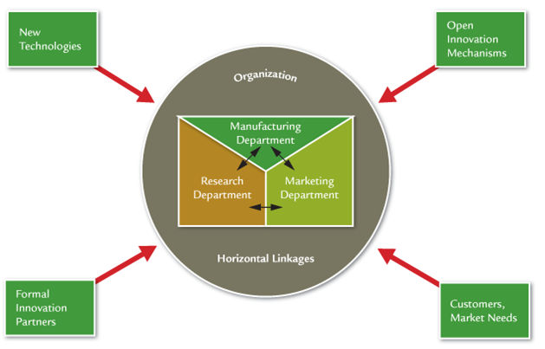

Source: Daft, R. L., & Marcic, D. (2015). Understanding management (9th ed., p. 321). Stamford, CT: Cengage Learning.
You work for a company whose mobile apps help children with various kinds of learning disabilities complete schoolwork more easily. Your company markets its products primarily to parents, but it is beginning to approach school system administrators and teachers about using the software in the classroom. Currently, the research department determines what kinds of apps to make, the software development department makes the apps, and the marketing department sells the apps. To be competitive, it is necessary to constantly update products to reflect the latest learning science research and users’ preferences. Your boss has read about the horizontal linkage model, shown above, and asks you how it might help the company innovate more effectively.
If the company implements the horizontal linkage model, which of the following are likely to occur? Check all that apply.
Employees in research will share the latest learning science research with the marketing department so those employees can gauge its importance to customers.
Cross-functional teams and/or task forces will be formed and meet regularly to coordinate activities between departments.
Managers of each department will interpret the company’s goals for that department and communicate what tasks their employees should perform to achieve the goals.
Employees in marketing will pass along feedback to the software development and research departments about how enjoyable kids find

5. Open innovation (Connect)
Complete the following sentences with the correct term.
Even non-technology companies like GE and Sears are engaged in by using open source software, releasing the code and allowing anyone to develop applications with. This approach reduces costs and reduces the time it takes to bring a product to market.
A type of open innovation is , in which an organization uses the Internet to invite the public to contribute ideas. EyeWire.org has used this approach to engage 200,000 people in 145 countries in mapping the human brain, neuron by neuron, and improve Princeton University Seung Lab’s artificial intelligence algorithm that drives the brain-mapping game.

6. People and culture (Connect)
Thinking about how organizations change, complete the following sentence.
An organization invests in to help certain employees improve a given skill or set of skills.
For each of the situations below, choose whether training or organizational development (OD) would be the more appropriate response.
Need | Training | Organizational Development
All managers need to know how to interact with people of different sexes, races, religions, etc. without giving rise to legal issues, and they need to know how to handle allegations of discrimination that subordinates bring to them.
The company’s main product is becoming obsolete, and its last two efforts to introduce a new product have failed.

7. Organizational development (Connect, Perform)
Complete the following sentences with the correct organizational development (OD) term.
Sometimes when an organization first starts horizontal coordination efforts to promote innovation, is needed to help employees communicate with each other and constructively deal with conflict.
Because organizational change is a difficult endeavor, a company may use , who is an OD expert, to diagnosis problems, develop a training plan, and document performance.
Organizations often use surveys to determine how their employees feel about proposed changes before they happen. These surveys are distributed in the part of the change process.

© Shutterstock Images
Management at Work
Your company’s CEO recently attended a conference on organizational development (OD) where she heard about a number of new techniques, including large-group interventions. She wants you to write a report comparing these new techniques to more traditional OD tools, including team-building activities and surveys.
Use your knowledge of organizational development to answer the following questions, which contain information you would need to write your report.
The traditional organizational development model leads to .
In the traditional organizational development model, work is done:
Only by a consultant
By individuals and in small groups
By the entire organization
Only by employees

8. Overcoming resistance to change (Connect and Perform)
The following chart gives you an overview of the tactics for overcoming resistance to change. Fill in the missing labels.
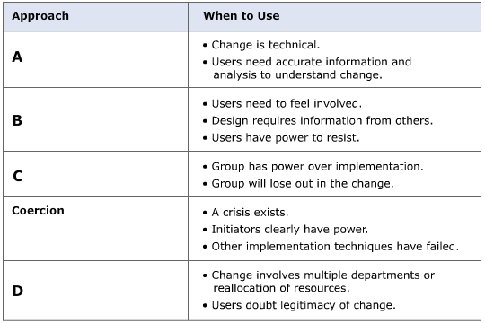

A.
B.
C.
D.
Source: Based on J.P. Kotter and L.A. Schlesinger, “Choosing Strategies for Change,” Harvard Business Review 57 (March–April 1979): 106–114.
For each of the following situations, select the most likely cause of resistance to change and indicate the most effective change tactic.
The senior partners at S. V. Lee & Associates, a law office, just announced that, going forward, the company will focus on employment law because such cases are typically resolved more quickly than other types of legal problems. Several of the junior partners believe that this is a bad idea because they have seen a decrease in the overall number of employment law cases. Talking amongst themselves, the junior partners decry their lack of involvement in developing the firm’s strategies. They are considering refusing to take on employment law cases when they arise.
The most likely cause of resistance to change in this situation is:
Self-interest on the part of the junior partners
The junior partners’ lack of information about future events
Junior and senior partners have different goals
The most effective tactic for implementing change in this situation would be:
Negotiation
Coercion
Participation
Top management support
Shoreline Heating specializes in installing gas furnaces in homes built before 1950. Now, dispatchers are receiving more and more calls asking if the company can put in solar heating systems. Claire Toombs, the owner of Shoreline Heating, has always had a good working relationship with her technicians, and they trust her. Now she wants to start working with solar, but the technicians are objecting loudly. Most of them spent years learning every aspect of gas heating, and they are not very tolerant of change. Claire needs information from the technicians if the change is going to be successful, because they will have to tell her what changes need to be made to their tools and equipment in order to install solar heating.
The most likely cause of resistance to change in this situation is:
The employees’ uncertainty about change
Employees’ lack of trust
Employees and the CEO have different goals
The most effective tactic for implementing change in this situation would be:
Coercion and communication
Top management support and coercion
Negotiation and participation
Participation and education

9. Force field analysis (Connect, Perform)
Complete the following sentence with the correct term.
Managers conduct when they consider the problems and opportunities that drive change and the factors that restrain change.
Management in Life
You’ve been meaning to start exercising for a while now, but it’s hard to get the change process started. On one hand, you like sitting quietly in front of the TV, but on the other, you’d like to feel better and look better. The following diagram presents your dilemma as a force-field analysis, showing the factors for change on the left and the factors against change on the right. The numbers in parentheses represent the strength of each factor, and you can select “Total” to see a visual representation of the combined effects of change.
Use your knowledge of force-field analysis and the diagram to answer the following questions.

Which of the following factors would keep a person from changing in this situation? Check all that apply.
Desire to run a marathon
Fear of looking silly
Desire to get healthy
Not having enough time
According to this force-field analysis, change occur.
Your best friend is coming over to give you an exercise pep talk. According to force-field analysis, what’s the best topic for the talk?
How great you’re going to look once you’ve started exercising.
How much exercise you can get into very short periods of time.
How healthy you’ll be once you’ve started exercising.

