Question 1
Consider a series of island populations each founded by a single individual that is heterozygous at a particular locus. If the alleles at this locus are neutral, and there is no mutation or migration, describe what the variation will look like after many generations within each population. Why?
Answer:

Question 2
Why is underdominance so rare in natural population?
Answer:
Question 3
Imagine a colorful population of insects. Out of 350 individuals in the population, 25% are red, 40% are purple, and the remaining are blue. Red collaration is caused by homorygorsity of the R allele at a single locus; blue coloration is caused by homozygously of the B allele at that locus; heterozygotes are purple. Is this population in Hardy-Weinberg equilibrium at this locus? Show all work.
Answer: 4
Question
What would result 1/4 of the F2 population to be short. This is known through doing a punnet square with the F1 generation like shown below (Tt x Tt)
Answer:
Question 5
Describe how to determine whether a population is in Hardy-Weinberg equilibrium at a locus with two incompletely dominant alleles. For example, imagine that flower color is controlled by two alleles, R and W. Individuals with the RR genotype have red flowers; those with WW have white flowers; and heterozygotes (RW) have pink flowers.
Answer:

Question 6
Pea aphids are found in two colors, pink and green. Imagine that those colors are determined by two alleles at a single locus, when green is dominant to pink. Consider a population when these are 520 pink aphids out of a total of 800 aphids. If the population is in Hardy-Weinberg equilibrium, how many of the green aphids do you expect to be homozygote?
Answer: 7
There are 2 kinds of aphids: pink and green where green is dominant over pink. Let us assume that the locus is G and pink (recessive) is represented by gg whereas green being dominant can be GG or Gg. To solve this problem, lets assume that p is the proportion of allele G in the population and q is the proportion of g allele in the population. Then, as there are only two types of alleles, therefore:
p + q = 1
Remember this will be the case only when there are only two alleles for a given gene. Also, as the probability of finding g is q, therefore, by product law, probability of finding gg will be q*q = q². Similarly, probability of finding GG will be p*p = p². The probability of finding Gg will be p*q + q*p because it can be either Gg or gG. Therefore, probability of finding heterozygote is 2pq. Now in the question it is given that proportion of pink aphids is 328 out of 750. This means that,
q² = 328/750 = 0.4373333333333333
=> q = square root (0.4373333333333333)
=> q = 0.6613118276073197
Now, p + q = 1
=> p = 1 - q
=> p = 0.3386881723926803
Now, the question is to find out the green aphids that are homozygous. These aphids will be represented by GG. Therefore, as explained above, the probability of these will be p² i.e.
p² = p * p = 0.1147096781186939
Now as the total number of plants are 750, therefore, we multiply p² with 750 to get the number of plants having green aphids and homozygous alleles.
required # of plants = 0.1147096781186939 * 750 = 86.03
rounding it off, the number of plants having green aphids and homozygous alleles is 86.

Question 8
Joan Peris and her colleagues induced mutations in a virus called bacteriophage fl. What can be concluded from the distribution of observed fitness effects as a result of the mutations?

Answer:
From the graph we can see that when the frequency of mutation is 0.2, the fitness is zero. But when the frequency of mutation is 0.4 which is the maximum value given in the graph, the fitness value is also high.

Mutations are changes in DNA which may or may not affect the phenotype of the organism carrying it. Mutation can be either neutral or beneficial or harmful.
In this case we can see that when the frequency of mutation is increased, the fitness level also increases. Therefore, we can conclude that the mutation which was induced in the bacteriophage was beneficial to the survival of the bacteriophage thereby increasing its fitness level.
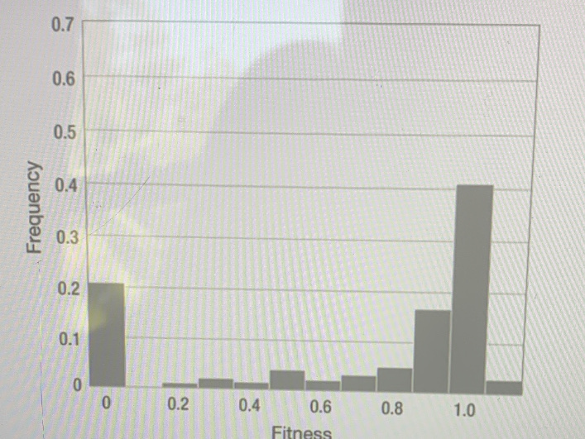
Question 9
Where on a DNA molecule would you expect to find genes that are unexpressed?
A.where the chromatin is decondensed
B.where RNA polymerase binds to the promoter
C. Where the chromatin is condensed
D. Where there are histones
Question 10
Why did the pre-Mendelian theory of blending inheritance pose a major challenge to Charles Darwin’s theory of evolution by natural selection?
A. Blending inheritance would eliminate variation in a population
B. With blending inheritance, genes are passed down across generations even when they are not visibly expressed in offspring.
C. The hereditary determinants of phenotype are particulate
D. Blending inheritance does not challenge Darwin’s theory of natural selection.
Question 11
Which of the following are consistent with law of independent assortment?
A. Purple-flowered plants will never produce white-flowered offspring
B. Characters are blended in hybrid offspring
C. the allele passed down to the next generation at one locus is independent of the allele passed down at a second locus. D. Alleles from two separate loci, once combined in a hybrid, cannot be separated in future reproductive events.
Question 12
DNA is tightly wound in a double helix for much of the time. Which of the following enzymes unwinds the double helix and begins transcription of RNA?
A. RNA polymerase
B. DNA polymerase
C. Transcriptase
D. RNA isomerase
Question 13
An allele frequency change at one locus does not change the allele frequency at a second locus; these loci are most likely:
A. Unlinked
B. Recessive
C. Linked
D. Dominant
Question 14
A sample of 3,000 individuals from a human population was scored for MN blood group. The following frequencies were found: 2,400 MM, 375MN, and 225NN. How do these numbers compare to those expected under hardy-weinberg equilibrium?
A. The genotype frequencies match the expectation
B. The population has fewer MM homozygotes than expected C. The population has more N alleles than expected
D. The population has fewer MN heterozygotes than expected
Question 15
A rancher genotypes all of her 150 head of cattle. In her herd, 25 are A1A1, 75 are A1A2, and 50 are A2A2. Assuming there is random mating, no selection, no mutation, and no new cattle are introduced into the population, what is the probability that the A1 allele will be fixed?
A. 0 B.0.4167 C. 0.6588 D. 1

Question 16
The figure shows the trajectory of allele frequency for two populations starting at two different initial frequencies. Which evolutionary princesses may produce this result?
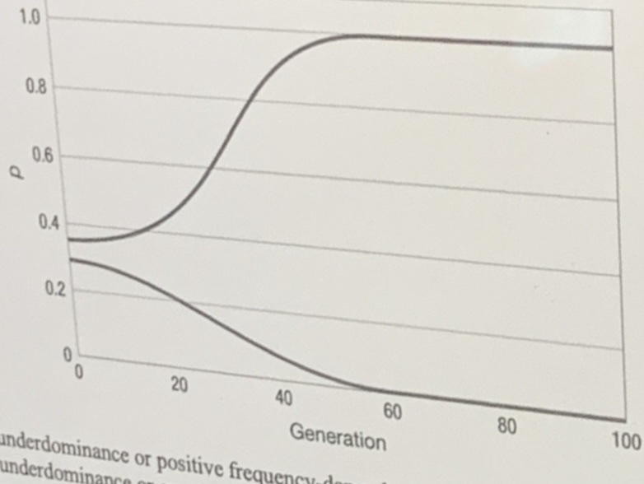

A.Underdominance or positive frequency-dependent selection
B. Underdominance or overdominance
C. Negative frequency-dependent selection or mutation-selection balance
D. Directional selection only

Question 17
Inbreeding increases the frequency of ________ in a population. A. Heterozygotes
B. The dominant allele
C. Homozygotes
D. The recessive allele
Question 18
Which scenario will rare recessive deleterious alleles presence cause the greatest decline in fitness in a population? A. When the deleterious allele affects viability but not fecundity
B. When there is a high rate of migration from neighboring populations
C. When the rate of forward and back mutation are nearly equal
D. When mating occurs mostly among close genetic relatives
Question 19
Which of the following statements would best help you predict the fate of an allele in a population? A. Calculate the rate of nonrandom mating
B. Determine survival rates of individuals of each genotype
C. Determine whether individuals mate randomly with respect to genotype
D. Calculate the frequency of each genotype in the population
Question 20
Consider a locus with two alleles, B and b. Under which of the following scenarios will the frequency of the B allele increase? A. The fitness of heterozygotes is higher than the fitness if bb individuals.
B. The fitness of BB and Bb individuals are higher than the fitness of bb individuals
C. The fitness of heterozygotes is lower than the fitness of either homozygote
D. The fitness of aa individual is higher than the fitness of Bb and BB individuals

Question 21
Natural selection can act on both _______, which is the probability of survival, and ________, which is the number of offspring produced.
A. Epistasis; epigenetics
B. Directional selection, frequency-dependent selection
C. Livelihood; income
D. Viability; fecundity
Question 22
The equilibrium produced by overdominance is: A. Mixed
B. Neutral
C. Stable
D. Unstable
Question 23
Pocket mice have dark- or light-colored coats and live in light- or dark-colored habitats. Pocket mice whose coat colors match their environment are less susceptible to predation. In the scenarios shown in the figure, which of the following selection coefficients might you expect (on each genotype in each habitat)?
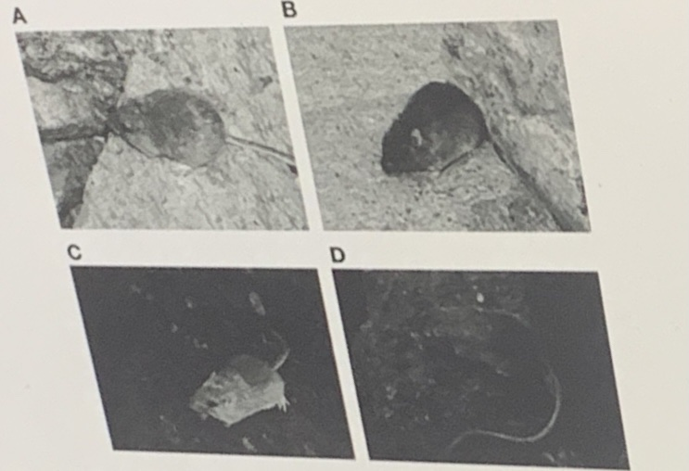

A. A:1 B:0 C:0 D:1
B. A:0 B:0.2 C: 0.1 D:0
C. A: 0.5 B:0.2 C:0 D:0.5
D. A: 0.1 B:0 C:0 D:0.2

Question 24
Population bottlenecks can result in rapid fixation or loss of alleles in otherwise large populations because the bottleneck A. Selectively eliminates or fixes alleles
B. Reduces the effective population size
C. Allows migrant alleles to overwhelm native alleles
D. Creates many new small populations
Question 25
A founder event changes allele frequencies because
A. Only a subset of alleles in the orginal population are represented in the newly founded population B. Selection in the newly founded population differs from selection in the original population
C. Coalescent processes generate alleles that share a common ancestory
D. Mutation is higher in the newly founded population than in the original population
Question 26
The figure below indicates the relationship between the size of an island and the number of alleles found at a micro satellite loci in lizard populations. What do these data demonstrate?
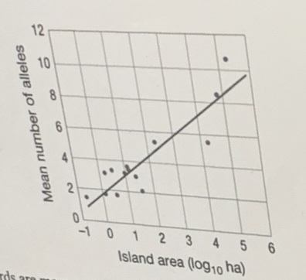
A. Lizards are more successful on larger islands
B. Effective populations size does not affect allelic diversity
C. Populations on smaller islands experience more natural selection D. Genetic drift is stronger in smaller populations

Question 27
F-statistics are used to quantify the effects of genetic drift by measuring A. The change in identity by descent over time
B. Effective population size
C. The rate of change in allele frequency
D. The relative strength of selection on two alleles
Question 28
....the level of diversity at three loci in two spec...following could be true of these species according to
A. The northern elephant seals have a higher mutation rate than the southern elephant seals
B. The northern elephant seals have a larger effective population size
C. The northern elephant seals experience balancing selection at these loci and the southern elephant seals experience directional selection
D. The northern elephant seals experienced a population bottleneck, but the southern elephant seals did not.

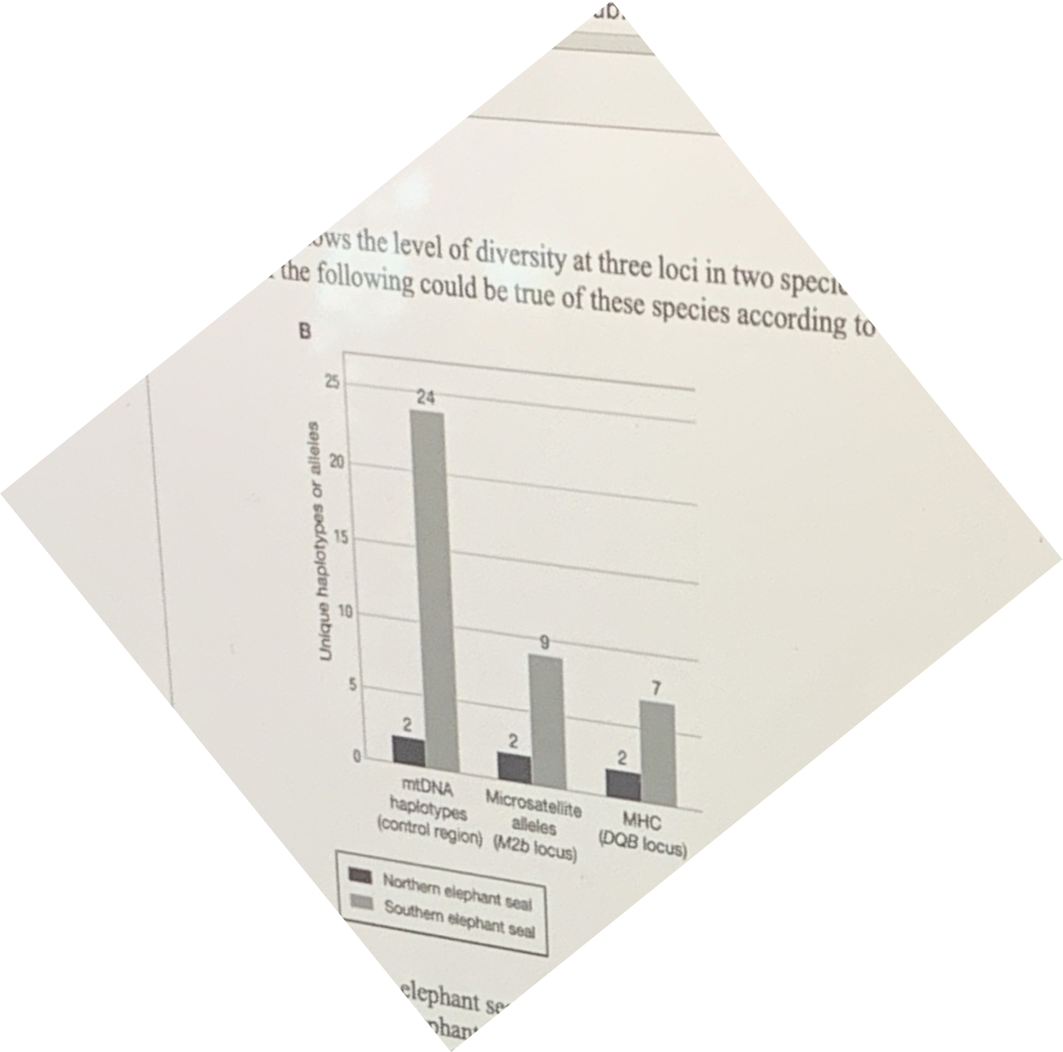

Question 29
What effect does small population size have on the degree of heterozygosity in a population? A. Heterozygosity will increase over time
B. Heterozygosity will decrease over time
C. Heterozygosity will not change.
D. Heterozygosity will be subject to natural selection
Question 30
Which of the following statements is FALSE?
A. Epigenetic changes play important roles in organismal development, such as during cell differentiation
B. Epigenetic information cannot be passed down across generations
C. Epigenetic changes during prenatal development or early in life are responsible for aspects of developmental plasticity D. Most epigenetic changes to the genome are reset at each generation.
Question 31
The null model for population genetics is
A. Mendel’s first law
B. The Hardy-Weinberg model
C. Newton’s first law
D. Biological evolution
Question 32
Which of the following statements would best help you predict the fate of an allele in a population? A. Calculate the rate of nonrandom mating
B. Determine survival rates of individuals of each genotype
C. Determine whether individuals mate randomly with respect to genotype
D. Calculate the frequency of each genotype in the population

Bonus questions:

