Project Report Phase 2
  - Deadline: Wednesday 07/04/2021 @ 23:59
[Total Mark for this project is 5]

Business Computer Languages
IT401

Students Details:
Name1: ### (Leader)  Name2: ###  Name3: ###  Name4: ### | ID1: ###  ID2: ###  ID3: ###  ID4: ### | CRN: ###

Instructions:
- This project report must be submitted on Blackboard (WORD and PDF) via the allocated folder.
- Only the group leader submit the report and the java classes.
- You are advised to make your work clear and well-presented; marks may be reduced for poor presentation.
- Late submission will result in ZERO marks being awarded.
- The work should be your own, copying from students or other resources will result in ZERO marks.
- Use Times New Roman font for all your answers.

Project objective:
This project is an opportunity for you to practice your knowledge in Java. It will allow you to develop your skills of working within a team, thanks to your interaction with your colleagues in designing and creating a small program.

Project Description:
The Saudi Heart Association recommends that no more than 30 percent of a person's daily calories come from fat. Each gram of fat is 9 calories. Given the grams of fat and the number of calories in a food item, we can calculate the percentage of calories that comes from fat for that food item as follows:
Fact calculate percent = $\frac{ 9 X Fat }{calories}$ * 100

Project Phase 2 questions:
In this project, you are requested to
- Prompt user to enter name of a food
- Input food name
- Prompt user to enter the grams of fat in the food(for the food he/she entered in previous input)
- Input grams of fat
- Prompt user to enter the number of calories in the food "Enter the the number of calories: "
- Input the number of calories
- Print the food item and the percentage of calories that come from fat
(fatCalPercent)
- Print one of the two following messages depending on the percentage
of calories from fat (value of fatCalPercent)
- "This item is Heart Heathy!" When FactCalculatePercent <= 30
- "This item is NOT Heart Heathy!" otherwise.
- Ask the user if he/she would like to continue Y/ N? The program should be continue until the user press N.

IV: Hint
You can use the do while loop as figure 1
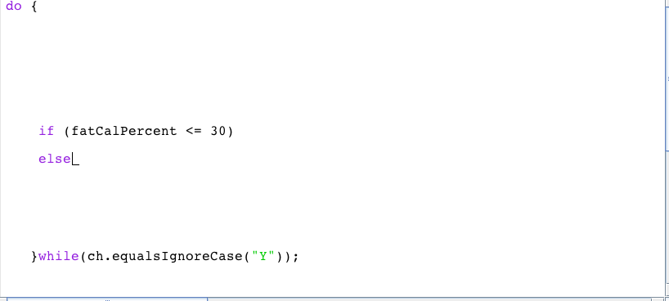
Figure 1: do while loop
Run your program at least 3 times. An example of test data is given in table 1.
Item | Grams of fat | Calories
Tuna | 1 | 60
Beef | 7 | 200
V8 Juice | 0 | 35
Table 1: example of test data

Your output should be similar to the result in figure 2.
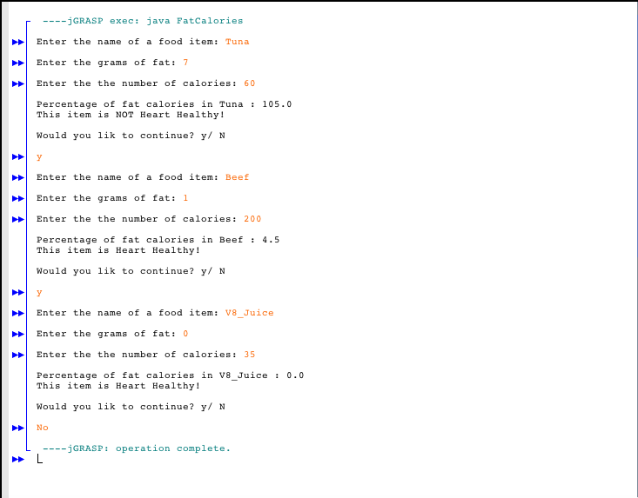
Figure 2: example of output

Marking Criteria

Criteria | Marks
The program is bugs-free | /5
The source code is well documented (commented) and program uses standard Java naming conventions | /5
Question 1,2,3,4,5 and 6 | /10
Question 7 | /10
Question 8 and 9 | /10
Output screenshots provided in the report | /10
Total | /50
Final Grade | /5

Answer
- Brief description
Provide a brief description of your program in this section.

- Program code
Put the code of your program in this section. Do not forget to document (comment) your code.

- Screenshots
Put the different screenshots with a brief description in this section.

- Difficulties Faced
Provide a brief description of difficulties and challenges faced during this phase of the project.

