Biomedical Optics Lab Spring 2021 Date:03/12/21
Class Assignment #5
Time allocated: 2 hrs
Material: Webcam and cell phone LED light
This assignment builds on the second experiment of the previous assignment.
Experiment
- Like the experiment in assignment #4, take time sequence images of your first finger with optical configurations shown below but with an additional requirement of holding your breath for fixed intervals (4-6) of time during the total period of image acquisition.
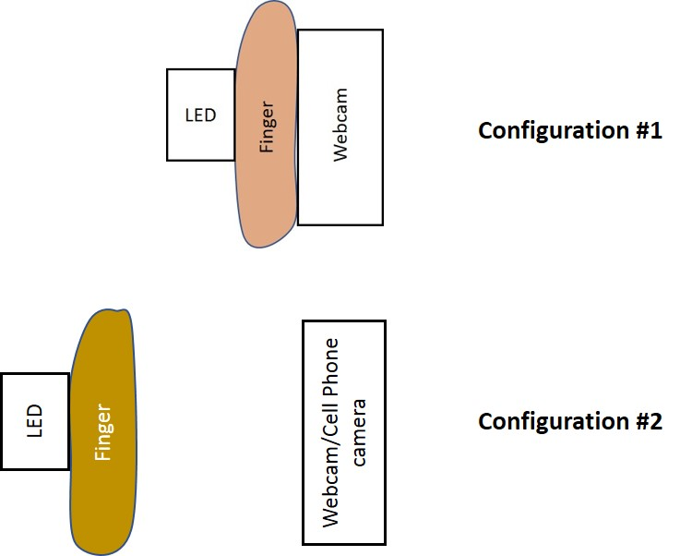

After acquiring the images, process them to quantify the variation in the intensity of light in RGB channels. Repeat the experiment 6 times and check if you can correlate the change in optical signal with the periods of breath holding and the average heart beats per minute during the period of breath holding and outside it. Discuss the results to verify if they make physiological sense.

Submission: Upload pdf file on Canvas under assignment 5 folder. Your file should include sample images, Matlab script, and plots of temporal change in optical signals.

