Assignment #1 part 1
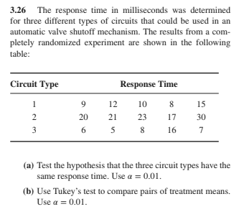
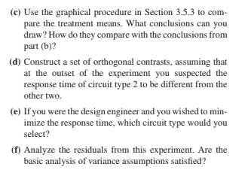

- Consider the data from problem 3.26. Use a hand calculator to answer these questions (do not use R). Show your work!
  - Calculate the sums of squares and construct the ANOVA table of this experiment (you may use a hand calculator but not R). Show your work!

  - Give the rejection region of the test that the three circuit types have the same mean response time (use α = 0.05): _______________
  - Do we have enough evidence to conclude that the three circuit types don’t have the same mean response time? ____
  - Construct a 90% confidence interval for the mean response time of circuit type 2 ________________

  - Construct a 95% confidence interval for the difference in mean response time between circuits of types 2 and 3 ______________

  - Calculate Tukey’s HSD ________. Using Tukey’s HSD method, which circuit types have the same mean response time and which circuit types have different mean response times?

  - Suppose circuit type 2 is the control treatment. Use Dunnett’s method to perform comparisons of the other two treatments means to the control.

  - Write down a contrast that can be used to compare the mean response time of circuit type 3 to the average of the mean response times of the other two circuit times _______________________ Construct a 95% confidence for your contrast.

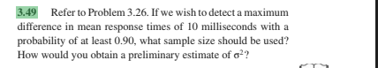
- Solve problem #3.49. Use MSE found in problem 3.26 as the value of σ². Answer: ____

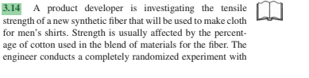
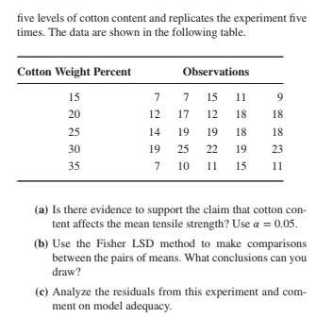

- Use R to solve problem #3.14. Copy/paste the R output that helped you answer each question (you can paste into this file or into a separate file). For part c), be sure to construct plots of residuals and carry out statistical tests of normality and constant variance.

