Assignment 1 part 2

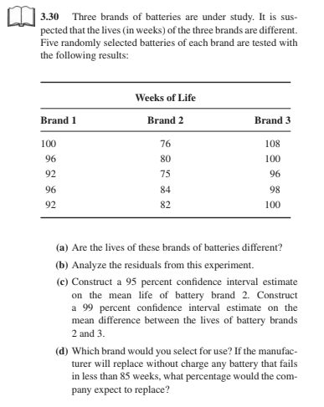
- Use the Kruskal-Wallis test for the experiment described in problem #30 from chapter 3 (page 130): “Three brands of batteries are under study…” Do the calculations by hand to find the test statistic (you may use a calculator but show your work). Give the rejection region of the test. What do you conclude?

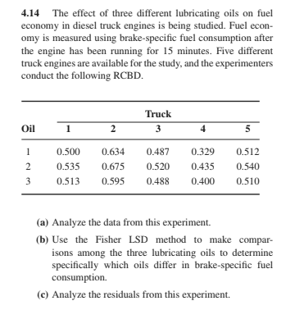

A.
Use R to solve problem #14 from chapter 4 (page 173): “The effect of three different lubricating oils on fuel economy on diesel truck engines is being studied…” Copy/paste the relevant R output that helps you answer each question. In addition, be sure to type or write your answer/conclusion for each part (it is not enough to submit the R output). For instance, in part c you need to decide if the ANOVA assumptions are satisfied, so comment on each plot of residuals – what does it show regarding the assumptions? If in doubt, you may also use a test of hypotheses.

B.

This is a continuation of the second problem. Assume the five trucks were randomly selected from a large population of trucks. Estimate (by hand, using the results from the previous problem) the variance components. What percent of the total variability is due to differences among trucks?

C.

This is a continuation of the second problem. Assume the five trucks were randomly selected from a large population of trucks and the three lubricating oils were randomly selected from a large population of oils. Estimate (by hand, using the results from problem 2) the variance components. What percent of the total variability is due to differences among trucks? _____ What percent of the total variability is due to differences among lubricating oils? ______

