Exercise 6: Simulating Crystallization in a Silicate Magma 200 points

Geology Lab 111 Name(s)______________________________________________
Objectives:
- Use data collected from cooling magma (simulated) to observe
  - Crystallization temperatures of minerals
  - The order in which minerals crystallize in igneous rocks
  - How mineral composition affects crystallization temperature
  - How the composition of magma changes as minerals crystallize from it
  - Observe dissolution and crystallization phenomena

- (8 pts) Before you begin, what are the chemical formulas of the following minerals? Fill in the table below. Look their compositions up online in Wikipedia or some other source.

Mineral Name | Chemical Formula | Felsic or mafic
Olivine such as forsterite-fayalite |  | mafic
Pyroxene (look up enstatite-ferrosilite) |  | mafic
Amphibole (look up hornblende) |  | mafic
Biotite such as annite |  | mafic
Plagioclase feldspar such as anorthite or albite |  | felsic  (Calcium-rich variety, anorthite, is found with mafic minerals in mafic rocks)
Potassium feldspar (K-feldspar) such as orthoclase |  | felsic
Muscovite |  | felsic
Quartz |  | felsic

In general, mafic minerals contain iron and/or magnesium. Felsic minerals do not. Olivine and pyroxene are more mafic than amphibole which is more mafic than biotite.

In this exercise, you will launch a detailed simulation of minerals crystallizing from magma or lava. This site explains the simulation you will use
https://web.viu.ca/earle/geol111/magma-crystallization.htm

and this is the actual simulation.
http://www.mathieu-lessard.com/Geology/magma.html

The simulation allows you to control:
- The composition of the magma
- The rate at which the magma cools
- The simulation’s run time or duration (set this at 3 minutes)

You will be running several simulations and filling out a table that shows the results of each simulation. You will have to watch the simulation as it runs. This does require some patience.

Key details
Elements tracked in the magma are:
O = oxygen, Si = silicon, Al = aluminum, K = potassium, Mg = magnesium, Fe = iron, Ca = calcium, Na = sodium, H = hydrogen

The elements that are still free in the magma are shown as little circles with different symbols.

The “Initial Composition” slider bar sets the % of each element in the magma at the beginning of the simulation. To describe the magma compositions in a single word, look at the Si% and use the word in bold that describes that Si%:

Magma Composition
Felsic = magma with Si% ranging from 21.7-24.7%
Intermediate = magma with Si% ranging from 19.5-21.7
Mafic = magma with Si% ranging from 17.5-19.5%
Ultramafic = magma with Si% ranging from 15.8-17.5%

Do four different simulations matching the parameters given at the top of each table.

The “Cooling Rate” slider bar has values ranging from 1°C/1000 years (very slow cooling deep underground) to 1°C/year (slow cooling underground but closer to the surface) to 1°C/month (cooling in the shallow subsurface or inside a very thick lava flow) to 1°C/hour (rapid cooling inside a thinner lava flow) to10°C/second (very rapid cooling on the surface of a lava flow).

All the simulations run until they cool to 400°C. It is not necessary to wait until the simulation reaches that temperature. New crystals stop forming in the simulation at temperatures in the mid-800’s. At 400°C, the leftover magma magically disappears without any new crystals—one of the many flaws in this otherwise really cool program.
On the next pages, fill out the charts while your run the simulations then answer the questions based on what you filled out in the chart for that simulation.

Simulation #1 has a lot of information set up for you so you can get used to running this simulator program. At each of the temperatures listed at the top of the table, you should hit the pause button on the simulation and record the information on the screen. To unpause the simulation, simply hit unpause and wait—it is slow to react. Sometimes, that doesn’t work and you have to hit play again. Don’t hit restart—it will restart the simulation all over again. There is no rewind or fast forward on this simulation. Sorry!!!

Simulation #1 Duration 5 minutes—30 points for filling in the table below
Starting Temperature | Cooling Rate | Si % | Magma Composition (use chart on page 2)
 | 1°C/hour | 24.7

Temperature °C | 1192 | 1098 | 1085 | 893 | 885
%Magma

%Olivine

%Pyroxene

%Amphibole

%Biotite

%Plagioclase

%K-feldspar

%Muscovite

%Quartz

Elements left as free atoms | Answer >5,1-5,0 | Answer >5,1-5,0 | Answer >5,1-5,0 | Answer >5,1-5,0 | Answer >5,1-5,0
O
Si
Al
K
Mg
Fe
Ca
Na
H
For elements left as free atoms, look at each pause point and count if there are 0 left, 1-5 left, or more than 5 left at that point.

Questions from Simulation #1 (17 pts)
- Is Simulation #1 the cooling of magma underground or lava on the surface? How do you know?

- What are the first minerals to crystallize?

- What happens to Ca, calcium, in your simulation at 1192°C? You might have to go back and pause the simulation right at the beginning for you to find any Ca atoms in the magma, then track them as the temperature goes to 1192°C. This happens quickly, so watch carefully. What mineral formed that would have used it?

- What happens to Na, sodium, in your simulation at 1085°C? What mineral formed that would have used it?

- What happens to K, potassium, in your simulation at 1085°C? What mineral formed that would have used it?

- If you look, you notice that plagioclase feldspar crystallizes at a variety of temperatures. What about its composition do you think allows this to happen?

- What happens to amphibole as the magma cools from 1098°C to 1085°C?

- Which minerals form as the temperature cools to 1085°C? Which of these minerals likely replaced the amphibole? Explain your reasoning.

- What is the last mineral to form?

- What elements are still left as atoms in the magma at 885°C?

- These photos show granite, a rock that formed from magma at slower cooling rates deep underground, and rhyolite, a rock that formed from lava at the surface. Which one matches the rock you formed in your simulation? Why?
Granite Rhyolite
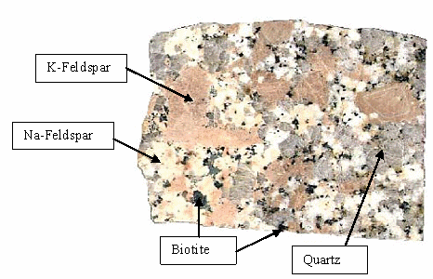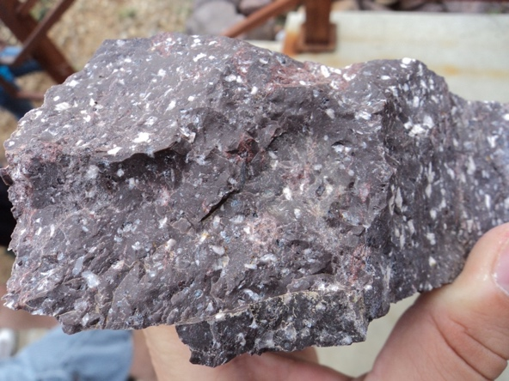
Round grey Quartz
White Plagioclase feldspar
Purple Groundmass (microscopic minerals of plagioclase, K-feldspar, biotite, and quartz)
Photo on left https://qph.fs.quoracdn.net/main-qimg-58d57420e7e15ef3d74298c9cbf8bfa4
Photo on right https://secureservercdn.net/160.153.137.153/xjn.93b.myftpupload.com/wp-content/uploads/2018/04/Rhyolite.jpg

Run three more simulations (#2-#4) using the sheets provided. In these, you are responsible for determining the temperatures at which you see crystallization occurring throughout each experiment. For each simulation you should follow the starting conditions given at the top of the table for that simulation.

If you watch carefully during the simulation, the free-floating atoms suddenly start coming together when crystallization is going to occur. If you hit pause and wait, crystallization will occur while paused. Let it finish, write down the results, and then unpause. Remember you can’t rewind or fast forward, so be careful so you do not have to redo your simulated experiments over and over. (Kind of like a real experiment.)

Simulation #2 Duration 5 minutes 30 points for filling in the table; there are more columns than you may need to use; stop your simulation when you reach a temp of 850°C.
Make sure to pause this simulation at 1433°C to change the cooling rate. Use as many columns as needed.
Starting Temperature | Cooling Rate | Si % | Magma Composition
 | 1°C/1000 yr change to 10°C/s at 1433°C | 19.9

 | A | B | C | D | E | F
Temperature °C
%Magma

%Olivine

%Pyroxene

%Amphibole

%Biotite

%Plagioclase

%K-feldspar

%Muscovite

%Quartz

Elements left as free atoms | Answer >5,1-5,0 | Answer >5,1-5,0 | Answer >5,1-5,0 | Answer >5,1-5,0 | Answer >5,1-5,0 | Answer >5,1-5,0
O
Si
Al
K
Mg
Fe
Ca
Na
H
For elements left as free atoms, look at each pause point and count if there are 0 left, 1-5 left, or more than 5 left at that point.

Answer the following questions based on your results from the second simulation. (3 points)
- What happened to crystal size when you changed the cooling rate? Why did this change occur?

- This kind of rock with big and small crystals is called “porphyritic.” Rapidly cooled porphyritic rocks are given extrusive igneous rock names. What rock name would you give to what you made in this simulation? (Use the chart below)

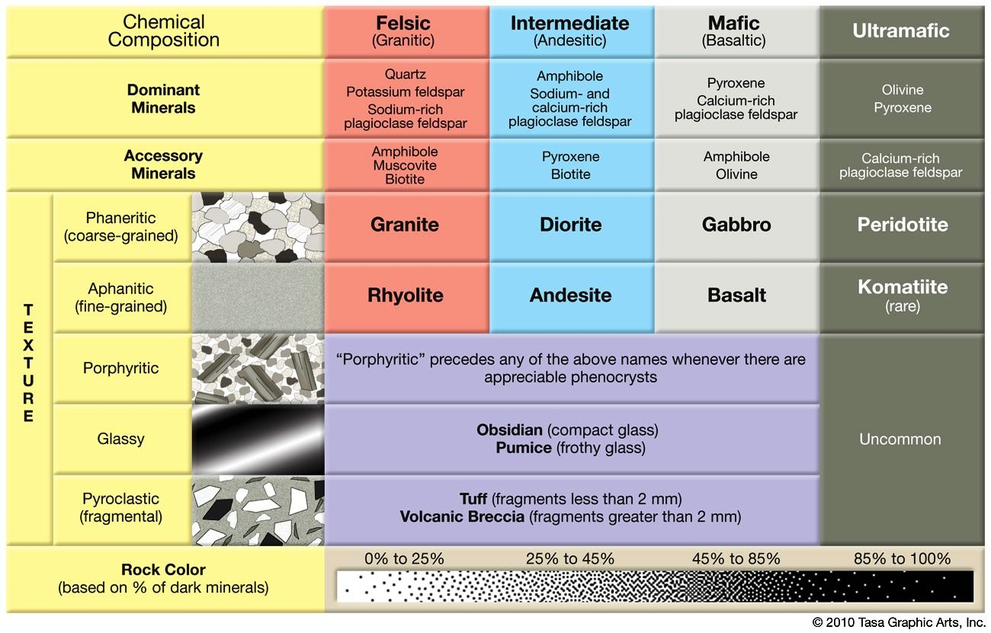

Simulation #3 Duration 5 minutes 30 points for filling in the chart; there are more columns than you may need to use; stop your simulation when you reach a temp of 850°C.
Use as many columns as needed
Starting Temperature | Cooling Rate | Si % | Magma Composition
 | 1°C/hour | 18.3

 | A | B | C | D | E | F
Temperature °C
%Magma

%Olivine

%Pyroxene

%Amphibole

%Biotite

%Plagioclase

%K-feldspar

%Muscovite

%Quartz

Elements left as free atoms | Answer >5,1-5,0 | Answer >5,1-5,0 | Answer >5,1-5,0 | Answer >5,1-5,0 | Answer >5,1-5,0 | Answer >5,1-5,0
O
Si
Al
K
Mg
Fe
Ca
Na
H
For elements left as free atoms, look at each pause point and count if there are 0 left, 1-5 left, or more than 5 left at that point.

Answer the following questions based on your results from simulation #3. (3 points)
- What happens to pyroxene between 1530°C and 1393°C?

- What rock name would you give to the rock you made in this simulation? (Use the chart below)

Simulation #4 Duration 5 minutes 30 points for filling in the chart; there are more columns than you may need to use; stop your simulation when you reach a temp of 850°C.
Use as many columns as needed. Note the change in cooling rate here.
Starting Temperature | Cooling Rate | Si % | Magma Composition
 | 1°C/1000 years | 16.4

 | A | B | C | D | E | F
Temperature °C
%Magma

%Olivine

%Pyroxene

%Amphibole

%Biotite

%Plagioclase

%K-feldspar

%Muscovite

%Quartz

Elements left as free atoms | Answer >5,1-5,0 | Answer >5,1-5,0 | Answer >5,1-5,0 | Answer >5,1-5,0 | Answer >5,1-5,0 | Answer >5,1-5,0
O
Si
Al
K
Mg
Fe
Ca
Na
H
For elements left as free atoms, look at each pause point and count if there are 0 left, 1-5 left, or more than 5 left at that point.

Answer the following questions based on your results from simulation #4. (7 points)
- What happens to olivine, pyroxene, plagioclase feldspar, magnesium (Mg), calcium (Ca), 1772°C and 1594°C?

- What happens to pyroxene, amphibole and biotite between 1594°C and 1093°C?

- What rock name would you give to the rock you made in this simulation? (Use the chart below)

- In what layer of the earth is this rock found?

Your Summary: Use your results from all four simulations and the answers to the questions after each simulation to answer the following questions.

- (18 pts) The temperatures at which these minerals crystallize in magma are
Mineral name | Temperature | Order of crystallization (1st, 2nd, 3rd, etc.) as magma cools
Olivine
Pyroxene
Amphibole
Biotite
Plagioclase feldspar Ca-rich
Plagioclase feldspar Na-rich
K-feldspar
Muscovite
Quartz

(next page)

- (12 pts) Look at the composition (felsic, intermediate, mafic, or ultramafic) of the minerals from what you wrote in question 1 before you did the simulations compare to their crystallization temperature. Fill in the chart to help you make the comparison. Discuss the patterns you see below this chart.
Mineral name | Composition | Crystallization temperature and Order of crystallization (1st, 2nd, 3rd, etc.) as magma cools
Olivine
Pyroxene
Amphibole
Biotite
Plagioclase feldspar Ca-rich
Plagioclase feldspar Na-rich
K-feldspar
Muscovite
Quartz

(next page)
- (6 pts) Which elements (not minerals—so look at the elements you tracked in the simulation, such as Na, Ca, Fe, etc.) get used up early in the cooling of magma, while the magma is still relatively hot? Which elements tend not to get used up until the very end?

- (6 pts) Explain what you think happened when you observed mafic minerals appearing and disappearing as magma cooled.

