It 402 assignment 2 web design

Question One
Learning Outcome(s): CLO1
Identify most HTML tags and CSS properties and use a text editor to construct the basic HTML and CSS structure for a webpage.

Create a code that gives the following output, use the CSS to change the color of all <p> and <h1> elements, to "green". Group the selectors to minimize code and use the internal CSS.
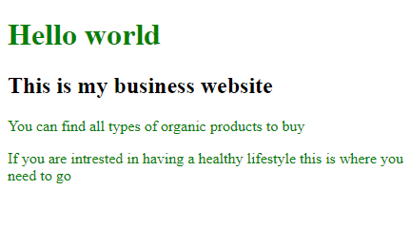
Answer:

Question Two
Learning Outcome(s): CLO2
Develop websites that present information, graphics and hypertext using CSS and JavaScript.

The following codes are using the RGB, change it to RGBA color in order to set the opacity for the background color of <h1> element to “0.3”.
<!DOCTYPE html>
<html>
<head>
<style>
h1 {
background-color: rgb(0,255,0);
}
</style>
</head>
<body>
<h1>Welcome to my world </h1>
<p>This is a Disney Website where you can have the full experience</p>
<p>Have fun and enjoy your time</p>
</body>
</html>

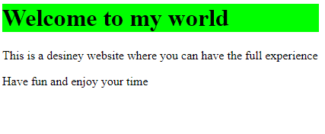
Answer:

Question Three
Learning Outcome(s): CLO2
Develop websites that present information, graphics and hypertext using CSS and JavaScript.

Create a code with <h1>, two paragraphs <p> and make sure you apply internal CSS where the background color of <h1> element is blue and the Set the transparency/opacity of it to "0.4".
Answer:

Question Four
Learning Outcome(s):
CLO3
Recognize and evaluate a range of real-world web design approaches.

Find the mistakes in the following codes based on the output shown:
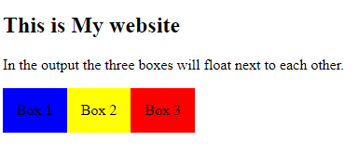
<!DOCTYPE html>
<html>
<head>
<style>
div {
float: right;
padding: 15px;
}
.div1 {
background: green;
}
.div2 {
background: yellow;
}

div3 {
background: red;
}
</head>
<body>
<h2>This is My website</h2>
<p>In the output the three boxes will float next to each other.</p>
<div class="div1">Box 1</div>
<div class="div3">Box 3</div>
</body>
</html>

Answer:

