Name:

1. Give an example of each of the following:

## Trademark

* 1. Service mark
  2. Collective mark
  3. Certification mark

2. Explain why APPLE can be used as a trademark for electronic devices but cannot be used as a trademark for a Fruit Store.

3. Polar Beverages located in Worcester, MA uses the Trademark below and has been using the Orson Bear since 1902. Coca Cola recently began an advertising campaign for its Cola using the character shown below. Should Polar be able to stop Coca Cola?

[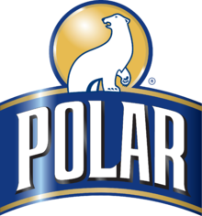](https://en.wikipedia.org/wiki/File:Polar_Logo_2012.png)

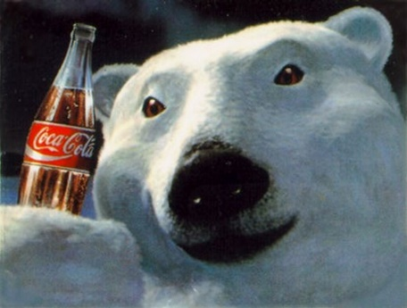

4. Give an example for each of the following:

* 1. Inherently distinctive trademark
  2. Acquired distinctive trademark (i.e. descriptive with secondary meaning)
  3. Merely descriptive trademark
  4. generic term for goods

5. How can Lowe’s Home Improvement Store and Loew’s Theaters coexist, sometimes in the same or nearby malls? It is because of the difference in spelling?

6. Before Burger King Corporation went national with their chain of hamburger restaurants. Bill Johnson was known for making the best hamburger in Western, MA and was often called “The Burger King.” Still prior to Burger King Corporation registering a trademark and operating in Massachusetts. Bill opened a small restaurant in Springfield, MA called BURGER KING, and the logo was a picture of Bill with a crown. Burger King Corporation has told Bill that they plan on opening a store in Springfield. Is there anything that Bill can do to stop them?