Instructions:

- Make a group of 3 members. Submit on Moodle 2 files one cisco packet tracer file and other word file with all snapshots.
- Submit:
  - A soft copy of your Cisco packet tracer file with your names.
  - Word document with step 2, step 3 designing details of classles subneting (VLSM) and snapshots of step 5.

Building a Switches and Router Network using CISCO Packet Tracer 7.2.2

Given Topology:
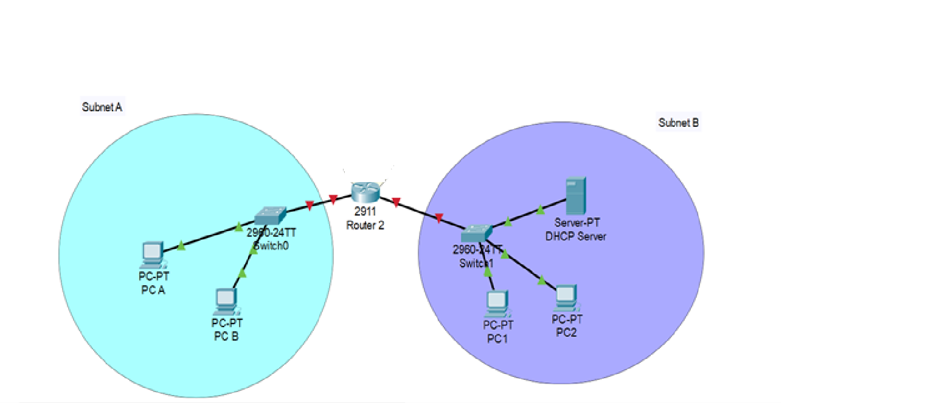

Addressing Table

Device | Interface | IP Address | Subnet Mask | Default Gateway
Router 2 | G0/0 |  |  | N/A
 | G0/1 |  |  | N/A
S1 & S2 | VLAN 1 | N/A | N/A | N/A
PC A | NIC
PC B | NIC
PC 1 | NIC | DHCP enabled | - | -
PC 2 | NIC | DHCP Enabled | - | -
DHCP server | NIC

Required Resources
2 Routers (Cisco 2911) – Router 2 with 2 interfaces Gigabit Ethernet 0/0, Gigabit Ethernet 0/1 connected to Subnet A and B as per the given network above.

- Switches (Cisco 2960)
- PCs as end devices and 1 server
Download CISCO packet tracer free version from link below: Download cisco packet tracer 7.2.2

Designing the Network with Classful Subneting
- Network given is provided with network address of 192.168.10.128 /25 (Network ID).
- Design 3 subnets for the above network using classless subnetting (VLSM).
  - Subnet A with 13 computers
  - Subnet B with 25 computers
- Subnet A is connected to Router 2 G0/0 interface. Subnet B is connected to G0/1 of Router 2.
- Answer the following: (Note: the first and last Subnet IDs are not valid in traditional classful subnetting) (Show all steps in the word document)
- Calculate new subnet mask or prefix for each subnet?
- Find the valid address ranges in each subnet?

- After designing, fill the table with valid IP addresses and subnet masks.

Required Configuration
Step 1: Cable the network as shown in the topology.
- Layout the devices shown in the topology diagram, and cable, as necessary using cisco packet tracer. Note: you may use auto configuration option for cables.
- Power on all the devices in the topology.

Step 2: Configure the switch.
- No configuration is required on the switch.

Step 3: Configure the Routers.
- Configure the Router 2 two interfaces GigabitEthernet 0/0 and GigabitEthernet 0/1 with IP addresses and subnet masks according to the table.
- Activate all interfaces up.

Step 4: Configuration on PCs
- Configure the IP address, subnet mask, and default gateway settings on PC A and PC B.
- Configure the IP address, subnet mask, and default gateway settings on PC 1 and
- PC 2. All these computers are DHCP clients.
- Configure one server as DHCP server.

Step 5: Verifying the network
- Ping PC A to PC 2. Put the result as snapshot.
- Ping PC 1 to PC B. Put the result as snapshot.
- Show the DHCP setting on server and PC 1. Put the snapshots in word document.

Rubric for Project
Criteria | Covering all requirements. Correctly Done-above satisfaction | One or two points are missed-satisfactory | 60% of the configuration steps are missing-Needs Improvement | 100% to 80% steps are not done correctly-Poor | Marks
IP addressing calculation, subnetting and applying to network devices based on given requirements in the table. | 4-3.5 | 3-2.5 | 2-1.5 | 1-0 | /4
Overall network implemented using cisco packet tracer | 3-2.5 | 2-1.5 | 1-0.5 | 0.5-0 | /3
DHCP server configuration settings | 2 | 1.5 | 1 | 0.5-0 | /2
PING computers of network A and network B | 1 | 0.75 | 0.5 | 0.25-0 | /1

