College of Administrative and Financial Sciences

Assignment-3
Deadline: 08/04/2021 @ 23:59

Course Name: Microeconomics | Student’s Name:
Course Code: ECON101 | Student’s ID Number:
Semester: I | CRN:22607
Academic Year: 1441/1442 H

For Instructor’s Use only
Instructor’s Name: Dr Jihen Bouslimi
Students’ Grade: / 5 | Level of Marks: High/Middle/Low

Instructions – PLEASE READ THEM CAREFULLY
- The Assignment must be submitted on Blackboard (WORD format only) via allocated folder.
- Assignments submitted through email will not be accepted.
- Students are advised to make their work clear and well presented, marks may be reduced for poor presentation. This includes filling your information on the cover page.
- Students must mention question number clearly in their answer.
- Late submission will NOT be accepted.
- Avoid plagiarism, the work should be in your own words, copying from students or other resources without proper referencing will result in ZERO marks. No exceptions.
- All answered must be typed using Times New Roman (size 12, double-spaced) font. No pictures containing text will be accepted and will be considered plagiarism).
- Submissions without this cover page will NOT be accepted.

Assignment 3

- Explain the effects of low price-guarantee on the price. (1.5 Marks)
- Give reasons, when average cost increases as the total output increases for an increasing cost industry. (1.5 Marks)

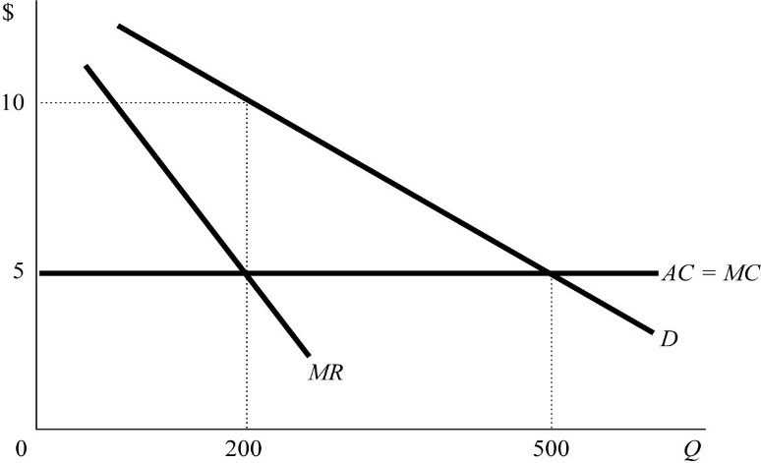

Figure shows the market for a successful price-fixing arrangement (cartel) between two identical firms. When the two firms act like one and charge the same price (2 Marks)
- What will be the market price?
- How much each firm will produce and sell quantity?

Write a one to two-page paper, addressing the following:
a. Describe in your own words the concept of market power.
b. What are the three reasons that a market might have a Monopoly?
c. Give an examples of two monopoly Firm exercising its market power.

