Project Title: “Why is there a global hunger problem and how can it be solved?”
Frame # Timecode Scene Title (Mood) | Narration | Visuals | Sound
Frame #1  Time: 00:00  Introduction  Emotional, concerned, in-touch with situation at hand | Tone:  Script (~words): With every passing year the world seems to be shrinking. With a growing population that’s adding 80 million more people every year, the plant and its inhabitants are struggling to sustain itself. The increasing number of people on earth has led to a severe world hunger issue, caused by other problems connected to population increase, such as: natural disasters, war, lack of leadership, poverty, and unstable markets. With such a high magnitude of people, the globe is struggling to manage the usage and distribution of resources efficiently, provide effective leadership and civil authority towards its citizens, and live cohesively in peace with one another. | Color scheme: Light Blue- represents responsibility, understanding, and healing  Photos: Illustration of the Earth struggling to maintain all the people living within it  Video: None  Text: None  Example photo below:  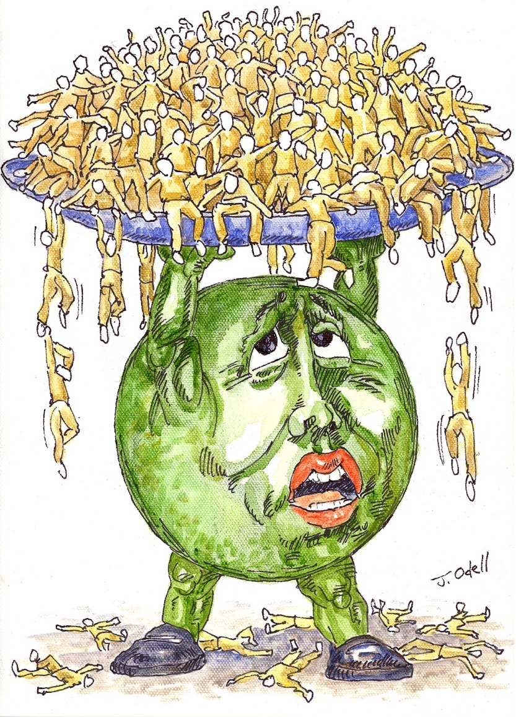 | Music: “Man in the Mirror” Micheal Jackson  Other audio:
Frame #2  (Izzy)  Time: 1:15 - 1:30  Body 1 - Poverty  (Formal, Passionate) | Tone: Informative  Script (143 words): Did you know that about 85% of the world lives on less than $30 (US) per day? With such little income, people are unable to get food, water or the tools necessary to grow their own food. Prices are too high for people to live. An effect that this can have is gentrification, which typically occurs in cities forcing these people to congregate together in the outskirts. These low income areas lack the resources for grocery stores or markets creating a food desert. One of the best solutions for this is access to education. Education means that there are better opportunities and access to income and food. Some countries have also developed the “Food for Education” program where students will receive meals as a part of coming to school. It seems like a simple idea, but implicating it will take everyone working together. | Color scheme: Red - this represents passion, love and anger. All can be directly applied to this topic  Photos: 2-3 Photos of kids (Pathos) skinny, living on the streets or holding a sign.  Video: https://www.youtube.com/watch?v=FWB7G7OzpZw  Text:  Example photo below:  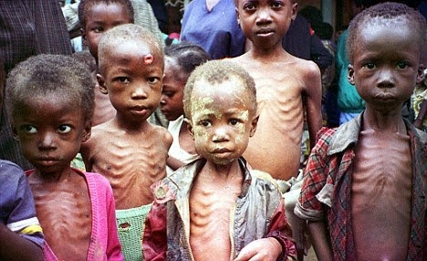  https://images.app.goo.gl/ftpgiEQLwNNziykC7 | Music:  “Is this the world we created?” Queen  (0:19- 0:41)  Other audio:
Frame #3  (Alejandro)  Time: 1:30 - 1:45  Body 2 Lack of leadership (Government)  (Disappointment, lack of hope and anger) | Tone:???  The lack of leadership from governments and corruption is one of the reasons many people suffer economically which leads to hunger. People in power have used their position to benefits themselves, especially in third-world countries, and have led to many economic crises where many are left without food. A big example is Venezuela, a poorly run government where food is scarce and inflation makes prices skyrocket. Could you imagine paying $150 for a dozen eggs? Countries like Venezuela need help from abroad to be able to have a democratic government again and hopefully begin to recover from this crisis to get out of this position. NGOs should help with these changes as well with food donations so people can have a decent life and food on their tables. | Color scheme: Dark, not clear that could represent the lack of hope and sadness of these people  Photos: People in line to be able to get food in Venezuela  Text: none  Example photo below:  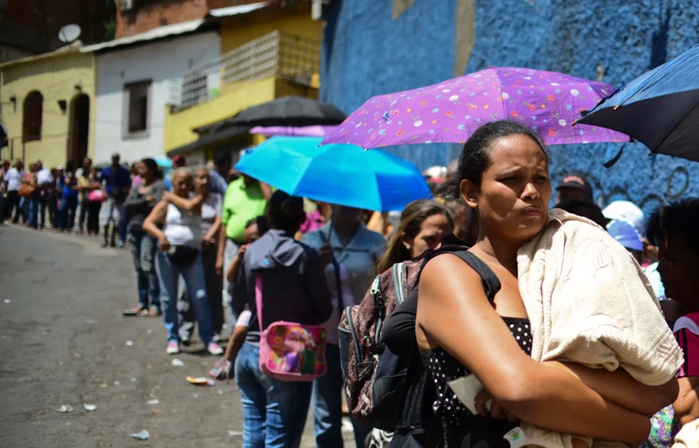 | Music: Rolling in the Deep by Adele
Frame #4  Time: 00:00  Body 3  (comprehensive,touching) | Tone:logically  Many force majeure natural disasters can also lead to different degrees of famine. The well-known global locust disaster in India which happened in 2020 is a great example. According to the data reported by CNN, The locust group has destroyed about 50,000 hectares of farmland, which directly caused 30% of the forty percent of the food production. As a country With a huge population like Indian, this locust disaster is an enormous traumatize for the local society. The Indian government said this is the most serious disaster in India suffered in the past 30 years.  Besides, Drought is also the main reason for induced famine. According to historical records, China Shandong has encountered a four-year drought in 1875. The number of deaths due to hunger in this incident were reached more than 10 million. The Lack of food supply is caused by the long period of water shortage. Without food storage, there is no choice for the Shandong people but to escape their motherland, which leads to the vast refuge movement throughout history. | Color scheme: grey  Photos: locust disaster and famine in Shandong  Text: none  Example photo below: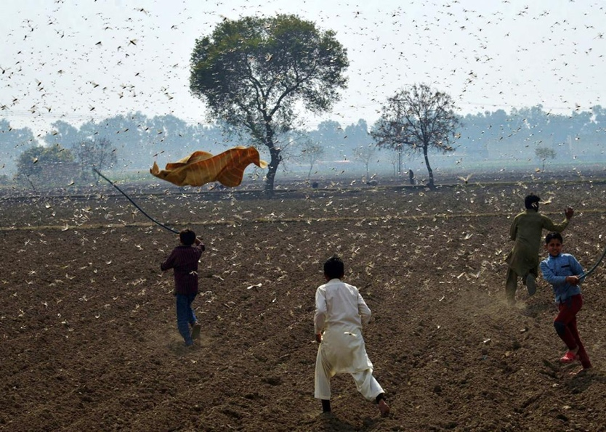  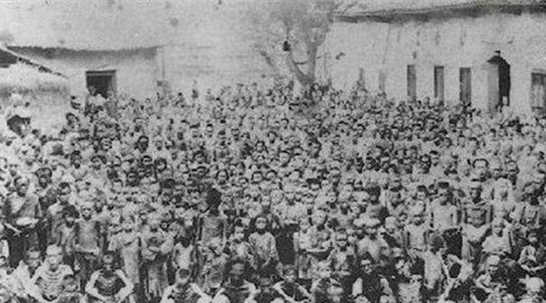 | Music: Where is the love by Black Eyed Peas
Frame #5
Time: 00:00
Conclusion

Sources for Poverty:
https://borgenproject.org/10-ways-stop-world-hunger/
https://ourworldindata.org/extreme-poverty
http://tcglobalissues.blogspot.com/2015/03/un-wants-to-end-poverty-hunger-by-2030.html

