Web Design
IT404

Assignment 2
  - Deadline: Thursday 8/04/2021 @ 23:59
[Total Mark for this Assignment is 5]

Instructions:
- You must submit two separate copies (one Word file and one PDF file) using the Assignment Template on Blackboard via the allocated folder. These files must not be in compressed format.
- It is your responsibility to check and make sure that you have uploaded both the correct files.
- Zero mark will be given if you try to bypass the SafeAssign (e.g. misspell words, remove spaces between words, hide characters, use different character sets or languages other than English or any kind of manipulation).
- Email submission will not be accepted.
- You are advised to make your work clear and well-presented. This includes filling your information on the cover page.
- You must use this template, failing which will result in zero mark.
- You MUST show all your work, and text must not be converted into an image, unless specified otherwise by the question.
- Late submission will result in ZERO mark.
- The work should be your own, copying from students or other resources will result in ZERO mark.
- Use Times New Roman font for all your answers.
Student Details:
Name: ###  CRN: ### |  | ID: ###

Question One
1.5 Marks
Learning Outcome(s): CLO1
Identify most HTML tags and CSS properties and use a text editor to construct the basic HTML and CSS structure for a webpage.

Create a code that gives the following output, use the CSS to change the color of all <p> and <h1> elements, to "green". Group the selectors to minimize code and use the internal CSS.
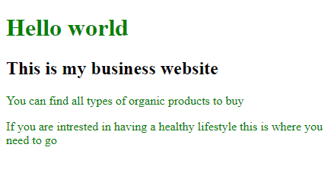
Answer:

Question Two
1 Mark
Learning Outcome(s): CLO2
Develop websites that present information, graphics and hypertext using CSS and JavaScript.

The following codes are using the RGB, change it to RGBA color in order to set the opacity for the background color of <h1> element to “0.3”.
<!DOCTYPE html>
<html>
<head>
<style>
h1 {
background-color: rgb(0,255,0);
}
</style>
</head>
<body>
<h1>Welcome to my world </h1>
<p>This is a Disney Website where you can have the full experience</p>
<p>Have fun and enjoy your time</p>
</body>
</html>

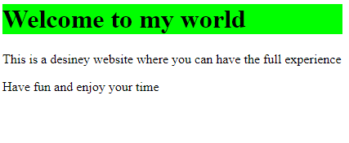
Answer:

Question Three
1 Marks
Learning Outcome(s): CLO2
Develop websites that present information, graphics and hypertext using CSS and JavaScript.

Create a code with <h1>, two paragraphs <p> and make sure you apply internal CSS where the background color of <h1> element is blue and the Set the transparency/opacity of it to "0.4".
Answer:

Question Four
1.5 Marks
Learning Outcome(s):
CLO3
Recognize and evaluate a range of real-world web design approaches.

Find the mistakes in the following codes based on the output shown:
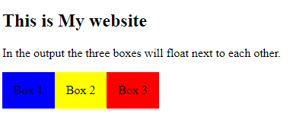
<!DOCTYPE html>
<html>
<head>
<style>
div {
float: right;
padding: 15px;
}
.div1 {
background: green;
}
.div2 {
background: yellow;
}

div3 {
background: red;
}
</head>
<body>
<h2>This is My website</h2>
<p>In the output the three boxes will float next to each other.</p>
<div class="div1">Box 1</div>
<div class="div3">Box 3</div>
</body>
</html>

Answer:

