QUESTION:

As you can see from the chart - it's quite startling how exposed people are.
HIV takes about 6 week to show up in blood work and since many people do not get blood work, it's obvious how many people may be infected.
Go to the following url. https://www.cdc.gov/std/default.htm
Imagine that you are working in the field, educating young people on the concept of "safe" sex, and avoidance of STI"s.
Choose 3 concepts (any 3) to highlight with these young people. Why did you choose these 3 concepts and what did you learn?
Please go into the textbook as always and reference it in your response.
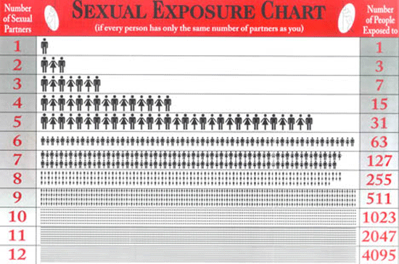

The concepts of "safe" sex, and avoidance of STI’s.
Inthavong (2020) noted that teenagers need to be imbued with thorough information about preventing unsafe sex, STIs, and even underage pregnancy. Adolescents are at heightened risk from a range of detrimental health effects related to early and risky sexual behaviors, such as STIs, during their teenage years. Adolescent experts and educators have many incentives to strengthen teenagers’ sexual and developmental health as well as minimize the rates of unexpected pregnancy and sexually infectious diseases in several contexts, including families, educational institutions, community education and primary care clinics (Santa Maria, 2017). This brief aims to identify three key concepts a health educator would highlight in a field event involving teenagers’ awareness of safe sex and STI avoidance.
As an educator, the first principle I do like to emphasize is prevention, which corresponds to safeguarding oneself before engaging in sexual activity. Since STIs can be avoided, substantial drops in new outbreaks are feasible and required. STI prevention can help to lower medical expenses while also reducing the harmful long-term effects of the infection. Preventing sexually transmitted infections (STIs) starts with getting screened, refraining from sex whenever drunk, staying vaccinated for the human papillomavirus (HPV), hepatitis A, and hepatitis B (HBV), limiting the count of sexual partners and using contraceptive methods like condoms. The next concept is STI diagnosis or testing, which encompasses scanning for vital health safety. This could incorporate HIV tests at a minimum annually and regular genital warts, chlamydia, hepatitis B, and trichomoniasis screenings (Montalto, 2019).
The third and final aspect to acknowledge is seeking timely treatment as contraceptives and other precautions are ineffective at eliminating the spread of a virus or bacteria-infected bodily fluids. As a result, if a person tests positive for an STI, they should speak with a doctor on the most appropriate treatment options (Montalto, 2019). Because of these principles’ inherent effectiveness in creating knowledge, which most adolescents lack due to insecurity, fear, and misconceptions frequently associated with adolescent growth, they were chosen to focus on them. I found that the adolescents involved’ plurality was conscious that using the effective condom, being vaccinated, and taking constant STI screenings culminated in safer sex.

References
Inthavong, K., Ha, L. T. H., Anh, L. T. K., & Sychareun, V. (2020). Knowledge of safe sex and sexually transmitted infections among high school students, Vientiane Prefecture, Lao PDR. Global Health Action, 13(sup2), 1785159. https://doi.org/10.1080/16549716.2020.1785159
Montalto, G. J. (2019). Sexually Transmitted Infections: Prevention, Diagnosis, and Treatment in Primary Care. Pediatric annals, 48(9), e370-e375. DOI: 10.3928/19382359-20190815-02
Santa Maria, D., Guilamo-Ramos, V., Jemmott, L. S., Derouin, A., & Villarruel, A. (2017). Nurses on the Front Lines: Improving Adolescent Sexual and Reproductive Health Across Health Care Settings. The American journal of nursing, 117(1), 42–51. https://doi.org/10.1097/01.NAJ.0000511566.12446.45

