Project –Phase 2
  - Deadline: Sunday 11/04/2021 @ 23:59
[Total Mark for this project is 5]

Network Management
IT340

Student Details:
Name: Student1 (Leader)  Name: Student2  Name: Student3  CRN: | ID:  ID:  ID:

Instructions:
- You must submit two separate copies (one Word file and one PDF file) using the Assignment Template on Blackboard via the allocated folder. These files must not be in compressed format.
- It is your responsibility to check and make sure that you have uploaded both the correct files.
- Zero mark will be given if you try to bypass the SafeAssign (e.g. misspell words, remove spaces between words, hide characters, use different character sets or languages other than English or any kind of manipulation).
- Email submission will not be accepted.
- You are advised to make your work clear and well-presented. This includes filling your information on the cover page.
- You must use this template, failing which will result in zero mark.
- You MUST show all your work, and text must not be converted into an image, unless specified otherwise by the question.
- Late submission will result in ZERO mark.
- The work should be your own, copying from students or other resources will result in ZERO mark.
- Use Times New Roman font for all your answers.

Project description
5 Marks
Learning Outcome(s):
Evaluate different SNMP tools, network statistics tools, and protocol analyzer for network management.

1. Objectives
The main objective of this project is to familiarize with network management and monitoring tools.
2. Introduction
According to comparitech web site (https://www.comparitech.com/net-admin/network-monitoring-tools/) selecting a network management and monitoring tool is a challenging task for network administrator due to various factors such as the huge number of tools in the market, the environment and the budget.
3. Presentation of the best network tools for monitoring
Also, according to the website, the 10 best network monitoring tools for 2021 are presented as follows:
- SolarWinds Network Performance Monitor EDITOR’S CHOICE
Far more than just a simple scanner. Most network security issues arise when configurations are changed and SolarWinds NPM identifies these and can automatically resolve many. Alongside solid vulnerability scanning and advanced options to create and monitor policies, this is by far the top choice for network monitoring systems. Get a 30-day free trial.
- Datadog Network Performance Monitoring (FREE TRIAL) A cloud-based monitoring system for onsite, remote, cloud, or hybrid network resources.
- ManageEngine OpManager (FREE TRIAL) Network monitor that can monitor SNMP devices, switches, servers, and virtualized network services.
- Progress WhatsUp Gold (FREE TRIAL) A network performance monitor that utilizes SNMP to check on network device health and can be expanded by paid add-ons to monitor other resources. Installs on Windows Server.
- Site24x7 Network Monitoring (FREE TRIAL) A combined IT infrastructure, applications, and user behavior monitoring service available in the cloud.
- Paessler PRTG Network Monitor (FREE TRIAL) Free network monitoring software that uses SNMP, packet sniffing and WMI to monitor your network.
- Nagios Core – One of the top open-source network monitoring tools. Includes a dashboard view, alerts system, community plugins, and more.
- Zabbix – Open source network monitoring software with SNMP and IPMP monitoring. Includes an alerts system and community plugins.
- Icinga – Open source network monitoring system with a DSL. Includes extensions.
- Spiceworks Connectivity Dashboard – Free network monitoring software with a high-quality dashboard and simple alert system.
4. Required work
Select one tool among the best network monitoring tools using SNMP presented in section 3 and perform the following tasks:
- Describe the monitoring tool and provide two arguments to support your choice (0.5 mark).
- Download and install the monitoring tool in your computer by giving the screenshot of his interface (0.5 mark).
- Configure the SNMP management tool by selecting the SNMP version, credentials, community name, context and so on by giving the screenshot for various selected parameters needed for configuration (0.5 mark).
- Make a discover of the network to know the connected devices in your network by providing the screenshot of the network map (0.5 mark).
- Describe three network analyzes provided by the monitoring tool by giving three screenshots and describe their network parameters (3 marks). Use three different analyze categories like Performance/Top 10, Log/SNMP Trap and Tools/SNMP MIB Walker.

5- Appendix
1-Example of network management tool interface based on SNMP.
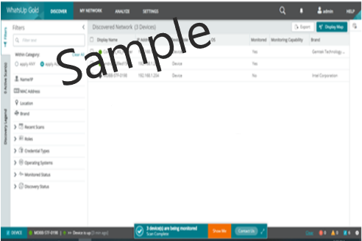
2- Example of scan results of the network.
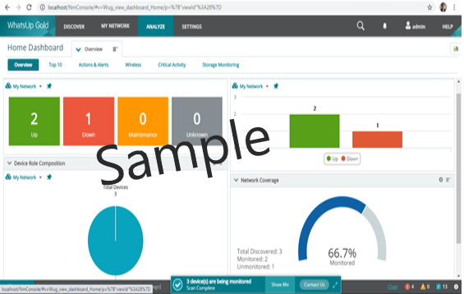
3- Example of network analyze that can be performed by the network management tool.
