1. “The Impact of COVID-19 on Small Business Outcomes and Expectations” by Alexander Bartik and 5 other coauthors[1] is a paper that reports the results from a survey of the effects of COVID-19 on small businesses. Please answer the following questions as we explore the results from the paper:
   1. Figure 1 from the paper plots histograms of the firm size for firms from the survey (green) versus the 2017 Census of US Businesses (brown):

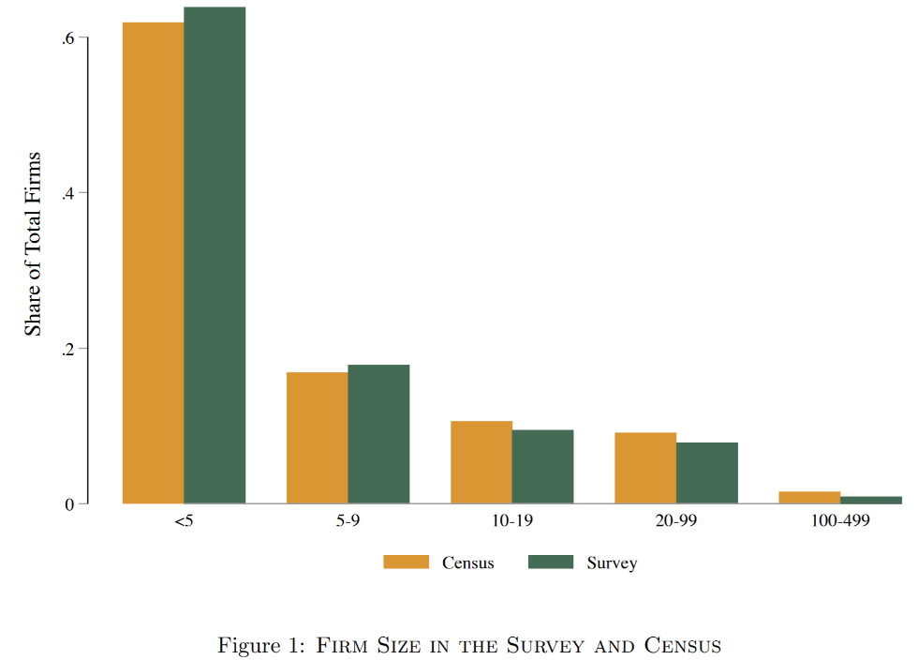

The horizontal axis is the number of employees in the firm. Please compare the number of employees of firms in the survey versus the Census. Does the Census data have a larger or smaller share of firms with 10 or more employees? (7 points)

* 1. Figure 6 shows the mean and median number of months of cash on hand for firms by monthly expense level:

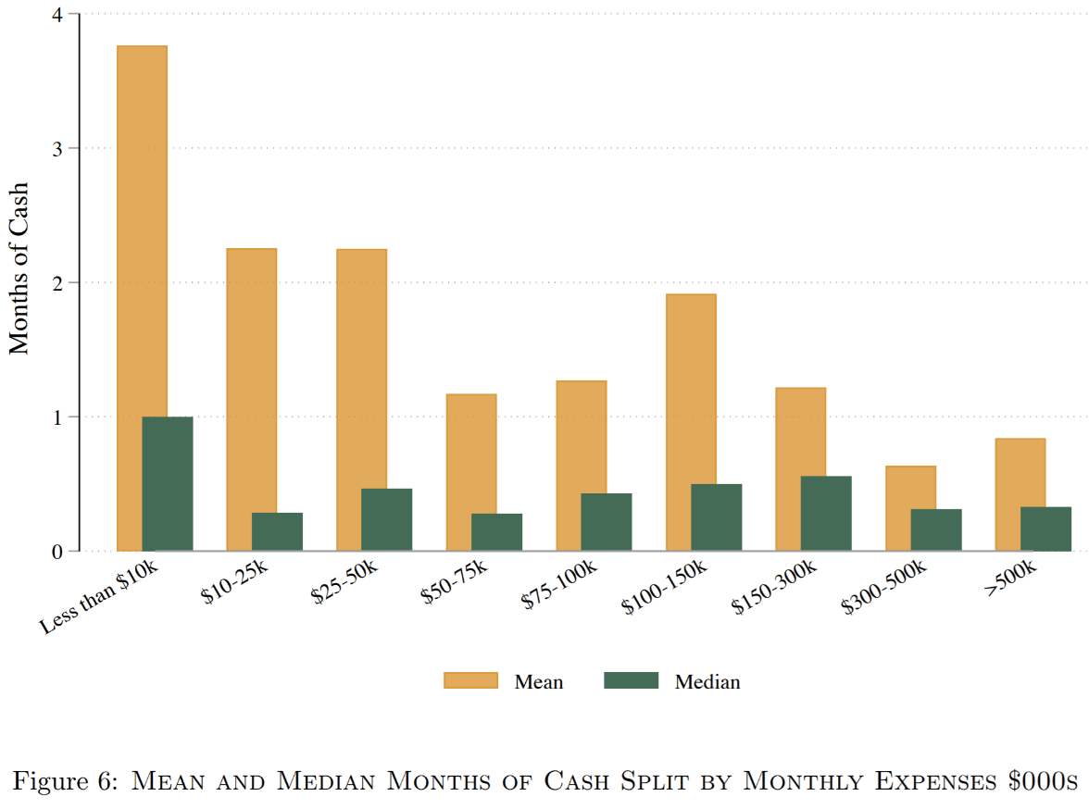

If the distribution of months of cash at each expense level is unimodal, would you expect the distributions of months of cash to be left-skewed, right-skewed, or symmetrical? (7 points)

* 1. The figure below shows the survival function for the businesses’ expectations of the end date of the crisis as of when they were surveyed around April 1st, 2020:

Survival Function of Expected COVID-19 Crisis End Date

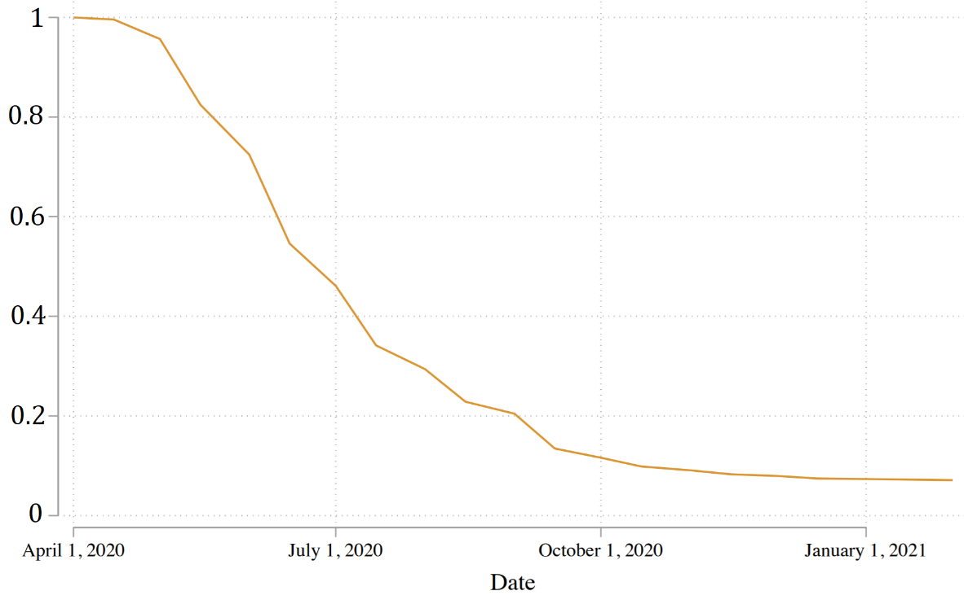

The event studied is the expected COVID-19 crisis end date. About what fraction of businesses thought that the crisis end before 2021 as of the time of the survey? (7 points)

* 1. Table 3 shows the summary statistics for different survey questions broken down by industry:

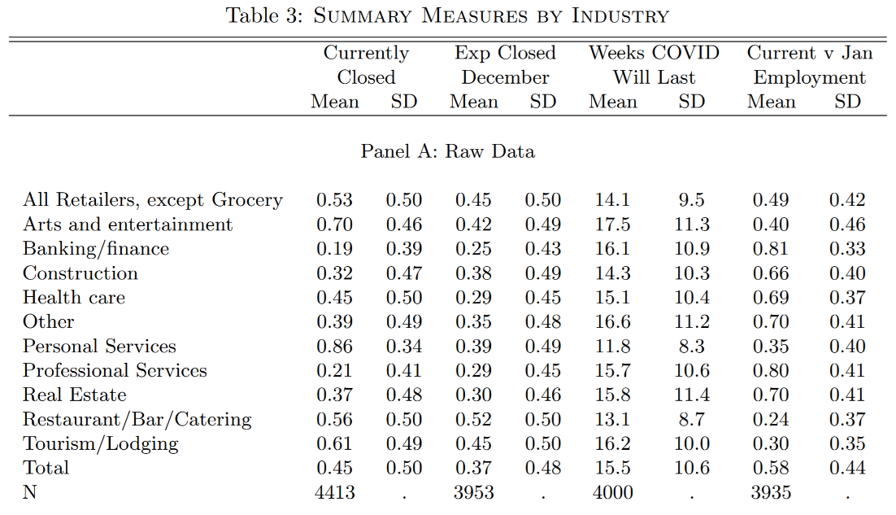

The “Currently Closes” and “Exp Closed December” are dummy variables that are 1 when the firm is closed and expects to be closed in December, respectively. Please compare the effects and forecasts of the crisis from the perspective of the personal services industry compared to the banking and finance industry. Which industry was harder hit? How did they differ in their forecasts of the effects of the crisis? (8 points)

1. “Estimating the Effects of Movie Piracy on Box-office Revenue” by Arthur De Vany and W. David Walls[2] studies how movie revenue declines are related to the availability of movies on piracy websites. An unnamed movie studio used web crawlers to track the number of downloads available on piracy websites and provided the data on a confidential basis to the authors. Figure 1 from the paper and the main regression results from Table 1

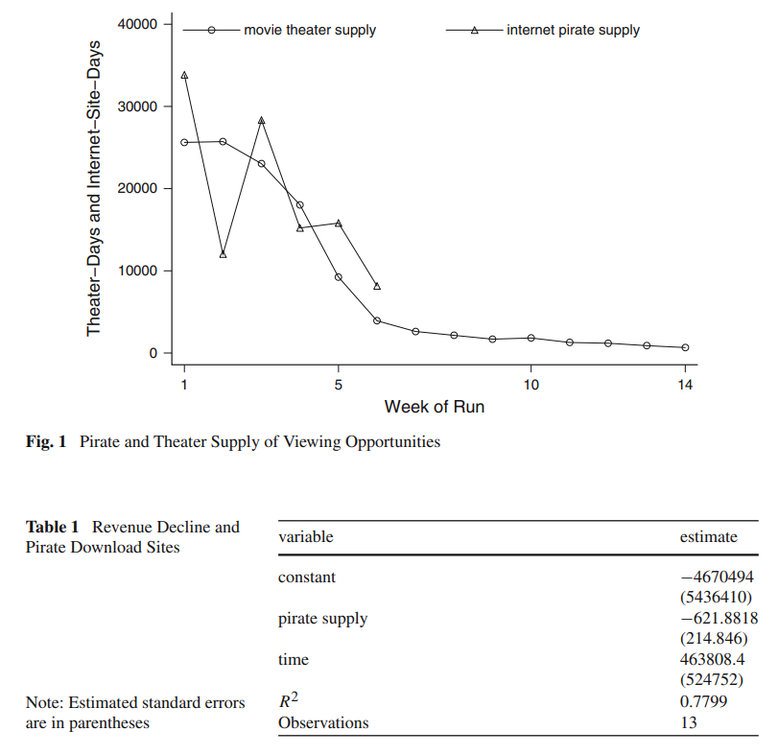

The regression equation for table 1 is:

* 1. Please interpret the R squared of the regression in terms of the model’s ability to explain the revenue changes. (7 points)
  2. Please interpret the parameter estimate for $β_{2}$ in Table 1. How does the regression suggest piracy supply affects movie revenue? (7 points)
  3. Suppose a movie was in its 4 week since release and was available on piracy websites for 20,000 site days (site days = the units of pirate supply). What is the regression’s prediction for the change in movie revenue? (8 points)
  4. Please perform a t test of the claim that pirate supply does not affect the revenue changes ($β_{2}=0$). Please specify the test statistic, critical value, and result of your test. (8 points)
  5. Figure 1 suggests a violation of the classical linear model assumptions exists with the regression model in Table 1. What kind of problem exists? (7 points)
  6. Figure 1 suggests that something about the regression results of Table 1 is misreported. What is wrong in the Table 1 results (besides what you found in the previous part)? (4 points)

1. The Calvo model of sticky prices in macroeconomics models firms as having a constant probability of being able to change prices in every month or quarter. Fougere, Le Bihan, and Sevestre (2004)[3] estimate hazard functions from millions of observations of prices in the French Consumer Price Index to examine when firms decide to change prices (event being studied: product changes price). Their results for service industry products are below:

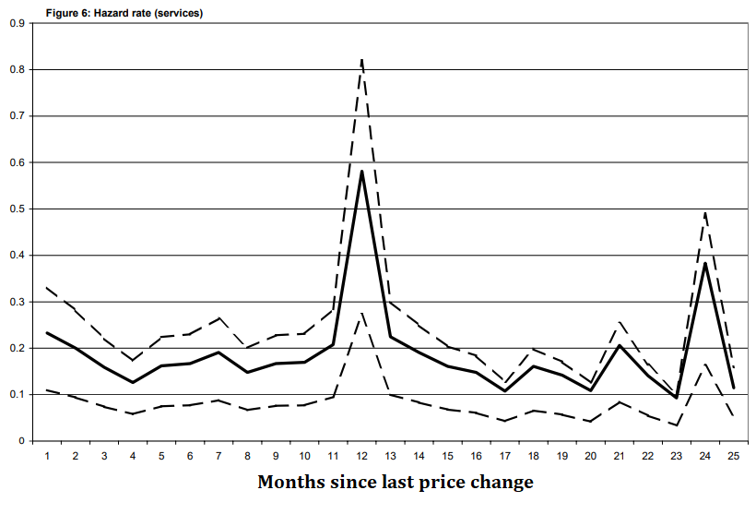

If price changes were consistent with the Calvo model, we would expect that the rate businesses change their prices would be constant regardless of how long it has been since they last changed their prices. Does the hazard function plot above support the Calvo model? Why or why not? (8 points)

1. Economist David Card in his 1992 paper “Do Minimum Wages Reduce Employment? A Case Study of California, 1987-1989” published in *Industrial and Labor Relations Review* studied the effects of the 1988 minimum wage increase in California from $3.35 an hour to $4.25 an hour. He compared a sample of Californian teenagers from the Current Population Survey to a comparison group of teenagers from states without a change in the minimum wage between 1987 and 1989.
   1. One predicted effect of the minimum wage increase would be an increase in prices in the most affected industries. David Card surveyed the price of McDonald’s Quarter Pounder during and after the minimum wage changes in Californian and other cities to track the prices of fast food. Please compute the mean price of a Quarter Pounder in the 2nd quarter of 1988 in California as a weighted mean using the table below. Please use the cities’ population in 1990 as the weight in your calculations. Please report the average price to two decimal places (nearest cent). (8 points)

Price of McDonald’s Quarter Pounder in California Cities in the 2nd Quarter of 1988

|  |  |  |
| --- | --- | --- |
|  | Price | Population (1990) |
| Bakersfield | $ 1.67 | 185,405 |
| Fresno | $ 1.65 | 357,662 |
| Riverside | $ 1.74 | 231,053 |
| Sacramento | $ 1.71 | 398,256 |
| San Diego | $ 1.85 | 1,118,000 |

* 1. Why might the simple (unweighted) mean of Quarter Pounder prices computed from the above table might not be the best way to compute the mean price that Californians pay? (7 points)

c. Figure 3 from Card’s paper presents a scatterplot of teenage employment in 1987 versus teenage employment in 1989 across US states:

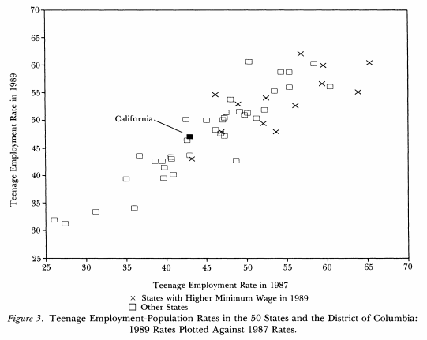

Suppose that you ran the following regression:

$$Employment Rate in {1989}_{i}=β_{1}+β_{2}*Employment Rate in {1987}_{i}+e_{i}$$

Do you think you will have a multicollinearity problem in this regression? Why or why not? (7 points)

Important Formulas

$$ρ\left(x,y\right)=\frac{s\left(x,y\right)}{s_{x}*s_{y}}; \\ s\left(\right):covariance, ρ:correlation coefficient,s_{x}: standard deviation of x$$

$$ρ\left(x,y\right)=\sqrt[{}_{-}^{+}]{R^{2}} \left(for two variable regression model\right) \\ x: independent variable in regression \\ y: dependent variable in regression$$

$$Simple Average of X=\frac{\sum_{i=1}^{n}{X_{i}}}{n}, n=number of observations$$

$$Weighted Average of X=\frac{\sum_{i=1}^{n}{w_{i}*X_{i}}}{\sum_{i=1}^{n}{w_{i}}}$$

$$Conditional Average of X=\frac{\sum_{i=1}^{n}{X_{i}*{I(X=x)}_{i}}}{\sum_{i=1}^{n}{{I(X=x)}_{i}}}$$

$${I(X=x)}_{i}: dummy variable=1 if X satisfies condition X=x; =0 otherwise$$

$$\hat{Y}=\hat{β_{1}}+\hat{β_{2}}X$$

$$\hat{Y}=\hat{β_{1}}+\hat{β_{2}}X_{2}+\hat{β_{3}}X_{3}+...+\hat{β_{k}}X_{k}$$

$$ESS=\sum_{i=1}^{n}{{\left(\hat{Y_{i}}-\overline{Y}\right)}^{2}}, RSS=\sum_{i=1}^{n}{{e_{i}}^{2}}, TSS=\sum_{i=1}^{n}{{\left(Y_{i}-\overline{Y}\right)}^{2}}$$

$$TSS=ESS+RSS$$

$$R^{2}=\frac{ESS}{TSS}$$

$$Risk Set\left(t\right)=Risk Set\left(t-1\right)-Failures\left(t-1\right)-Censors\left(t\right)$$

$S\left(t\right)=S\left(t-1\right)*\frac{\left(Risk Set\left(t\right)-Failures\left(t\right)\right)}{Risk Set\left(t\right)}$ or $S\left(t\right)=S\left(t-1\right)*(1-H\left(t\right))$

$$S\left(0\right)=1$$

$$H\left(t\right)=\frac{Failures(t)}{Risk Set\left(t\right)}$$

$$t=\frac{\hat{β}-c}{se(\hat{β})}$$

1. *Proceedings of the National Academy of Sciences* (July 2020), 117 (30), 17656-17666.
2. *Review of Industrial Organization* (2007), 30, 291-301.
3. “Calvo, Taylor, and the Estimated Hazard Function for Price Changes,” working paper.