# Objectives:

1. To introduce colligative properties of solutions
2. To determine the freezing point liquids
3. To use experimental freezing point depression data to calculate the molar mass of an unknown nonelectrolyte solute

# Materials:

* Large test tube*
* Thermometer
* Stir rod
* 250 mL beaker
* 100 mL graduated cylinder
* Unknown F *2g*
* Distilled water
* Ice
* NaCl (s) *100 g* *(provided by student)*

*\*the large test tube in this kit is actually a centrifuge tube and looks like this:*

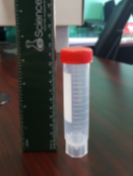

# Introduction:

Colligative properties of a solution are properties that depend upon the concentration of **solute particles** (ions, atoms, or molecules), but not upon the identity of the solute.

There are four colligative properties (see lecture notes for details):

* 1. freezing point depression
  2. boiling point elevation
  3. vapor pressure lowering
  4. osmosis

This lab focuses on the freezing point depression of an aqueous solution. When a solute is added to a pure solvent, the freezing point of the resulting solution is lower than that of the pure solvent. This observation is known to chemists as freezing point depression. An application of this effect is the use of salt to melt ice on the highways in the winter months.

At the molecular level, the freezing point depression can be explained by using the Kinetic Molecular Theory (KMT, see **lecture notes**). When the temperature of a solution is lowered, the average kinetic energy of the molecules decreases. Consequently, as the temperature is lowered, the molecules slow down. When the intermolecular attractive forces between the molecules overpower the forces of repulsion caused by the kinetic energy, the molecules get closer to each other and form a solid.

In a **solution**, the solute particles interfere with the solidification process described above by interacting with the solvent molecules. As a result, a lower temperature is required to cause the solvent particles to form a solid.

The relationship between the changes in the temperature and the concentration of the solution is given by the following formula:

**△Tf = *i* K*f**m***

where

* *m* is the **molality** of the solution (see lecture notes for more details)
* *i* is the **van't Hoff factor** (*i* = 1 for a nonelectrolyte)
* K*f*  is the **molar-freezing-point-depression constant** (K*f* = 1.86°C/m for water).

**△**Tf can be found experimentally by determining the difference between the freezing points of the pure solvent and the solution.

**△**Tf must be determined by **extrapolation** of graphic data because of the phenomenon of **supercooling**, which is the sudden lowering of freezing point of a solution beyond its actual freezing point.

# Procedure:

PART I: Freezing Point of the Solvent (water)

1. Prepare an ice bath as follows:
   * Fill a 250 mL beaker with crushed ice to the 200 mL line.
   * Add 100 g of table salt to the ice.
   * Add tap water until 2/3 of the ice is covered.
   * Stir vigorously with your stirring rod.
2. Measure 20.0 mL distilled water into a large test tube.
3. Insert a thermometer *into the liquid in the large test tube.*
4. Insert the test tube into the ice water bath. Make sure the ice bath water level is above the level of the liquid inside the test tube. If it is not, add more ice, salt and water.
5. Record the temperature of the liquid inside the test tube every 30 seconds.
6. Continue to stir the liquid inside the test tube until the liquid starts to freeze. When the liquid starts to freeze, do not stir anymore. Be careful not to break the thermometer by stirring it in ice! Mark the temperatures where the liquid starts to freeze. (by an asterisk or highlight or something.)
7. Continue to monitor until the temperature is fairly constant.
8. Record the data on your Report Sheet.
9. When done, remove the large test tube from the ice bath and melt the ice inside with the warmth of your hands or under running water.
10. Set the test tube with the water aside to use in Part II.

**Lab Technique Tip:** Do not remove the thermometer until the liquid inside is melted or your thermometer may break.

PART II: Freezing Point of the Solution

1. Weigh 2.0 g of unknown F (a nonelectrolyte.)
2. Record exact weight to 0.01g on your report sheet.
3. Dissolve it in the same 20.0 mL of water inside the large test tube from Part I.
4. Mix well until dissolved.
5. Refresh the ice bath with additional ice or salt.
6. Repeat Part I, steps 3-9.



**Calculations:**

Show all your work on your Lab Report Sheet.

1. Plot temperature versus time on the same graph paper for both the solvent (Part I) and the solution (Part II.)
2. Determine the change in freezing point, **△**Tf, from the graph. Refer to the following graph:

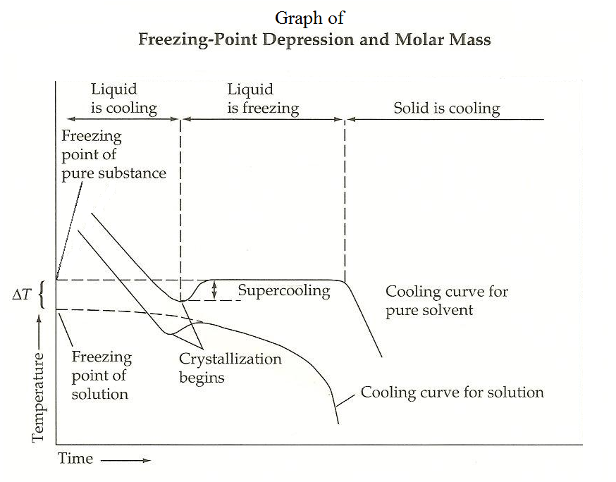

1. Determine the molar mass of your unknown compound (density of water = 1.00g/mL).
   1. Molality of unknown solute, *m =* **△**Tf /Kf
   2. Moles of unknown solute = *m* x kg of water
   3. Molar mass of unknown solute = mass of unknown solute/moles of unknown solute
2. Identify the unknown from the possibilities in the table below.

**Molar Masses of some Nonelectrolytes**

|  |  |
| --- | --- |
| **Compounds** | **Molar mass** |
| Ethanol | 42.0 |
| Glucose | 180.0 |
| Glycerol | 92.0 |
| Urea | 60.0 |
| Formaldehyde | 30.0 |
| Sucrose | 342 |

**Sample Calculations:**

In an experiment similar to the one you are performing here, 3.47 g of an unknown nonelectrolyte was dissolved in 20.0 mL of water (density = 1.00 g/mL). ∆Tf was graphically determined to be 1.81 oC. Calculate the molar mass of the unknown and identify it. (Kf of water = 1.86 oC/*m*)

1. **molality(*m)* of the solution:**  ∆Tf = *i* K*f**m*; *i = 1* (nonelectrolyte)

*m*  =

*m* =

*m* = 0.973 mol/kg of solvent

1. **moles of solute**

moles of solute = *m* x kg of solvent

kg of solvent = (density of water x 20.0 mL)/1000 mL

= (1.00 g/mL x 20.0 mL)/1000 mL

= 2.00 x 10-2 kg

moles of solute = 0.973 mol/kg x (2.00 x 10-2 kg)

= 1.95 x 10-2 mol

1. **molar mass of the unknown solute**

molar mass = $\frac{g of unknown}{moles of unknown}$

|  |
| --- |
| 3.46 g |
| 1.95 x 10-2 mol |

= 178 g/mol

**The unknown solute is: *glucose*.**

# Molar Mass Determination Lab Report Sheet

|  |
| --- |
| Name: |
| Partner (if applicable): |

# PART I: FP of the Solvent

|  |  |
| --- | --- |
| **Time (s)** | **Temperature ◦C** |
| 30 |  |
| 60 |  |
| 90 |  |
| 120 |  |
| 150 |  |
| 180 |  |
| 210 |  |
| 240 |  |
| 270 |  |
| 300 |  |
| 330 |  |
| 360 |  |
| 390 |  |
| 420 |  |
| 450 |  |

# PART II: FP of the Solution

|  |  |
| --- | --- |
| **Time (s)** | **Temperature ◦C** |
| 30 |  |
| 60 |  |
| 90 |  |
| 120 |  |
| 150 |  |
| 180 |  |
| 210 |  |
| 240 |  |
| 270 |  |
| 300 |  |
| 330 |  |
| 360 |  |
| 390 |  |
| 420 |  |
| 450 |  |

Fill in the excel data tables with your data and the graph will generate automatically. You may need to extend the table to determine a good freezing point.



Results Table

|  |  |
| --- | --- |
| 1. Freezing point of the solvent | °C |
| 1. Freezing point of the solution | °C |
| 1. ∆Tf  (Extrapolated from graph) | °C |
| 1. Mass of unknown solute | **g** |
| 1. Mass of solvent | kg |
| 1. Molality | *m* |
| 1. Mol solute | **mol** |
| 1. Molar mass | **g/mol** |
| 1. Identity of unknown |  |

# Conclusion