Q1) Write a code in python that display the list:
Final=[0,-3,5,100,5,10,30]
- Print the list
- Find how many elements the list contains
- Add number 3 to the third element which is 5. It should be replicated by 8.(5+3)
- Print the new list. (The output should be [0,-3,8,100,5,10,30])
- Find the last element of the list using length

Q2) what is the difference between code 1 and code 2?
Code 1:
F0=open("foo.txt","wb")
Foo.closed

Code 2:
F0=open("foo.txt","wb")
Foo.close()

Q3) deff(a,b=1, c=2)
This defined function prints values of arguments passed to the parameters, the write output of:

F(2, c=2)

F(c=100, a=110)

Q4) The syntax of opening file in python for both reading and writing format is:

Q5) write a code in python that welcomes the user when the username and password is correct.
- Username: "python"
- Password: "12345"
Output should be :

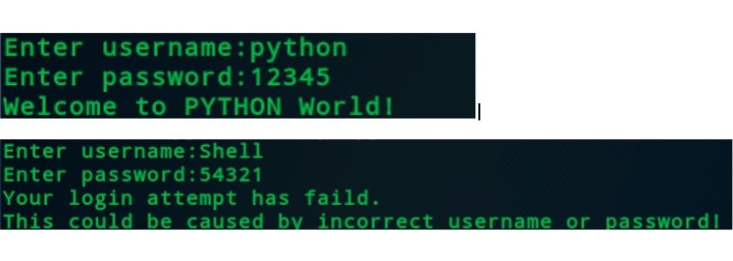

Q6) write a program to remove all deprecate elements from a tubal and create a new tubal. Print the newly created tuple. If the tuple is (10,15,8,10,5,4,3,5) then the new tuple will be (10,15,8,5,4,3)

