PR HW #1

- Problem 2.2 page 47
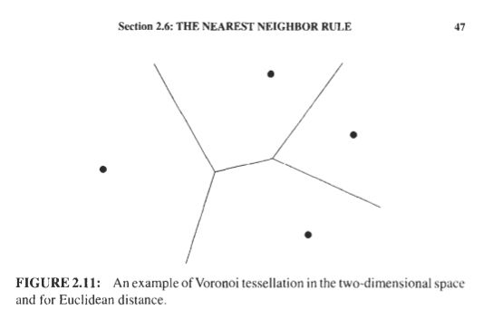
2.2 In a two-class one-dimensional problem the pdf’s are the Gaussians N(0,a2)and
,V(1. c 2 )for the two classes, respectively. Show that the threshold xu minimizing
the average risk is equal to
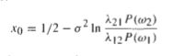
where h 11 = A22 = 0 has been assumed

- Problem 2.5 page 47
Consider a two (equiprobable) class one-dimensional problem with samples distrihuted according to the Rayleigh pdf in each class, that is,
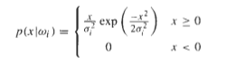
Compute the decision boundary point g ( x ) = 0

- Problem 2.7 page 48
2.7 In a three-class two-dimensional problem the feature vectors in each class are
normally distributed with covariance matrix
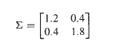
The mean vectors foreachclass are [O. 1,O.1IT, [2.1, 1.9IT, [- 1.5, 2.OlT. Assuming
that the classes are equiprobable, (a) classify the feature vector [1.6, 1S I T according
to the Bayes minimum error probability classifier; (b) draw the curves of equal
Mahalanobis distance from [2.1, 1.9IT

- Problem 2.12 page 49
2.12 Consider a two-class two-dimensional classification task, where the feature vectors
in each of the classes w1,LLV, are distributed according to
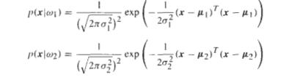
with
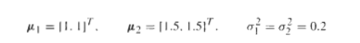
Assume that P ( w 1 ) = P(w2)and design a Bayesian classifier
(a)that minimizes the error probability
(h) that minimizes the average risk with loss matrix
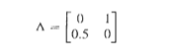
Using a pseudorandom number generator, produce 100 feature vectors from each
class. according to the preceding pdf's. Use the classifiers designed to classify the
generated vectors. What is the percentage error for eachcase?Repeat the experiments
for pz = [ I O . 3.OIT.

- Problem 2.10 page 49
2.10 Show that in the case in which the feature vectors follow Gaussian pdf's, the
likelihood ratio test in (2.19)
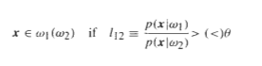
is equivalent to
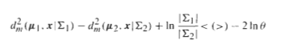
where 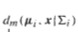 is the Mahalanobis distance between pi and x with respect to
the norm.

- Problem 2.11 page 49
2.11 If C I= C2 = E, show that the criterion of the previous problem becomes
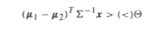
Where
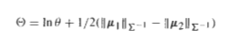

Problem 2.17 Page 50 (first question only)
2.17 In a heads ortails coin-tossing experiment the probability of occurrence of a head ( I )
is q and that of a tail (0)is 1-4. Let x; ,i = 1,2, . . .,N,be the resulting experimental
outcomes, xi E {0,1) .Show that the ML estimate of q is
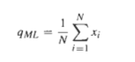
Hint: The likelihood function is
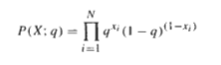
Then show that the ML results from the solution of the equation
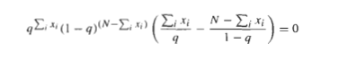

- Problem 2.19 page 51
Show that if the likelihood function is Gaussian with unknowns the mean p as well
as the covariance matrix C, then the ML estimates are given by
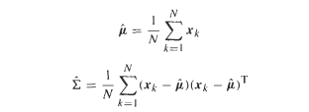

- Problem 2.24 page 52
Show that for the lognormal distribution
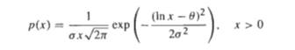
the ML estimate is given by
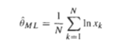

To be continued …

